Date: 10 Aug 2019

**CIRCULAR**

All the new faculties of the department are hereby informed to attend a meeting on 13 Aug 2019 at 12:15 pm in HoD office.

Agenda: Induction programme’s like:

1. Subject allotment and teaching methodology

2. Attendance – Faculties & Student

3. Evaluation – IA, Seminar, Internship, Mini, Micro & Major Project work

4. Code of Conduct – Faculties & Student

5. Other Activities

Date: 13 Aug 2019

Time: 12:15 pm

Venue: HoD office

|  |  |  |  |  |  |
| --- | --- | --- | --- | --- | --- |
| **Sl. No.** | **Faculty Name** | **Signature** | **Sl. No.** | **Faculty Name** | **Signature** |
|  | Anusha B Rao |  |  | Billigraham M Kurian |  |
|  | Sindhurashmi |  |  | Kavyashree S |  |
|  | Tanvi Rai A |  |  | Mohanraj |  |
|  | Kavyashree Aradhya |  | 4. | B E Gururaja |  |
|  | Ashish Shetty |  |  |  |  |

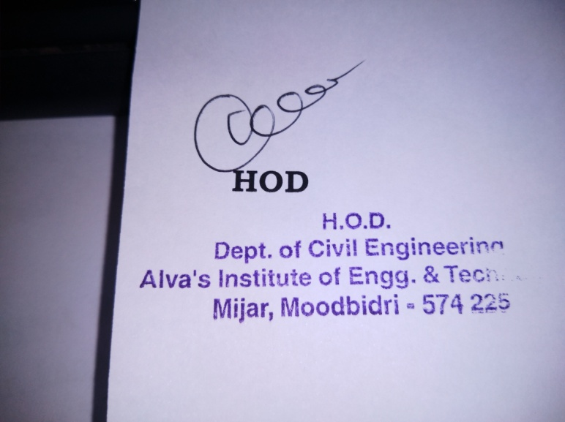

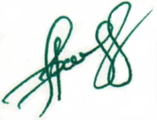

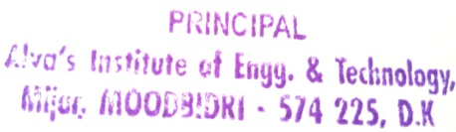 **Principal**