Date: 23 Aug 2018

**CIRCULAR**

All the new faculties of the department are hereby informed to attend a meeting on 28 Aug 2018 at 10:45 am in HoD office.

Agenda: Induction programme’s like:

1. Subject allotment and teaching methodology

2. Attendance – Faculties & Student

3. Evaluation – IA, Seminar, Internship, Mini, Micro & Major Project work

4. Code of Conduct – Faculties & Student

5. Other Activities

Date: 28 Aug 2018

Time: 10:45 am

Venue: HoD office

|  |  |  |
| --- | --- | --- |
| **Sl. No.** | **Faculty Name** | **Signature** |
|  | Srikantha H |  |
|  | Sandeepkumar D S |  |

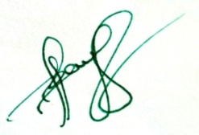

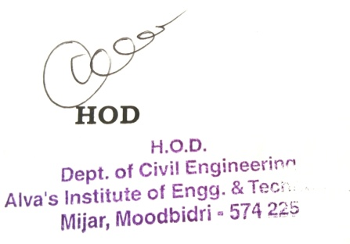

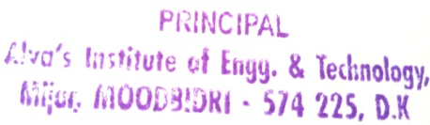 **Principal**