Date: 10 Aug 2017

**CIRCULAR**

All the new faculties of the department are hereby informed to attend a meeting on 12 Aug 2017 at 02:30 pm in HoD office.

Agenda: Induction programme’s like:

1. Subject allotment and teaching methodology

2. Attendance – Faculties & Student

3. Evaluation – IA, Seminar, Internship, Mini, Micro & Major Project work

4. Code of Conduct – Faculties & Student

5. Other Activities

Date: 12 Aug 2017

Time: 2:30 pm

Venue: HoD office

|  |  |  |  |  |  |
| --- | --- | --- | --- | --- | --- |
| **Sl. No.** | **Faculty Name** | **Signature** | **Sl. No.** | **Faculty Name** | **Signature** |
|  | Adithya B Shenoy |  |  | Santhosh K |  |
|  | Aishwarya Laxmi |  |  | Shwetha K |  |
|  | Akshatha Durgekar |  |  | Sneha P |  |
|  | Akshatha S.P |  |  | Sooraj Kumar |  |
|  | Ashwini Nayak |  |  | Swathi |  |
|  | H C M Swamy |  | 6. | Naveen Francis |  |
|  | Rashmi H |  |  |  |  |

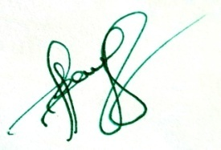



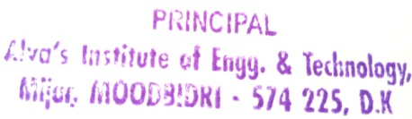**CV-HoD Principal**

Date: 29 Jan 2018

**CIRCULAR**

All the new faculties of the department are hereby informed to attend a meeting on 31 Jan 2018 at 10:00 am in HoD office.

Agenda: Induction programme’s like:

1. Subject allotment and teaching methodology

2. Attendance – Faculties & Student

3. Evaluation – IA, Seminar, Internship, Mini, Micro & Major Project work

4. Code of Conduct – Faculties & Student

5. Other Activities

Date: 31 Jan 2018

Time: 10:00 am

Venue: HoD office

|  |  |  |
| --- | --- | --- |
| **Sl. No.** | **Faculty Name** | **Signature** |
|  | Hemanth Tunga |  |



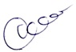

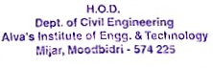**CV-HoD Principal**