Date: 16 Aug 2016

**CIRCULAR**

All the new faculties of the department are hereby informed to attend a meeting on 17 Aug 2016 at 10:30 am in HoD office.

Agenda: Induction programme’s like:

1. Subject allotment and teaching methodology

2. Attendance – Faculties & Student

3. Evaluation – IA, Seminar, Internship, Mini, Micro & Major Project work

4. Code of Conduct – Faculties & Student

5. Other Activities

Date: 17 Aug 2016

Time: 10:30 am

Venue: HoD office

|  |  |  |  |  |  |
| --- | --- | --- | --- | --- | --- |
| **Sl. No.** | **Faculty Name** | **Signature** | **Sl. No.** | **Faculty Name** | **Signature** |
|  | Aditya Tantri |  |  | Rakesh.N |  |
|  | Akruth K |  |  | Ramesh Rao B |  |
|  | Arun Kumar G S |  |  | Shilpa S Vadavadagi |  |
|  | Avinash Nayak |  |  | Dr. H G Umeshchandra |  |
|  | Bhojaraja B E |  |  | Veena D Savanth |  |
|  | Jayalatha N A |  |  |  |  |
|  | Manjunath H S |  |  |  |  |

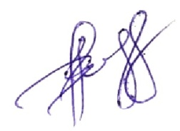



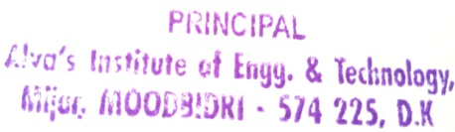**CV-HoD Principal**