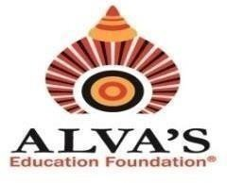
ALVA’S INSTITUTE OF ENGINEERING & TECHNOLOGY
Shobhavana Campus, Mijar, Moodbidri, D.K – 574225
Phone: 08258-262725, Fax: 08258-262726

QUALITY INDICATOR FRAMEWORK (QIF)

5.3.2 Institution facilitates students’ representation and engagement in various administrative, co- curricular and extracurricular activities following duly established processes and norms (student council, student’s representation on various bodies)

Policy on Student Council |  |  | View Document
Sl No. | Description |  | Links
01 | Student Council | 2016-17 | View Document
 |  | 2017-18 | View Document
 |  | 2018-19 | View Document
 |  | 2019-20 | View Document
 |  | 2020-21 | View Document
02 | Student Representations in various activities |  | View Document
03 | Details of various clubs at AIET which involves student Partsipation. |  | View Document

