‘
ALVA’S INSTITUTE OF ENGINEERING AND TECHNOLOGY

Shobhavana Campus, Mijar, Moodbidri 574225, Karnataka
(Affiliated to VTU, Belagavi, Approved by AICTE New Delhi, Recognized by Govt. of Karnataka)
Accredited by NAAC with A+ Grade and NBA (CSE & ECE)

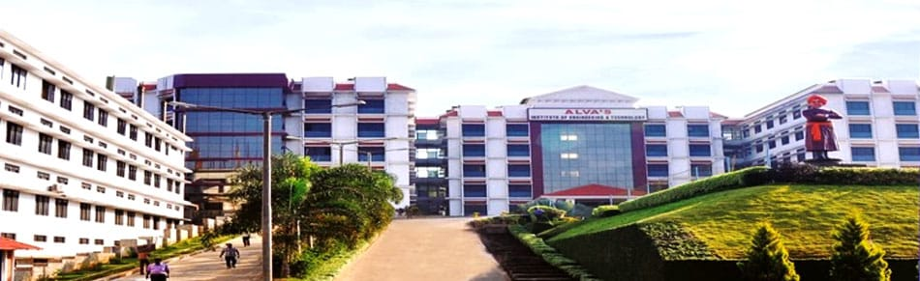

Department of Library and Information Centre

Handbook

CONTENTS
Page no.
- About Library 3
- Library sections 5
  - Circulation Section 5
  - Lending section 6
  - Reference Section 7
  - Reading section 8
  - Journals & Periodicals Section 9
  - Digital library 13
  - Photocopy section 15
  - Group Discursion Section 15
  - Staff reading section 16
2.10 Technical Section 16
- Support and facilities to Students for self-learning activities 16
- Library statistics 17
- Collection development 17
- Library Staffs 18
- Rules and regulations 19

1 .About the Library

PU Alva’s Institute of Engineering and Technology is a young affiliating institution in Karnataka State. Established in 2008, it is an education foundation with a distinctive academic profile, blending in its commitment to rural ethos and a modern spirit. The AIET library has a modern and well-equipped building, which offers excellent infrastructure facilities in reading, borrowing, and reference to the reference to the teachers, students of all the departments.

This Central Library located at the heart of the Institution is easily accessible to the department, classrooms, and hostels. The building occupies a total area of about 1540 sq.mt and has the 1st floor. The building has a seating capacity for more than 280 users at a time. Over 26798 volumes and 5 periodicals are available. The library has fully automated with the RFID system, barcode reader and automated circulation facility with OPAC (Online Public Access Catalogue). The library has kept pace with modernization by introducing the Digital library with E-journals. E-books database, CD-ROMs, Internet, and e-mail facilities to the students and staff community. The library has also been provided with excellent facilities for the self - learning of the students beyond institution hours. Librarian is the head of the department and he is directly responsible to the principal of the college for the performance of his duties and there is an assistant librarian to deal with the day to day activities of the library.

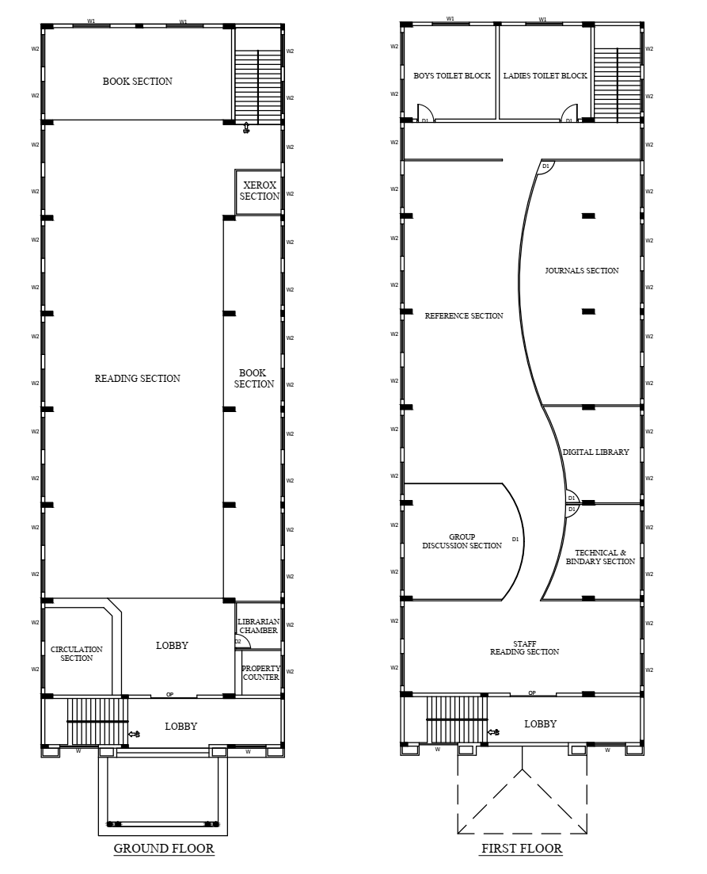
Library layout

2. Library Section
Members of library may easily access library as bellow mentioned sections.
The AIET library mainly organized as following section
  - Circulation Section
  - Lending section
  - Reference Section
  - Reading section
  - Journals & Periodicals Section
  - Digital library
  - Photocopy section
  - Group Discursion Section
  - Staff reading section
  - Technical Section
2.1 Circulation Section
Department of Library and Information Centre is enriched with a huge collection of valuable books. To make the functioning of the library easy and effective, the college library is automated using an Integrated Library Management System called EASYLIB software (EASYLIB 4.3.3 version) 2009 onwards. The software was consists of various modules on acquisition, cataloguing, circulation, serials control, and Online Public Access to Online Public Access Cataloguing (OPAC).
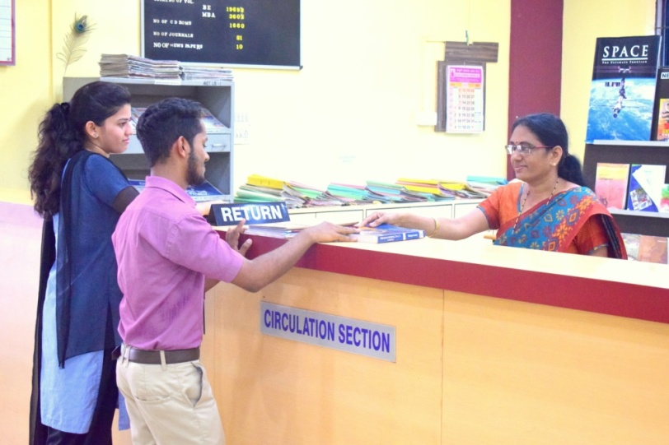
The EASYLIB software was upgraded to WEB 5.0 version software in 2016 and in 2024 upgraded to WEB version 64a. This new version fully automated with RFID technology which enables to issue, renewal of books, maintain the database of books, journals, periodicals and to maintain the data of students and faculty who utilize the library resources. Users can access the library facilities all over the campus. This technology makes the library more accurate and save the time of users.
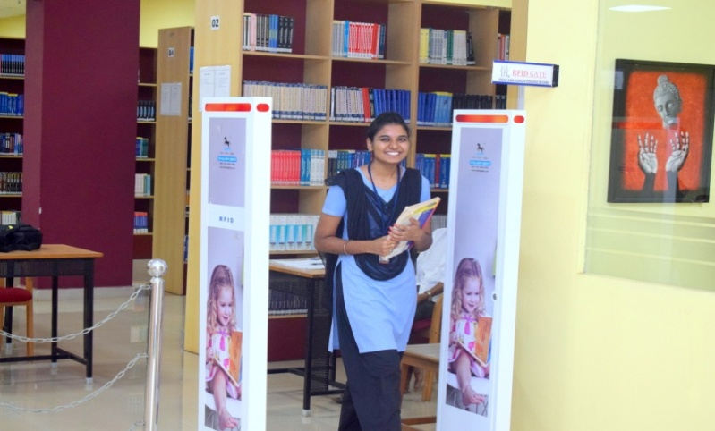
Web OPAC (Online Public Access Catalogue) facility is made available this Software to know the bibliographical details about the collection. Two separate nodes are made available in the Central Library for OPAC facility and further Web OPAC, can be accessed anywhere in the campus, to brows the library collections.
Security of library resources is ensured through a system of checking at the exit point for all resources borrowed by the users. RFID system can help the circulation of books and track the Visitor time of entry and exit. CCTV cameras are installed in the library for strict surveillance.

2.2Lending section
Lending /Textbook section is located at the entrance of the library at the ground floor, the spacious lending section has 94 Sqm. All the lending books are stacked in this section are classified as per the DDC 22 Ed Online Public Access Catalogue code. This method may help users to find the books in racks easily.
The lending section have 180 seating capacity
Timings of lending section: 8.30 AM – 5.30 PM

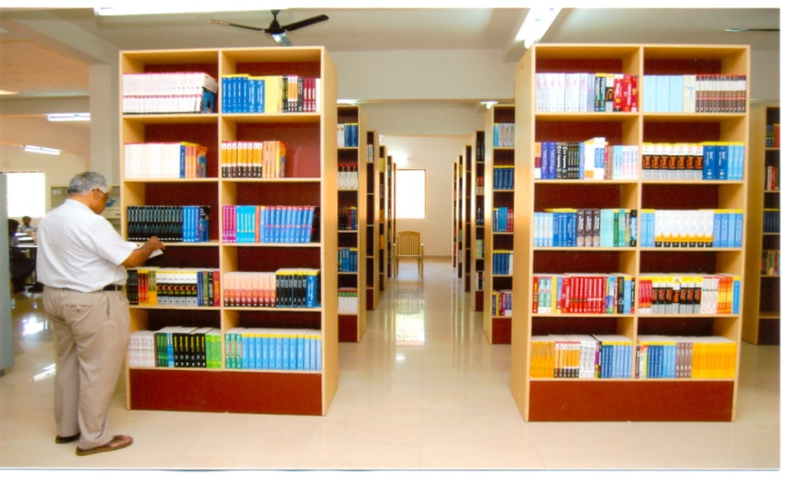
The lending provision for the students and the staffs are as follows:
UG: 02 books at a time for 15 days
PG: 03 books at a time for 15 days
Research scholars: 9 books for 90 days
Staff: 09 Books at a time for one semester

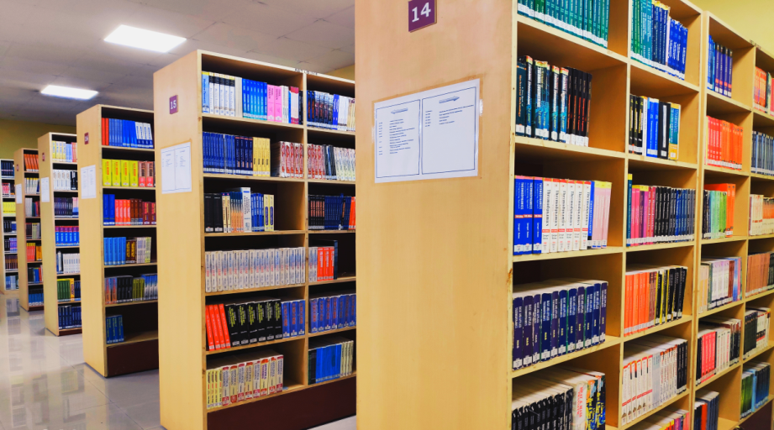

2.3Reference section
The AIET central Library has good reference collections and provides reference service to the members using these reference resources, which have been organized at the first floor of the library. The reference section has very valuable sources like Encyclopedias, Dictionaries, Maps and Atlas, Directories, Thesis, Textbooks, etc. this section resource is only available for reference,

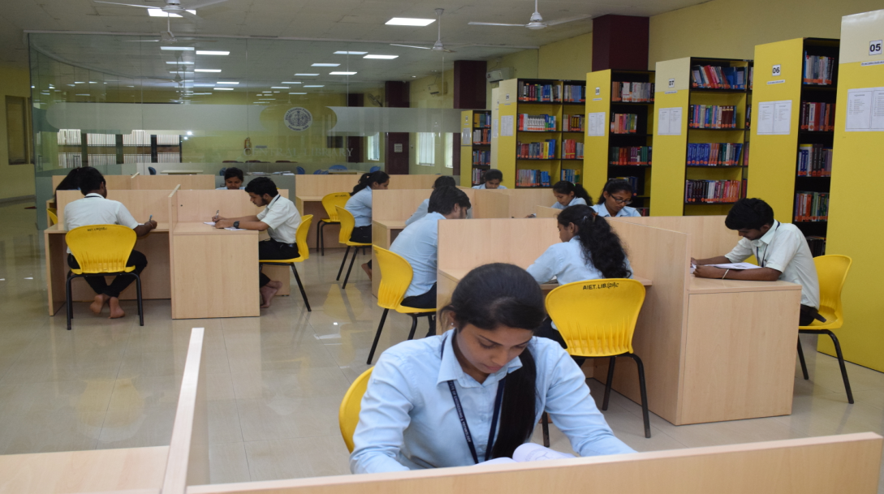

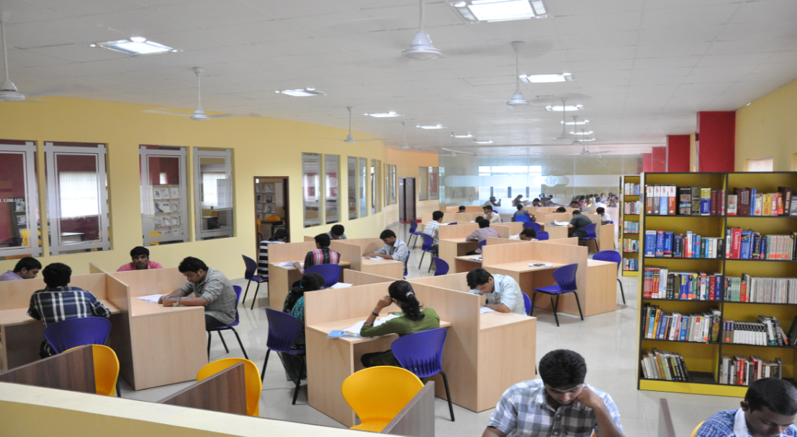
Reference section have 50 seating capacity.
Timings of this section: 8.30 am – 11.00 pm

2.4 Reading section
Reading section has total 180 seating capacity and this section kept open from 8.30 am to 11.00 pm
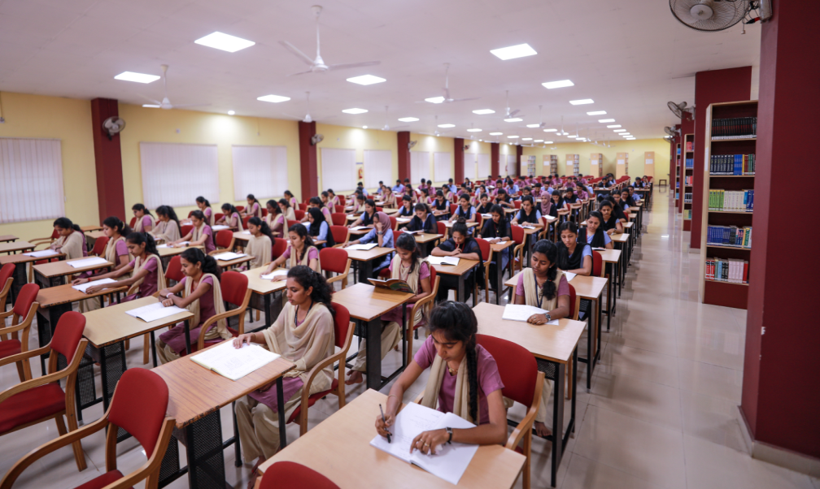
2.5Journals and Periodicals section
Journals and periodical section is located at the first floor of the library, this section have 30 seating capacity, magazines, Journals and journals back volumes are placed in this section. Total 47 journals including reputed national and international journals are available in this section.
Timings of this section
Monday – Saturday 8.30 am – 9.00 pm
Sunday and other holidays 9.00 am – 1.00 pm

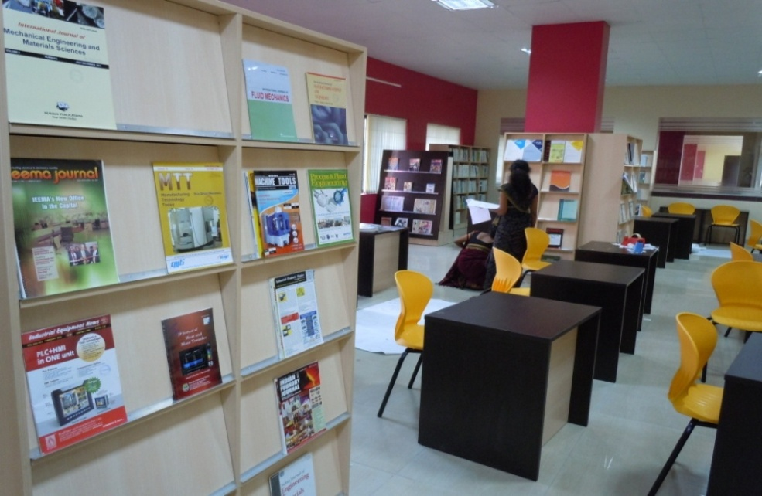

Available of journals 2024

Sl No | Computer Science & Engineering
1 | International Journal of Computational Linguistics Research
2 | Journal of Networking Technology
3 | Journal of Intelligent Computing
4 | Journal of Multimedia Processing and Technology
5 | Journal of Information Technology Review
6 | Journal of Electronic Systems
7 | Journal of E-Technology
8 | Indian Journal of Computer Science
9 | International journal of Engineering and Advanced technology
10 | International journal of Innovative Technology and Exploring Engineering
11 | International journal of Recent Technology and Engineering
Information Science & Engineering
1 | Journal of Data Processing
2 | Journal of Digital Information Management
3 | Journal of Information Security Research
4 | Journal of Information Organization
Electronics &Communication Engineering
1 | IEEMA Journal
2 | Differential Equations and Dynamical Systems
3 | Journal of the Institutions of Engineers
4 | Journal of Electronic Design Technology
Civil Engineering
1 | Journal of Structural Engineering
2 | Journal of Indian Water works Assn
3 | Indian Concrete Journal
4 | AMC Indian Journal of Civil Engineering
5 | The Bridge and Structural Engineering
6 | Construction World
Mechanical Engineering
1 | Advances and applications in Fluid Mechanics
2 | Journal of Mines, Metals and Fuels
3 | Journal of Vibration Engineering & Technology
Basic Science
1 | Resonance- journal of Science Education
2 | Current Science
MBA
1 | IUP Journal of Accounting Research & Audit Practices
2 | Indian Journal of Marketing
3 | Indian Journal of Finance
4 | Prabandhan: Indian Journal of Management
5 | Arthshastra: Indian Journal of Economics and Research
6 | RBI Bulletin
7 | Harvard Business Review
8 | AMC Indian Journal of Entrepreneurship
9 | Finance India
10 | Indian Journal of Research in Capital Markets
AIML
1 | Current Development in Artificial Intelligence
2 | Journal of Artificial Intelligence Research
3 | Journal of Image Processing and Artificial Intelligence
AGR
1 | Research & Reviews: Journal of Agricultural Science& Technology
2 | International Journal of Agriculture and Plant Science
CSD
1 | Journal of Computer Science Engineering and Software Testing
2 | Journal of Web Development and Web Designing

Available Magazines (7)
Sl.No | Periodicals
1 | The Week
2 | Sports Star
3 | Time
4 | Digit
5 | Dataquest
7 | Down to Earth
8 | Employment News

Available News Papers (09)
Sl. No | News Paper
01 | The Hindu
02 | Deccan Herald
03 | Times of India
04 | Business line
05 | Indian Express
06 | Udayavani
07 | Vijayavani
08 | Prajavani
09 | Vijaya Karnataka

2.6 Digital Library
Digital library is located in the first floor of the library, With the 1000 Mbps leased line of broadband institution providing Wi-Fi facility in the campus, In the digital library total 11 systems are available for accessing the e- resources like CD- ROMs, e- journals, NPTEL videos, e-books, Seminar papers, National Digital library (NDL) contents, Thesis, Abstracts, etc. To help Users, the library introduced NPTEL Local Guru Software in 2018, which is helps the students and the faculties to use NPTEL contents by the joint initiatives of the IITs and the IISc. Systems contents 800 courses from 17 disciplines, and GATE mapped NPTEL videos in college LAN.
Through this initiative, users can access courses like Engineering and Humanities streams. This system provides high quality learning materials without bandwidth Constraints. This can helps students to improve their technical skills and employability. 24x7 Students can access all the contents through Intranet
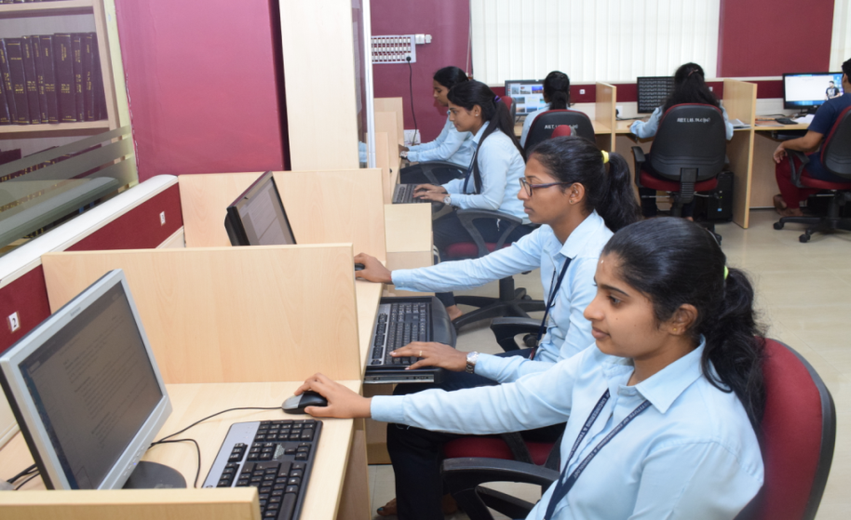

AIET library is member for VTU-Consortium since 2014. The bellow mentioned databases are accessing the library through VTU consortium for the year 2024

Publisher | Branch | E- Resource
IEEE-IEL | CSE,ISE&ECE | e- journals 252  Conf. Proc.30000+  Standards 4000+
Elsevier | ECE, CSE, ISE, CE & ME | e-journals 844  e-books 430
Springer | ECE, CSE, ISE, CE & ME | e-journals 950  e-books 13600
Taylor &Francis | BE &MBA | e-journals 580 +  e-books 5100+
Pro-quest Engg + Management | BE & MBA | Full Text 4900+
Emerald | MBA | e-journals 220+
K-Nimbus | BE &MBA | Open access  20000+
Drillbit | Plagiarism test software

and also digital library provides the digital question paper archives, best answer scripts of the students and all basic facilities like scanner, printer, etc. are available in this section.
2.7 Photocopy Section
Photocopy section is one of the important sections in the library for users; here users may take a copy of their much needed information.
2.8 Group Discursion Section
Group discussion section is situated on the first floor of the library, a total 20 seating capacity have in this section, and this section fully made by toughens glass to observe the user and fully voice proof. Students are discus the academic subject related topics.

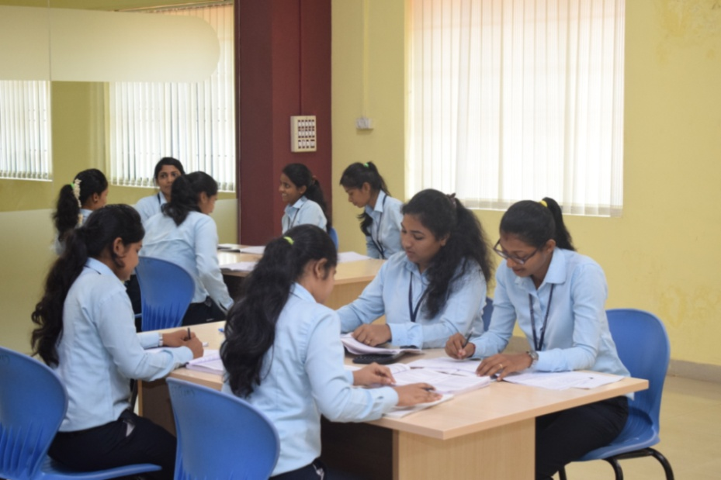

Timings of this section: Monday – Saturday 8.30 am – 11.00 pm

2.9 Staff reading section
In this section total, 12 seats are available for staffs, they may preparing the notes for class, to prepare question papers, research related activities are done in this section
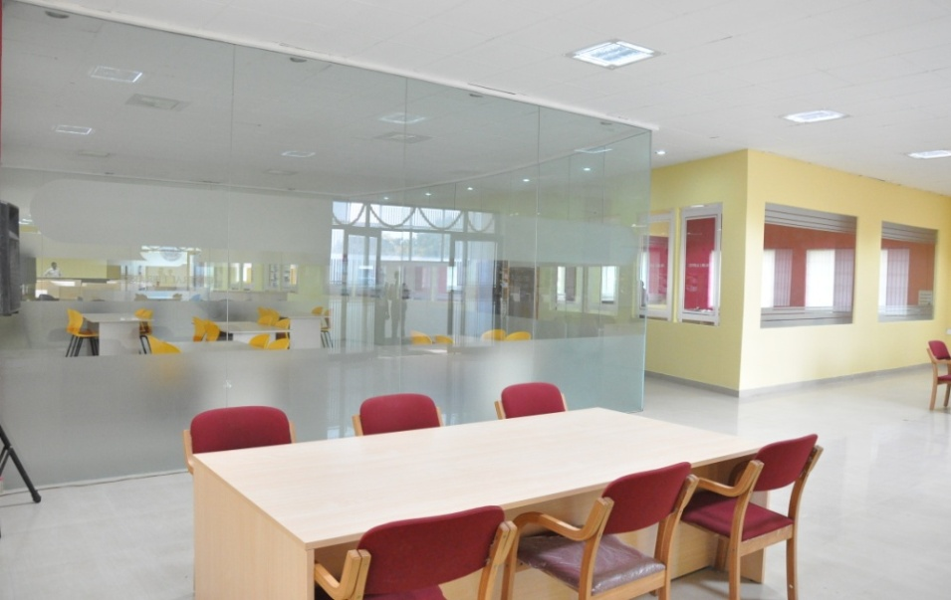

2.10 Technical Section
Acquisition and a technical section is the backbone for the library, the library development planning, and all technical works are done by this section, in this section books have been check for circulation. And major activities like binding, stock verification, maintenance of files shortlist of books, etc. are done by this section.
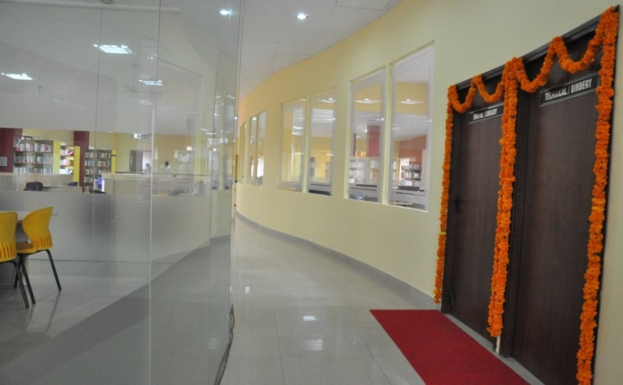
3. Support and facilities to Students for self-learning activities
Library provides a support to students for self-learning facilities like
- NPTEL Membership
- NDL Membership
- VTU E- Consortium
- 24x7 (1000mbps) Wi-Fi facility in campus
- K-Nimbus Remote access
- Library Digital-support through intranet
- Providing best answer scripts
Facilities available at library for Students and Staff members

1 | Lending
2 | reading
- 3 | Reference
- 4 | SC/ST Book Bank
- 5 | Group Discussion
- 6 | Staff Reading
- 7 | Journals/Periodicals
- 8 | OPAC
- 9 | NPTEL resource sharing
10 | Intranet resource sharing
11 | National Digital library (NDL)
12 | Digital Library
13 | Question Bank
14 | NEWS Paper
15 | News paper clipping
- 16 | Rare books
- 17 | Best answer scripts
18 | New arrivals
19 | Scanning
20 | RFID & Bar Code
21 | Reprography
22 | Printing
23 | Drinking Water
24 | Wash Room

4. Library Statistics
With the help of well trained and experienced library staff, AIET central library providing excellent service to the user community, the following statistics are showing the quality of the library.
- Library area 1540 sq.mt including 1st floor
- Seating capacity 280
Working hours: Monday – Saturday 8.30AM – 11.00 PM
Sunday and Holiday 8.30AM – 1.00PM
- Total Number of Books – 26798
- Total Number of Titles – 8720
- Total Number of Reference Books–6706

5. Collection development
Collection development of library from 2020-21 to 2023-24,the major library resources availability details for academic year –2023-2024, 2022-23,2021-2122, and 2020-2021

Types of resource |  | Titles | Volumes | Year of purchase
Books | 2023-2024 | 262 | 944 | July 23-June 24
Books | 2022-2023 | 117 | 591 | July 22-June 23
Books | 2021-2022 | 465 | 1663 | July 21-June 22
Books | 2020-2021 | 13 | 54 | July 20-June 21
E- resources | 2023-2024 | 80,876 + |  | Mar 2023
E- resources | 2022-2023 | 54012 + |  | Feb 2022
E- resources | 2021-2022 | 48847 + |  | Feb 2021
E- resources | 2020-2021 | 42189+ |  | Feb 2020
Print Journals | 2023-2024 | 47 |  | Jan 23 Dec24
Print Journals | 2022-2023 | 48 |  | Jan 22- Dec 23
Print Journals | 2021-2022 | 46 |  | Jan 21-Dec 22
Print Journals | 2020-2021 | 46 |  | Jan 20– Dec 21

Department wise book collection

Titles | No of Titles | No of Copies
Electronics and Communication | 1694 | 4905
Computer Science | 1017 | 3223
Information Science | 707 | 2310
INTERNET OF THINGS | 6 | 20
AIML | 241 | 1160
CSD | 17 | 54
Data Science and Engineering | 14 | 35
Mechanical Engineering | 1324 | 4484
Civil Engineering | 928 | 3344
AE-Agricultural Engineering | 35 | 137
Basic Science | 1017 | 2871
MBA | 1767 | 4255
Total : | 8767 | 26798

6. Library Staff

Sl_No | Name | Designation | Qualification
2 | Mr. Puneeth Kumar | Asst. Librarian | M.L.I.Sc.
3 | Mrs.Sumana Sudha | Lib. Assistant | D.Lib
4 | Mrs.Bhavyashree | SDA | B Com
5 | Mr. Dhananjaya R | Attender | PUC
6 | Mr. Vijay Sapaliga | Attender | SSLC
7 | Mr. Ramdas Pai | Attender | B Com

7. Rules and regulations
Do's:
1. Wear your Identify Card and enter your name at the login register
2. The library is a Temple of Knowledge. Dress properly!
3. Deposit your personal belongings in the racks provided at the entrance; you are permitted to carry only note books/writing paper into the library
4. Before entre the library ensure that you’re not carrying the cell phone
5. Maintain absolute silence and decorum inside the library
6. Use the OPAC system for locate your document
7. If you can't find the document that you are looking for, contact Library staff
8. Maintain silence and wait for your turn at the PC and the Photocopy facility
9. Other than just printed text, the library has CD-ROMs, E- Resources etc. Use them
10. If you need any help, contact the library staff. They are there to help you!
Don'ts:
1. Talking /whispering/laughing/discussions inside the library is strictly prohibited
2. Please do not damage or mutilate the books in any manner
3. Never write anything in a book. Remember, it is not your personal property!
4. Do not misplace books; intentionally or otherwise. A misplaced book is as good as lost!
5. If you notice somebody intentionally misplacing/hiding or damaging a book, inform the library staff immediately.
6. Leave the books on the table after use. Do not put them back in the rack; the library staff will do this job for you
7. Smoking/eating chocolates inside the library is strictly prohibited
8. Stealing books or pages from a book is a serious offence and will attract severe punishment

------THE END-----

