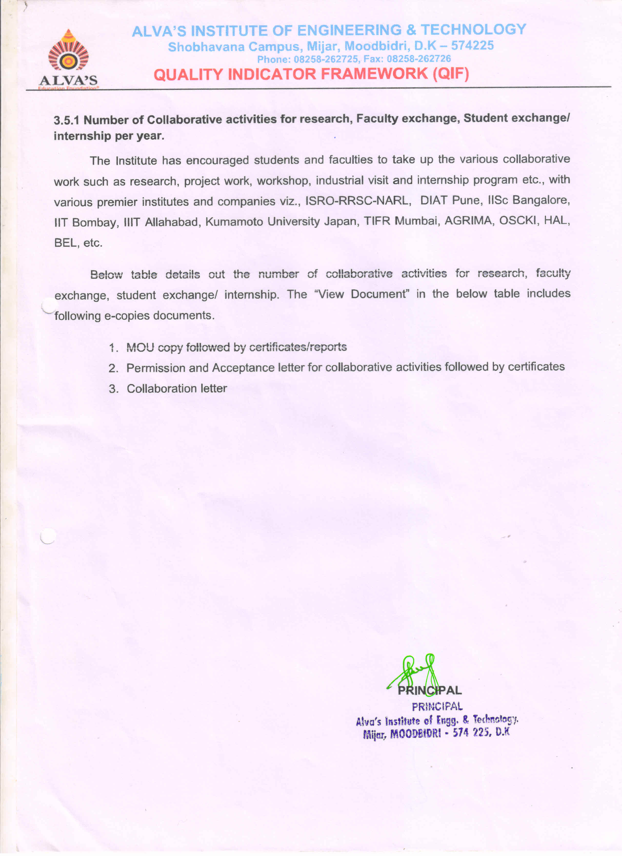

Table: Details of Collaborative Activities

| **Sl. No.** | **Academic Year** | **No. of collaborative activities** | **Document link** |
| --- | --- | --- | --- |
| 1 | 2020-21 | 89 | [View Document](https://cloud.aiet.org.in/storage/NAAC/criteria-3/3.5.1/E-Copies%20YEARWISE%20DOCUMENTS/2020-21.pdf) |
| 2 | 2019-20 | 73 | [View Document](https://cloud.aiet.org.in/storage/NAAC/criteria-3/3.5.1/E-Copies%20YEARWISE%20DOCUMENTS/2019-20.pdf) |
| 3 | 2018-19 | 67 | [View Document](https://cloud.aiet.org.in/storage/NAAC/criteria-3/3.5.1/E-Copies%20YEARWISE%20DOCUMENTS/2018-19.pdf) |
| 4 | 2017-18 | 52 | [View Document](https://cloud.aiet.org.in/storage/NAAC/criteria-3/3.5.1/E-Copies%20YEARWISE%20DOCUMENTS/2017-18.pdf) |
| 5 | 2016-17 | 13 | [View Document](https://cloud.aiet.org.in/storage/NAAC/criteria-3/3.5.1/E-Copies%20YEARWISE%20DOCUMENTS/2016-17.pdf) |