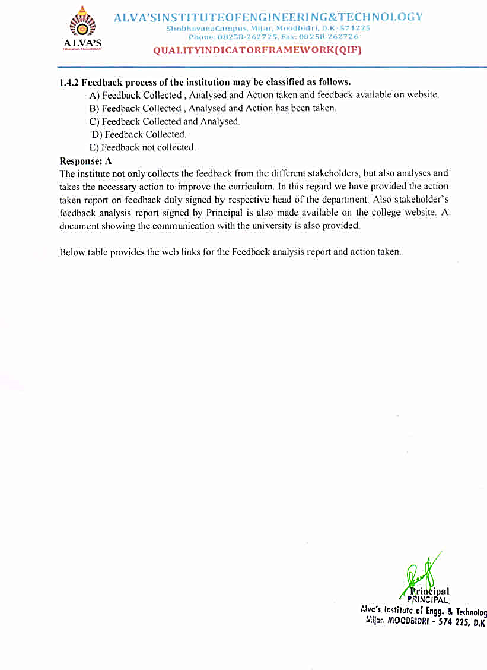

|  |  |  |  |  |  |
| --- | --- | --- | --- | --- | --- |
| Department | Feedback Analysis Report | | | | |
| **2016-17** | **2017-18** | **2018-19** | **2019-20** | **2020-21** |
| CSE | [View Document](https://cloud.aiet.org.in/storage/NAAC/criteria-1/1.4/New%20Feedback%20Analysis%20report%202016-17%20to%202020-21/2016-17/CSE%202016-2017%20updated%20feedback%20analysis%20report.pdf) | [View Document](https://cloud.aiet.org.in/storage/NAAC/criteria-1/1.4/New%20Feedback%20Analysis%20report%202016-17%20to%202020-21/2017-18/CSE%202017-2018%20updated%20feedback%20analysis%20report.pdf) | [View Document](https://cloud.aiet.org.in/storage/NAAC/criteria-1/1.4/New%20Feedback%20Analysis%20report%202016-17%20to%202020-21/2018-19/CSE%202018-2019%20updated%20feedback%20analysis%20report.pdf) | [View Document](https://cloud.aiet.org.in/storage/NAAC/criteria-1/1.4/New%20Feedback%20Analysis%20report%202016-17%20to%202020-21/2019-20/CSE%202019-2020%20updated%20feedback%20analysis%20report.pdf) | [View Document](https://cloud.aiet.org.in/storage/NAAC/criteria-1/1.4/New%20Feedback%20Analysis%20report%202016-17%20to%202020-21/2020-21/College%20Level%202020-21%20Curriculum%20Feedback%20new.pdf) |
| CV | [View Document](https://cloud.aiet.org.in/storage/NAAC/criteria-1/1.4/New%20Feedback%20Analysis%20report%202016-17%20to%202020-21/2016-17/CV%202016-2017%20updated%20feedback%20analysis%20report.pdf) | [View Document](https://cloud.aiet.org.in/storage/NAAC/criteria-1/1.4/New%20Feedback%20Analysis%20report%202016-17%20to%202020-21/2017-18/CV%202017-18%20updated%20feedback%20analysis%20report.pdf.pdf) | [View Document](https://cloud.aiet.org.in/storage/NAAC/criteria-1/1.4/New%20Feedback%20Analysis%20report%202016-17%20to%202020-21/2018-19/CV%202018-19%20updated%20feedback%20analysis%20report.pdf.pdf) | [View Document](https://cloud.aiet.org.in/storage/NAAC/criteria-1/1.4/New%20Feedback%20Analysis%20report%202016-17%20to%202020-21/2019-20/CV%202019-20%20updated%20feedback%20analysis%20report.pdf.pdf) |
| ISE | [View Document](https://cloud.aiet.org.in/storage/NAAC/criteria-1/1.4/New%20Feedback%20Analysis%20report%202016-17%20to%202020-21/2016-17/ISE%202016-17%20curriculum%20feedback%20new.pdf) | [View Document](https://cloud.aiet.org.in/storage/NAAC/criteria-1/1.4/New%20Feedback%20Analysis%20report%202016-17%20to%202020-21/2017-18/ISE%202017-18%20curriculum%20Feedback%20%20new.pdf) | [View Document](https://cloud.aiet.org.in/storage/NAAC/criteria-1/1.4/New%20Feedback%20Analysis%20report%202016-17%20to%202020-21/2018-19/ISE%202018-19%20curriculum%20Feedback%20%20new.pdf) | [View Document](https://cloud.aiet.org.in/storage/NAAC/criteria-1/1.4/New%20Feedback%20Analysis%20report%202016-17%20to%202020-21/2019-20/ISE%202019-20%20curriculum%20Feedback%20.pdf) |
| ME | [View Document](https://cloud.aiet.org.in/storage/NAAC/criteria-1/1.4/New%20Feedback%20Analysis%20report%202016-17%20to%202020-21/2016-17/ME%202016-17-scanned%20copy.pdf) | [View Document](https://cloud.aiet.org.in/storage/NAAC/criteria-1/1.4/New%20Feedback%20Analysis%20report%202016-17%20to%202020-21/2017-18/ME%202017-18%20scanned%20copy.pdf) | [View Document](https://cloud.aiet.org.in/storage/NAAC/criteria-1/1.4/New%20Feedback%20Analysis%20report%202016-17%20to%202020-21/2018-19/ME%20feedback%20analysis%20report%202018-19.pdf) | [View Document](https://cloud.aiet.org.in/storage/NAAC/criteria-1/1.4/New%20Feedback%20Analysis%20report%202016-17%20to%202020-21/2019-20/ME%20feedback%20analysis%20report%202019-20.pdf) |
| ECE | [View Document](https://cloud.aiet.org.in/storage/NAAC/criteria-1/1.4/New%20Feedback%20Analysis%20report%202016-17%20to%202020-21/2016-17/ECE%20FEEDBACK%20ANALYSIS%20REPORT%2016-17.pdf) | [View Document](https://cloud.aiet.org.in/storage/NAAC/criteria-1/1.4/New%20Feedback%20Analysis%20report%202016-17%20to%202020-21/2017-18/ECE%20FEEDBACK%20ANALYSIS%20REPORT%2017-18.pdf) | [View Document](https://cloud.aiet.org.in/storage/NAAC/criteria-1/1.4/New%20Feedback%20Analysis%20report%202016-17%20to%202020-21/2018-19/ECE%20FEEDBACK%20ANALYSIS%20REPORT%2018-19.pdf) | [View Document](https://cloud.aiet.org.in/storage/NAAC/criteria-1/1.4/New%20Feedback%20Analysis%20report%202016-17%20to%202020-21/2019-20/ECE%20FEEDBACK%20ANALYSIS%20REPORT19-20.pdf) | [View Document](https://cloud.aiet.org.in/storage/NAAC/criteria-1/1.4/New%20Feedback%20Analysis%20report%202016-17%20to%202020-21/2020-21/ECE%20Feedback%20Analysis%20on%20Curriculum%202020-21.pdf) |
| MBA | [View Documen](https://cloud.aiet.org.in/storage/NAAC/criteria-1/1.4/Feedback%20Analysis%20Report%202016-2020/MBA/MBA%20Feed%20Back%20Analysis%20Report%202016-17.pdf)t | [View Document](https://cloud.aiet.org.in/storage/NAAC/criteria-1/1.4/Feedback%20Analysis%20Report%202016-2020/MBA/MBA%20Feed%20Back%20Analysis%20Report%202017-18.pdf) | [View Document](https://cloud.aiet.org.in/storage/NAAC/criteria-1/1.4/Feedback%20Analysis%20Report%202016-2020/MBA/MBA%20Feedback%20Analysis%20Report%202018-19.pdf) | [View Document](https://cloud.aiet.org.in/storage/NAAC/criteria-1/1.4/Feedback%20Analysis%20Report%202016-2020/MBA/MBA%20Feedback%20Analysis%20Report%202019-20.pdf) | [View Document](https://cloud.aiet.org.in/storage/NAAC/criteria-1/1.4/New%20Feedback%20Analysis%20report%202016-17%20to%202020-21/2020-21/MBA%20Feedback%20Analysis%20Report%202020-21.pdf) |

|  |  |  |  |  |  |
| --- | --- | --- | --- | --- | --- |
| Department | Feedback Action Report prepared for Next Academic Year | | | | |
| 2016-17 | 2017-18 | 2018-19 | 2019-20 | 2020-21 |
| CSE | [View Document](https://cloud.aiet.org.in/storage/NAAC/criteria-1/1.4/New%20Action%20Taken%20Report%202016-17%20to%202020-21/CSE/updated%20action%20taken%202017-18.pdf) | [View Document](https://cloud.aiet.org.in/storage/NAAC/criteria-1/1.4/New%20Action%20Taken%20Report%202016-17%20to%202020-21/CSE/updated%20action%20taken%202018-19.pdf) | [View Document](https://cloud.aiet.org.in/storage/NAAC/criteria-1/1.4/New%20Action%20Taken%20Report%202016-17%20to%202020-21/CSE/updated%20action%20taken%202019-20.pdf) | [View Document](https://cloud.aiet.org.in/storage/NAAC/criteria-1/1.4/New%20Action%20Taken%20Report%202016-17%20to%202020-21/CSE/updated%20action%20taken%202020-21.pdf) | [View Document](https://cloud.aiet.org.in/storage/NAAC/criteria-1/1.4/New%20Action%20Taken%20Report%202016-17%20to%202020-21/CSE/updated%20action%20report%202021-22.pdf) |
| CV | [View Document](https://cloud.aiet.org.in/storage/NAAC/criteria-1/1.4/New%20Action%20Taken%20Report%202016-17%20to%202020-21/CV/action%20taken%20report-2016-17.pdf) | [View Document](https://cloud.aiet.org.in/storage/NAAC/criteria-1/1.4/New%20Action%20Taken%20Report%202016-17%20to%202020-21/CV/action%20taken%20report-2017-18.pdf) | [View Document](https://cloud.aiet.org.in/storage/NAAC/criteria-1/1.4/New%20Action%20Taken%20Report%202016-17%20to%202020-21/CV/action%20taken%20report-%202019-20.pdf) | [View Document](https://cloud.aiet.org.in/storage/NAAC/criteria-1/1.4/New%20Action%20Taken%20Report%202016-17%20to%202020-21/CV/action%20taken%20report%202020-21.pdf) | [View Document](https://cloud.aiet.org.in/storage/NAAC/criteria-1/1.4/New%20Action%20Taken%20Report%202016-17%20to%202020-21/CV/action%20taken%20report-2021-22.pdf) |
| ECE | [View Document](https://cloud.aiet.org.in/storage/NAAC/criteria-1/1.4/New%20Action%20Taken%20Report%202016-17%20to%202020-21/ECE/Action%20Plan%20ECE_2016-17.pdf) | [View Document](https://cloud.aiet.org.in/storage/NAAC/criteria-1/1.4/New%20Action%20Taken%20Report%202016-17%20to%202020-21/ECE/Action%20Plan%20ECE_2017-18.pdf) | [View Document](https://cloud.aiet.org.in/storage/NAAC/criteria-1/1.4/New%20Action%20Taken%20Report%202016-17%20to%202020-21/ECE/Action%20Plan%20ECE_2018-19.pdf) | [View Document](https://cloud.aiet.org.in/storage/NAAC/criteria-1/1.4/New%20Action%20Taken%20Report%202016-17%20to%202020-21/ECE/Action%20Plan%20ECE_2019-20.pdf) | [View Document](https://cloud.aiet.org.in/storage/NAAC/criteria-1/1.4/New%20Action%20Taken%20Report%202016-17%20to%202020-21/ECE/Action%20Plan%20ECE_2020-21.pdf) |
| ISE | [View Document](https://cloud.aiet.org.in/storage/NAAC/criteria-1/1.4/New%20Action%20Taken%20Report%202016-17%20to%202020-21/ISE/Action%20Taken%20Report%202017-18.pdf) | [View Document](https://cloud.aiet.org.in/storage/NAAC/criteria-1/1.4/New%20Action%20Taken%20Report%202016-17%20to%202020-21/ISE/Action%20Taken%20Report%202018-19.pdf) | [View Document](https://cloud.aiet.org.in/storage/NAAC/criteria-1/1.4/New%20Action%20Taken%20Report%202016-17%20to%202020-21/ISE/Action%20Taken%20Report%202019-20.pdf) | [View Document](https://cloud.aiet.org.in/storage/NAAC/criteria-1/1.4/New%20Action%20Taken%20Report%202016-17%20to%202020-21/ISE/Action%20Taken%20report%202020-21.pdf) | [View Document](https://cloud.aiet.org.in/storage/NAAC/criteria-1/1.4/New%20Action%20Taken%20Report%202016-17%20to%202020-21/ISE/Action%20Taken%20Report%20%202021-22.pdf) |
| ME | [View Document](https://cloud.aiet.org.in/storage/NAAC/criteria-1/1.4/New%20Action%20Taken%20Report%202016-17%20to%202020-21/ME/ME%20action%20report%202016-17%20scanned.pdf.pdf) | [View Document](https://cloud.aiet.org.in/storage/NAAC/criteria-1/1.4/New%20Action%20Taken%20Report%202016-17%20to%202020-21/ME/ME%20action%20report%202017-18%20scanned.pdf.pdf) | [View Document](https://cloud.aiet.org.in/storage/NAAC/criteria-1/1.4/New%20Action%20Taken%20Report%202016-17%20to%202020-21/ME/ME%20action%20report%202018-19%20with%20BOS.pdf.pdf) | [View Document](https://cloud.aiet.org.in/storage/NAAC/criteria-1/1.4/New%20Action%20Taken%20Report%202016-17%20to%202020-21/ME/ME%20action%20report%202019-20.pdf.pdf) | [View Document](https://cloud.aiet.org.in/storage/NAAC/criteria-1/1.4/New%20Action%20Taken%20Report%202016-17%20to%202020-21/ME/ME%202020-21%20action%20taken%20report%20.pdf.pdf) |
| MBA | [View Document](https://cloud.aiet.org.in/storage/NAAC/criteria-1/1.4/New%20Action%20Taken%20Report%202016-17%20to%202020-21/MBA/MBA%20Action%20Taken%20Report%202016-17.pdf) | [View Document](https://cloud.aiet.org.in/storage/NAAC/criteria-1/1.4/New%20Action%20Taken%20Report%202016-17%20to%202020-21/MBA/MBA%20Action%20Taken%20Report%202017-18.pdf) | [View Document](https://cloud.aiet.org.in/storage/NAAC/criteria-1/1.4/New%20Action%20Taken%20Report%202016-17%20to%202020-21/MBA/MBA%20Action%20Taken%20Report%202018-19.pdf) | [View Document](https://cloud.aiet.org.in/storage/NAAC/criteria-1/1.4/New%20Action%20Taken%20Report%202016-17%20to%202020-21/MBA/MBA%20Action%20Taken%20Report%202019-20.pdf) | [View Document](https://cloud.aiet.org.in/storage/NAAC/criteria-1/1.4/New%20Action%20Taken%20Report%202016-17%20to%202020-21/MBA/MBA%20Action%20Taken%20Report%202020-21.pdf) |

**The Internal Quality Assurance Cell (IQAC)**committee was established in the academic year 2015-16 to promote quality enhancement of all aspects of College functioning. Over the years it has evolved mechanisms and procedures to ensure efficient, effective and progressive performance of academic and administrative tasks and to maintain relevance and quality of the academic programs.

|  |  |
| --- | --- |
| The Internal Quality Assurance Cell (IQAC) Strategic Perspective Plan (SPP)– website Link | [VIEW DOCUMENTS](https://www.aiet.org.in/iqac/) |

The Visvesvaraya Technological University (VTU), to which the Alvas Institute of Engineering and Technology is affiliated, has revised the UG programme curriculum for the academic years 2015-16, 2017-18, 2018-19, and 2021-22 (Tentative Scheme) and once in two years for PG programme curriculum (MBA)

**The table below shows the action taken by the Affiliated University on Feedback**

|  |  |  |  |  |  |
| --- | --- | --- | --- | --- | --- |
| Department | Year | | | | |
| **2016-17** | **2017-18** | **2018-19** | **2019-2020** | **2020-21** |
| CSE |  | [View Document](https://cloud.aiet.org.in/storage/NAAC/criteria-1/1.4/New%20Action%20Taken%20Report%202016-17%20to%202020-21/CSE/BOS%20implementation%202017-2018.pdf) | [View Document](https://cloud.aiet.org.in/storage/NAAC/criteria-1/1.4/New%20Action%20Taken%20Report%202016-17%20to%202020-21/CSE/BOS%20implementation%202019-2020.pdf) |  |  |
| CV |  |  | [View Document](https://cloud.aiet.org.in/storage/NAAC/criteria-1/1.4/New%20Action%20Taken%20Report%202016-17%20to%202020-21/CV/Bos%20letter%202019-20%20with%202021-22%20scheme.pdf) |  |  |
| ECE | - | [View Document](https://cloud.aiet.org.in/storage/NAAC/criteria-1/1.4/New%20Action%20Taken%20Report%202016-17%20to%202020-21/ECE/BOS%20implementation%202017-2018%20highlighted.pdf) | - | - | - |
| ISE | [View Document](https://cloud.aiet.org.in/storage/NAAC/criteria-1/1.4/New%20Action%20Taken%20Report%202016-17%20to%202020-21/ISE/2016-17%20BoS%20Letter%20with%20outcome.pdf) |  | [View Document](https://cloud.aiet.org.in/storage/NAAC/criteria-1/1.4/New%20Action%20Taken%20Report%202016-17%20to%202020-21/ISE/2018-19%20BoS%20Letter%20with%20outcome.pdf) |  |  |
| MBA | - | - | - | [View Document](https://cloud.aiet.org.in/storage/NAAC/criteria-1/1.4/New%20Action%20Taken%20Report%202016-17%20to%202020-21/MBA/MBA%20BOS%20Letter%20with%20VTU%20outcome%202019-20.pdf) | - |
| ME | - | - | [View Document](https://cloud.aiet.org.in/storage/NAAC/criteria-1/1.4/New%20Action%20Taken%20Report%202016-17%20to%202020-21/ME/2018-19%20BOS%20letter%20with%202021-22%20scheme.pdf) | - | - |

**For further references:** [**https://vtu.ac.in/en/b-e-scheme-syllabus/#menu05**](https://vtu.ac.in/en/b-e-scheme-syllabus/#menu05)