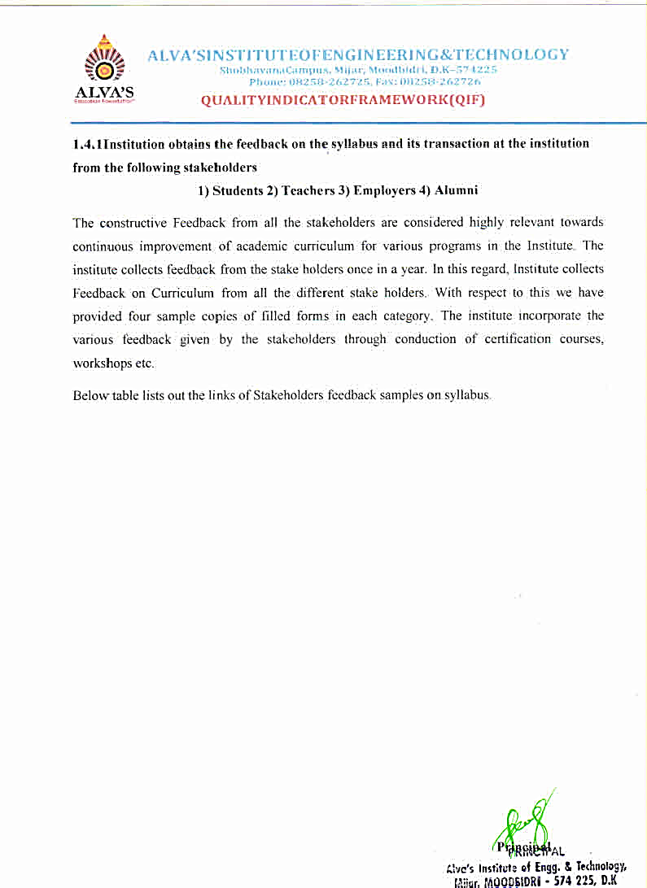

The Internal Quality Assurance Cell (IQAC) committee was established in the academic year 2015-16 to promote quality enhancement of all aspects of College functioning. Over the years it has evolved mechanisms and procedures to ensure efficient, effective and progressive performance of academic and administrative tasks and to maintain relevance and quality of the academic programs.The IQAC meets periodically to review the progress and its quality enhancement based on the criteria suggested by the National Assessment and Accreditation Council (NAAC) and suggests actions for further strengthening and sustaining the quality. The quality of the academic programmes are ensured through constant monitoring.

|  |  |
| --- | --- |
| The Internal Quality Assurance Cell (IQAC) Strategic Perspective Plan (SPP)– website Link | [VIEW DOCUMENTS](https://www.aiet.org.in/iqac/) |

|  |  |  |  |  |
| --- | --- | --- | --- | --- |
|  | Stakeholders feedback samples | | | |
|  | **Students** | **Faculty** | **Alumni** | **Employers** |
| 2016-17 | [View document](https://cloud.aiet.org.in/storage/NAAC/criteria-1/1.4/New%20Feedback%20Samples%202016-17%20to%202020-21/2016-17/Student/student.pdf) | [View document](https://cloud.aiet.org.in/storage/NAAC/criteria-1/1.4/New%20Feedback%20Samples%202016-17%20to%202020-21/2016-17/Faculty/faculty.pdf) | [View document](https://cloud.aiet.org.in/storage/NAAC/criteria-1/1.4/New%20Feedback%20Samples%202016-17%20to%202020-21/2016-17/Alumni/alumni.pdf) | [View document](https://cloud.aiet.org.in/storage/NAAC/criteria-1/1.4/New%20Feedback%20Samples%202016-17%20to%202020-21/2016-17/Employer/employer.pdf) |
| 2017-18 | [View document](https://cloud.aiet.org.in/storage/NAAC/criteria-1/1.4/New%20Feedback%20Samples%202016-17%20to%202020-21/2017-18/Student/student.pdf) | [View document](https://cloud.aiet.org.in/storage/NAAC/criteria-1/1.4/New%20Feedback%20Samples%202016-17%20to%202020-21/2017-18/Faculty/faculty.pdf) | [View document](https://cloud.aiet.org.in/storage/NAAC/criteria-1/1.4/New%20Feedback%20Samples%202016-17%20to%202020-21/2017-18/Alumni/alumni.pdf) | [View document](https://cloud.aiet.org.in/storage/NAAC/criteria-1/1.4/New%20Feedback%20Samples%202016-17%20to%202020-21/2017-18/Employer/employer.pdf) |
| 2018-19 | [View document](https://cloud.aiet.org.in/storage/NAAC/criteria-1/1.4/New%20Feedback%20Samples%202016-17%20to%202020-21/2018-19/Student/student.pdf) | [View document](https://cloud.aiet.org.in/storage/NAAC/criteria-1/1.4/New%20Feedback%20Samples%202016-17%20to%202020-21/2018-19/Faculty/faculty.pdf) | [View document](https://cloud.aiet.org.in/storage/NAAC/criteria-1/1.4/New%20Feedback%20Samples%202016-17%20to%202020-21/2018-19/Alumni/alumni.pdf) | [View document](https://cloud.aiet.org.in/storage/NAAC/criteria-1/1.4/New%20Feedback%20Samples%202016-17%20to%202020-21/2018-19/Employer/employer.pdf) |
| 2019-20 | [View document](https://cloud.aiet.org.in/storage/NAAC/criteria-1/1.4/New%20Feedback%20Samples%202016-17%20to%202020-21/2019-20/Student/student.pdf) | [View document](https://cloud.aiet.org.in/storage/NAAC/criteria-1/1.4/New%20Feedback%20Samples%202016-17%20to%202020-21/2019-20/Faculty/faculty.pdf) | [View document](https://cloud.aiet.org.in/storage/NAAC/criteria-1/1.4/New%20Feedback%20Samples%202016-17%20to%202020-21/2019-20/Alumni/alumni.pdf) | [View document](https://cloud.aiet.org.in/storage/NAAC/criteria-1/1.4/New%20Feedback%20Samples%202016-17%20to%202020-21/2019-20/Employer/employer.pdf) |
| 2020-21 | [View document](https://cloud.aiet.org.in/storage/NAAC/criteria-1/1.4/New%20Feedback%20Samples%202016-17%20to%202020-21/2020-21/Student/Student%20Feedback%20Form%20on%202020-21%20Curriculum%20(Responses).xlsx.xlsx) | [View document](https://cloud.aiet.org.in/storage/NAAC/criteria-1/1.4/New%20Feedback%20Samples%202016-17%20to%202020-21/2020-21/Faculty/Faculty%20Feedback%20on%20Curriculum%20Form%20on%202020-21%20curicullum%20%20(Responses).xlsx) | [View document](https://cloud.aiet.org.in/storage/NAAC/criteria-1/1.4/New%20Feedback%20Samples%202016-17%20to%202020-21/2020-21/Alumni/ALUMINA%20FEEDBACK%20FORM%20for%20Batch%202020-21%20Curriculum%20%20(Responses).xlsx) | [View document](https://cloud.aiet.org.in/storage/NAAC/criteria-1/1.4/New%20Feedback%20Samples%202016-17%20to%202020-21/2020-21/Employer/employer.pdf) |