**Resource Person Mr. Pramod V B, Mr Kiran C H and Mr. Praveen K C**

**AIET, Moodbidri**

### Convener:

### Dr. Satyanarayan

### Associate Prof. Department of ME

**Coordinators:**

1. **Prof. B G Keshavanth**
2. **Prof. Sudheer P N**

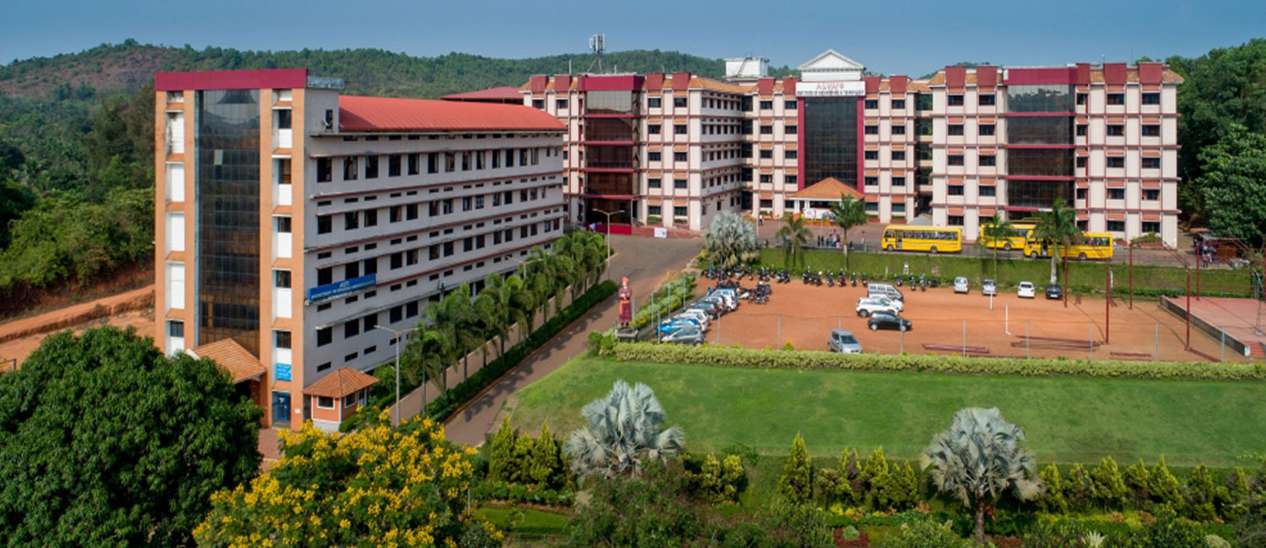 **ABOUT THE INSTITUTION**

Alva's Education Foundation (AEF) established in 1995 with the vision of our Chairman Dr. M. Mohan Alva has succeeded in making Moodbidri, an Educational hub in the South Canara Region, with more than 25000 students pursuing various courses ranging from primary school to post-graduate courses in social sciences, pure sciences, engineering and management. There are 21 institutions functioning under the Alva's Education Foundation.

Alva's Institute of Engineering and Technology, Moodbidri is a Premier Engineering Institute of Alva's Education Foundation, established in the year 2008. The college is certified to the ISO 9001: 2008 standards. The institute offers top quality education in five under graduate programs in Engineering- Computer Science, Civil, Electronics & Communications, Information Science, and Mechanical Engineering- Three Post Graduate programs- Master of Technology in Thermal Power Engineering, Computer Science & Engineering, VLSI Design Embedded System and Master of Business Administration.

**Alva’s Institute of Engineering and Technology, Moodbidri**



# 5 days Certification course/Workshop on

**"ANSYS”**

## From 7th Oct to 11th Oct 2019

***Organized by***

**Department of Mechanical Engineering**

**Venue: CNC lab, Mech Building, AIET, Mijar**

**ABOUT ME DEPARTMENT**

1. Empower student knowledge in basic and applied areas of Mechanical Engineering

2. Strengthening collaboration with industries, research organizations and institutes for internship, joint research and consultancy

3. To inculcate entrepreneurial skills and human values in order to cater the needs of society

4. Exposure to industrial practices for managerial skills and professionalism

The Department was started in the year 2008 Department of Mechanical Engineering was established in the year 2008 with an intake of 60 and has enhanced to 180 from academic year 201213. The Post Graduate course, M.Tech in Thermal Power Engineering was introduced from the academic year 2012-13 with an intake of 18 students. Department is recognized as a research centre by VTU. Department is actively involved in Curricular and extracurricular activities in associations with professional bodies. The main objective of the department is to provide academic excellence, knowledge and nurture talent in the area of Mechanical Engineering. The department has started Bio Diesel research testing centre in the campus to explore in the area of Alternative Fuels.

Department vision is to develop Quality Mechanical Engineers to meet the ever growing and ever changing needs of the economy. The Department is committed to provide high quality technical education at under graduate and post graduate level by means of state of art curriculum with best teaching-learning process.

**COURSE CONTENT**

## Introduction to FEA/FEM & ANSYS

## Creating geometry, key points, lines, areas and volumes

## Meshing

## Analysis of beams and plates

## Dynamic analysis

## PROGRAM SCHEDULE

|  |  |
| --- | --- |
| 7**-October - 2019**  Inauguration: 09:30 am to 10:00 am  Keynote Address: 10:00 am to 11:00 am  Tea Break: 11:00 am to 11:15 am  Session 1: 11:15 am to 01:00 pm  Lunch Break: 01:00 pm to 02:00 pm  Session 2: 02:00 pm to 05:00 pm | 11**-October- 2019**  Session 12: 09.00 am to 11:00 am  Tea Break: 11.00 am to 11.20 am  Session 13: 11.20 am to 01.00 pm  Lunch Break: 01:00 pm to 02:00 pm  Session 14: 02:00 pm to 05:00 pm |
| 8**- October - 2019**  Session 3: 09.00 am to 11:00 am  Tea Break: 11.00 am to 11.20 am  Session 4: 11.20 am to 01.00 pm  Lunch Break: 01:00 pm to 02:00 pm  Session 5: 02:00 pm to 05:00 pm | VISION OF THE DEPARTMENT  Impart Quality Technical Education to excel in Mechanical Engineering to meet the needs of the community  MISSION OF THE DEPARTMENT |
| 9**- October - 2019**  Session 6: 09.00 am to 11:00 am  Tea Break: 11.00 am to 11.20 am  Session 7: 11.20 am to 01.00 pm  Lunch Break: 01:00 pm to 02:00 pm  Session 8: 02:00 pm to 05:00 pm |  |
| 10**- October - 2019**  Session 9: 09.00 am to 11:00 am  Tea Break: 11.00 am to 11.20 am  Session 10: 11.20 am to 01.00 pm  Lunch Break: 01:00 pm to 02:00 pm  Session 11: 02:00 pm to 05:00 pm |  |
|  |  |
|  |  |
|  |  |
|  |  |