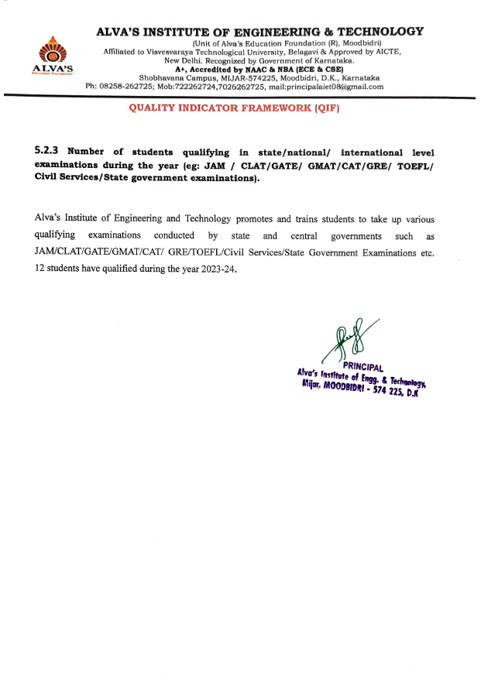

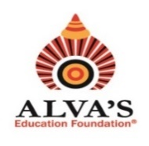 **ALVA’S INSTITUTE OF ENGINEERING & TECHNOLOGY**

(Unit of Alva’s Education Foundation (R), Moodbidri)

Affiliated to Visvesvaraya Technological University, Belagavi & Approved by AICTE,

New Delhi. Recognized by Government of Karnataka.

**A+, Accredited by NAAC & NBA (ECE & CSE)**

Shobhavana Campus, MIJAR-574225, Moodbidri, D.K., Karnataka

Ph: 08258-262725; Mob:722262724,7026262725, mail:principalaiet08@gmail.com

**QUALITY INDICATOR FRAMEWORK (QIF)**

**5.2.3 Average percentage of students qualifying in state/national/ international level examinations (eg: JAM /NET /SLET /GATE /GMAT /CAT /GRE /TOEFL/ Civil Services /State government examinations, etc) year wise during last five years.**

Below table furnishes details on students qualifying in state/national/international level examinations in the year 2023-24

|  |  |  |  |  |  |
| --- | --- | --- | --- | --- | --- |
| Sl. No . | Academic Year | Total no. of student appeared | Total no. of student qualified | Percentage of student qualified | Document link |
| 1 | 2023-24 | 18 | 12 | 66.67% | View Document |