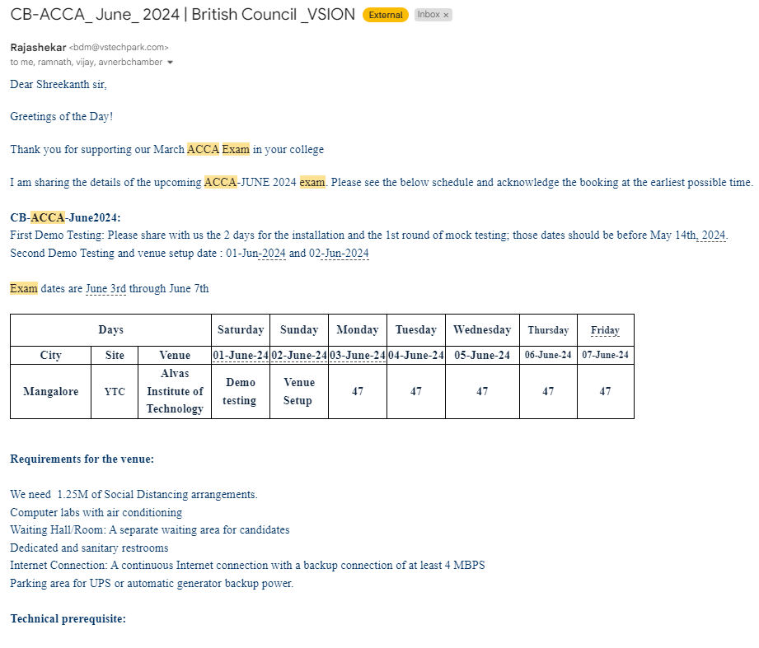

**Level-1 :** Vendors contact us, seeking IT infrastructure for hosting online tests.

**Level-2 :** The system administrator responds by sending a confirmation email to the vendors, along with details of the associated commercial fees for providing IT resources, including personnel support.

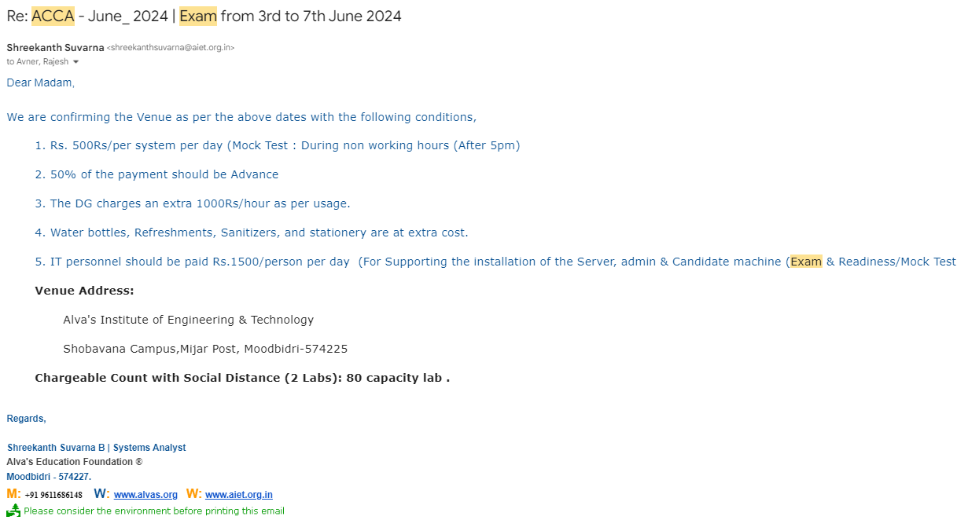

**Level-3 :** Upon successful test completion, the system administrator collaborates with the accounts executive to generate and process the invoice.and shares the invoice with the vendor for payment

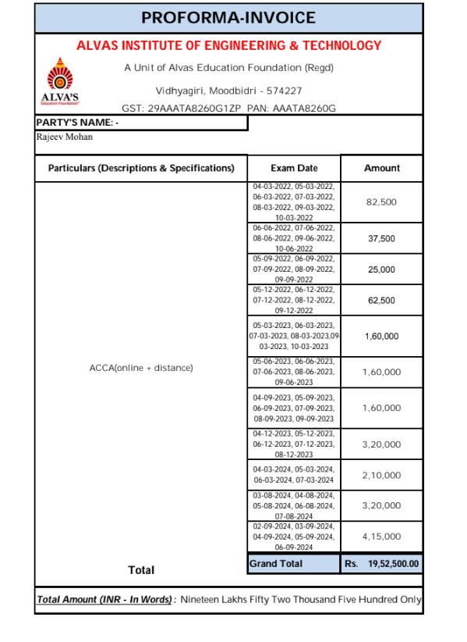

**Level-4 :** The vendor proceeds to make the payment and shares the payment particulars with the institution.

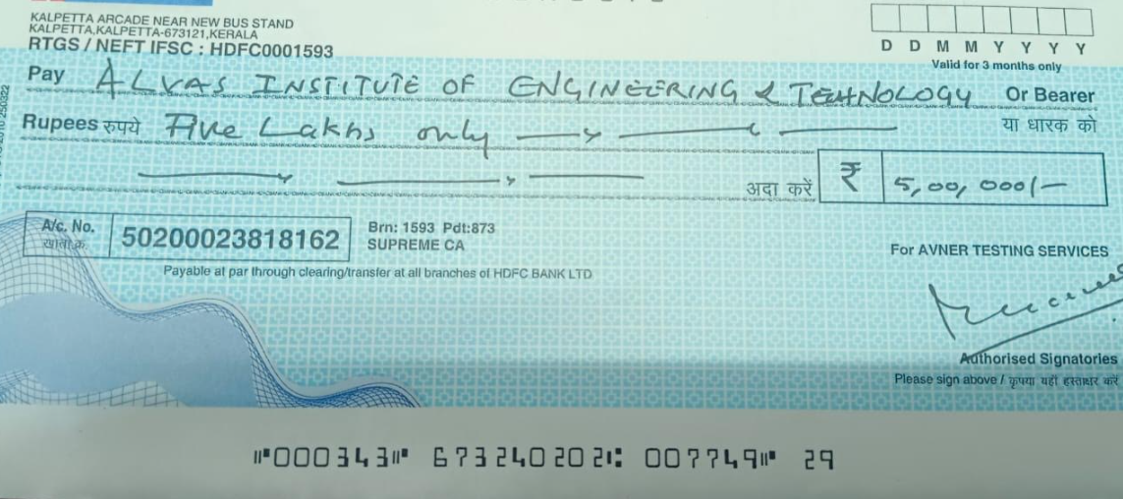

System Admin Principal