**ALVA’S INSTITUTE OF ENGINEERING AND TECHNOLOGY**

(Affiliated to VTU, Belagavi. Approved by AICTE & Recognized by Government of Karnataka)

Shobhavana Campus, Mijar - 574225, Moodabidire, Dakshina Kannada, Karnataka, India



**Department of Electronics and communication Engineering**

**Report on**

**Feedback Analysis Report on Curriculum**

**[2023-24]**

**Content**

|  |  |  |
| --- | --- | --- |
| **Sl no.** | **Content** | **Page no.** |
| 1 | Student Feedback Form |  |
|  | 1.1 Student’s Feedback form on curriculum | 4 |
|  | 1.2 Feedback Analysis Report | 5 |
| 2 | Faculty Feedback Form |  |
|  | 2.1 Faculty Feedback form on Curriculum | 7 |
|  | 2.2 Feedback Analysis Report | 8 |
| 3 | Alumni Feedback Form |  |
|  | 3.1 Alumni Feedback Form on Curriculum | 10 |
|  | 3.2 Feedback Analysis Report | 11 |
| 4 | Employer Feedback Form |  |
|  | 4.1 Employer Feedback form on Curriculum | 13 |
|  | 4.2 Feedback Analysis Report | 14 |
| 9 | Action Taken Report |  |

Quality vs. quantity has long been a debate topic. Students, as crucial stakeholders, are concerned about the predicted consequences. As the technical education scenario shifts from an output-based to an outcome-based one, quality in such procedures must be addressed. We must guarantee that the result parameters are mapped in relation to the objectives and that the programmes are aligned with national policies in light of the global trend. Stakeholder satisfaction, including students, professors, alumni, and employers, has always been a struggle. Because quality is a metric for success, there is always room for improvement in every system.

**A**lvas Institute of Engineering and Technology, Mijar, being unique from its very inception and foundation, has emerged as a benchmark of excellence and innovation for the world of education. With quality sustenance as its focus, the IQAC of the college has developed the feedback mechanism commencing with obtaining feedback from the various stakeholders through a structured rating based feedback form. The college draws feedback from students, teachers, alumnae and employers from respective department for continuous improvement in curriculum development and enrichment.

Feedback is gathered from all stakeholders in our Institute through an offline approach. Following the collection of data from stakeholders, the response sheet is prepared and analysed using preset parameters. Departments take necessary action based on the report. The department sends a copy of the report, together with the action performed, to the Internal Quality Assurance Cell (IQAC) for any additional action that is necessary.

**Figure 1: Feedback Analysis Process**

The primary goal of this feedback is to guarantee that every student has access to competent and high-quality instruction, which leads to vigorous academic, social, and personal development. The IQAC analyses the activities as well as other quality efforts on a regular basis. We must consistently adopt such Quality Initiatives into our processes and adhere to them in letter and spirit in order to satisfy stakeholders.

**1.0 Student Feedback Form**

The IQAC creates a feedback form, which is distributed to all departments for response collection.

**1.1 Student’s Feedback form on curriculum**

For the session 2023 -24, the analysis of stakeholder’s feedback is presented as under:

|  |  |  |  |  |  |  |  |  |  |
| --- | --- | --- | --- | --- | --- | --- | --- | --- | --- |
| **STUDENTS FEEDBACK FORM** | | | | | | | | | |
| **Name of the Student** | | **USN** | **Branch** | | | **Academic Year** | | | |
|  | |  |  | | |  | | | |
| Inorder to improve the effectiveness of the designed syllabus and to meet the needs of the contemporary advancements in the field of engineering, you are requested to share your valuable feedback and responses | | | | | | | | | |
| **Sl. No** | **Feedback Question** | | | **Strongly Agree** | **Agree** | | **Neutral** | **Disagree** | **Strongly Disagree** |
|  | Contents in syllabus are relevant to the course. | | |  |  | |  |  |  |
|  | Syllabus is updated based on the need and is career oriented. | | |  |  | |  |  |  |
|  | Aims and objectives of the syllabus are well defined and clear. | | |  |  | |  |  |  |
|  | Course content is followed by corresponding reference materials. | | |  |  | |  |  |  |
|  | Sufficient number of prescribed books is available in the Library. | | |  |  | |  |  |  |
|  | The syllabus has good balance between theory and application. | | |  |  | |  |  |  |
|  | The course increased knowledge and prespective in the subject area. | | |  |  | |  |  |  |
|  | The curriculum ensures student participation in learning process. | | |  |  | |  |  |  |
|  | The curriculum creates social awareness among the students. | | |  |  | |  |  |  |
|  | The curriculum is sufficient to cover the program /course outcomes. | | |  |  | |  |  |  |
|  | Comments/Suggestion: | | | | | | | | |
|  | | | | | | | | |

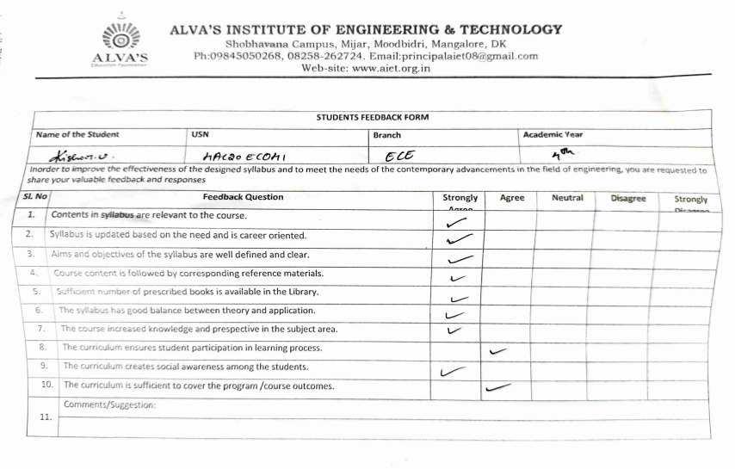

**1.2 Feedback Analysis report**

An attempt was made to solicit opinions from all college students. A feedback form had been produced for this purpose, and comments from the students had been solicited. A total of 312 responses have been gathered from students on the Syllabus of overall strength. To achieve complete findings, important statistical methods such as percentages, etc., were employed. Various sorts of graphs have been utilised to effectively portray the facts.

93.3% students found curriculum to be very effective in enhancing team work, developing analytical skills and constructive learning and 6.7 % students are expecting improvement in curriculum and resolving it timely.

|  |  |  |  |  |  |  |  |  |  |
| --- | --- | --- | --- | --- | --- | --- | --- | --- | --- |
| **STUDENT FEEDBACK 2023-24** | | | | | | | | | |
|  | **99% of total student have provided feedback** | | | | | | | **Positive** | **Negative** |
| **Sl. No** | **Feedback Question** | **Strongly Agree** | **Agree** | **Neutral** | **Disagree** | **Strongly Disagree** | **Total Response** | **A+B+C/ total** | **D+E/ total** |
|  |  | **A** | **B** | **C** | **D** | **E** |
| D1 | Contents in syllabus are relevant to the course. | 250 | 28 | 25 | 5 | 4 | 312 | 97.1% | 2.9% |
| D2 | Syllabus is updated based on the need and is career oriented. | 149 | 80 | 62 | 9 | 12 | 312 | 93.3% | 6.7% |
| D3 | Aims and objectives of the syllabus are well defined and clear. | 153 | 78 | 67 | 9 | 5 | 312 | 95.5% | 4.5% |
| D4 | Course content is followed by corresponding reference materials. | 144 | 73 | 67 | 14 | 14 | 312 | 91.0% | 9.0% |
| D5 | Sufficient number of prescribed books is available in the Library. | 146 | 76 | 60 | 15 | 15 | 312 | 90.4% | 9.6% |
| D6 | The syllabus has good balance between theory and application. | 159 | 75 | 55 | 10 | 13 | 312 | 92.6% | 7.4% |
| D7 | The course increased knowledge and perspective in the subject area. | 149 | 80 | 60 | 11 | 12 | 312 | 92.6% | 7.4% |
| D8 | The curriculum ensures student participation in learning process. | 152 | 80 | 61 | 8 | 12 | 312 | 93.9% | 6.4% |
| D9 | The curriculum creates social awareness among the students. | 147 | 80 | 60 | 11 | 14 | 312 | 92.0% | 8.0% |
| D10 | The curriculum is sufficient to cover the program /course outcomes. | 153 | 77 | 60 | 9 | 13 | 312 | 92.9% | 7.1% |
|  |  | **Average percentage** | | | | | | **93.3%** | **6.7%** |

**2. Faculty Feedback form**

The IQAC creates a feedback form, which is distributed to all departments for response collection**.**

**2.1 Faculty Feedback form on curriculum**

|  |  |  |  |  |  |  |  |
| --- | --- | --- | --- | --- | --- | --- | --- |
| **FACULTY FEEDBACK FORM** | | | | | | | |
| Name of the Faculty | **Branch** | **Designation** | | **Academic Year** | | | |
|  |  |  | |  | | | |
| Inorder to improve the effectiveness of the designed syllabus and to meet the needs of the contemporary advancements in the field of engineering, you are requested to share your valuable feedback and responses | | | | | | | |
| **Sl. No** | **Feedback Question** | **Strongly Agree** | **Agree** | | **Neutral** | **Disagree** | **Strongly Disagree** |
|  | Syllabus is relevant to the course and is career oriented. |  |  | |  |  |  |
|  | Syllabus is updated regularly as per the industry needs. |  |  | |  |  |  |
|  | Course objectives and outcomes are clearly defined. |  |  | |  |  |  |
|  | Course content is followed by sufficient reference materials. |  |  | |  |  |  |
|  | The course has a good balance between theory and applications. |  |  | |  |  |  |
|  | Teacher has the freedom to adopt new techniques/strategies in teaching. |  |  | |  |  |  |
|  | The curriculum ensures student participation in learning process. |  |  | |  |  |  |
|  | The curriculum creates social awareness among the students. |  |  | |  |  |  |
|  | The curriculum is sufficient to cover the program /course outcomes. |  |  | |  |  |  |
|  | Comments/Suggestion: | | | | | | |
|  | | | | | | |

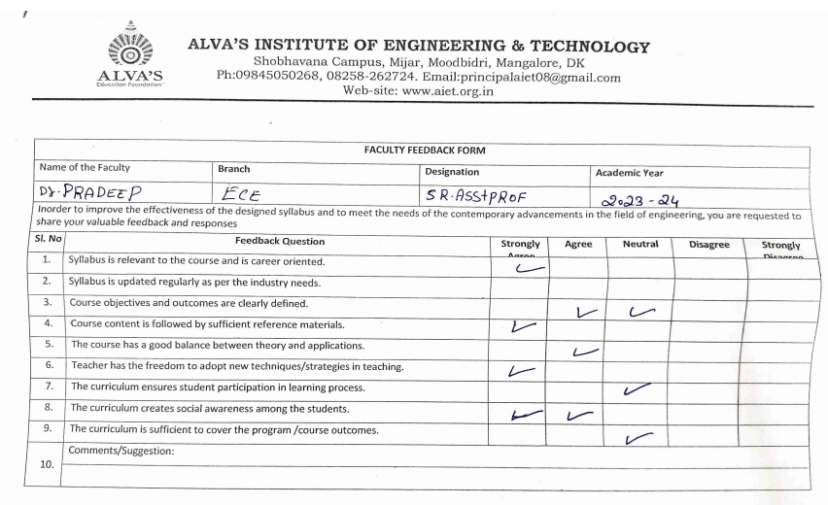

**2.1 Feedback Analysis Report**

An effort was made to receive feedback from all department faculties of the college. For this purpose, feedback form had been prepared and taken feedback. As many as 18 responses have been collected from the faculties on Syllabus . In order to arrive to comprehensive results, useful statistical tools like percentage, etc. have been used. For the effective presentation of the data, various types of graphs have been used.

93 % faculties found curriculum to be very effective in enhancing team work, developing analytical skills and constructive learning and 7% faculties are expecting improvement in curriculum and resolving it timely.

|  |  |  |  |  |  |  |  |  |  |
| --- | --- | --- | --- | --- | --- | --- | --- | --- | --- |
| **FACULTY FEEDBACK 2023-24** | | | | | | | | | |
|  | **Total Faculty : 18** | **100% of total faculties provided the feedback** | | | | | | | |
| **Sl. No** | **Feedback Question** | **Strongly Agree** | **Agree** | **Neutral** | **Disagree** | **Strongly Disagree** | **Total** | **A+B+C/ total** | **D+E/ TOTAL** |
| **`** |  | **A** | **B** | **C** | **D** | **E** |
| D1. | Syllabus is relevant to the course and is career oriented. | 10 | 6 | 1 | 1 | 0 | 18 | 94% | 6% |
| D2 | Syllabus is updated regulary as per the industry needs. | 8 | 6 | 2 | 2 | 0 | 18 | 89% | 11% |
| D3 | Course objectives and outcomes are clearly defined | 8 | 7 | 1 | 2 | 0 | 18 | 89% | 11% |
| D4 | Course content is followed by sufficient reference materials. | 9 | 7 | 2 | 0 | 0 | 18 | 100% | 0% |
| D5 | The course has a good balance between theory and applications. | 8 | 6 | 2 | 2 | 0 | 18 | 89% | 11% |
| D6 | Teacher has the freedom to adopt new techniques/strategies in teaching | 9 | 4 | 4 | 1 | 0 | 18 | 94% | 6% |
| D7 | The curriculum ensures student participation in learning process | 9 | 6 | 1 | 1 | 1 | 18 | 89% | 11% |
| D8 | The curriculum creates social awareness among the students. | 8 | 6 | 3 | 1 | 0 | 18 | 94% | 6% |
| D9 | The curriculum is sufficient to cover the program /course outcomes | 9 | 7 | 1 | 1 | 0 | 18 | 94% | 6% |
|  |  |  |  |  |  | **Average** | | **93%** | **7%** |

**3. Alumna Feedback**

The IQAC creates a feedback form, which is distributed to all departments for response collection

**3.1 Alumni Feedback form on curriculum**

|  |  |  |  |  |  |  |  |  |  |
| --- | --- | --- | --- | --- | --- | --- | --- | --- | --- |
| **ALUMINI FEEDBACK FORM** | | | | | | | | | |
| **Name of the Respondent** | | **Branch** | **Batch** | | | **Scheme** | | | |
|  | |  |  | | |  | | | |
| **Sl. No** | **Questions** | | | **Response** | | | | | |
| **Strongly Agree** | **Agree** | | **Neutral** | **Disagree** | **Strongly Disagree** |
|  | Content of the curriculum is need based. | | |  |  | |  |  |  |
|  | Core courses in the curriculum are adequate. | | |  |  | |  |  |  |
|  | Elective courses in the curriculum are sufficient. | | |  |  | |  |  |  |
|  | Ample practical content in the curriculum. | | |  |  | |  |  |  |
|  | Useful curriculum for Entrepreneurial development. | | |  |  | |  |  |  |
|  | Effective curriculum for developing skilled human resources. | | |  |  | |  |  |  |
|  | Valuable curriculum for innovative thinking and Employability. | | |  |  | |  |  |  |
|  | Curriculum helps in finding the solutions for engineering and societal problems. | | |  |  | |  |  |  |
|  | Curriculum helps in engaging independent and lifelong learning in the context of evolving technology. | | |  |  | |  |  |  |
|  | Suggestion/comments: | | | | | | | | |
|  | | | | | | | | |

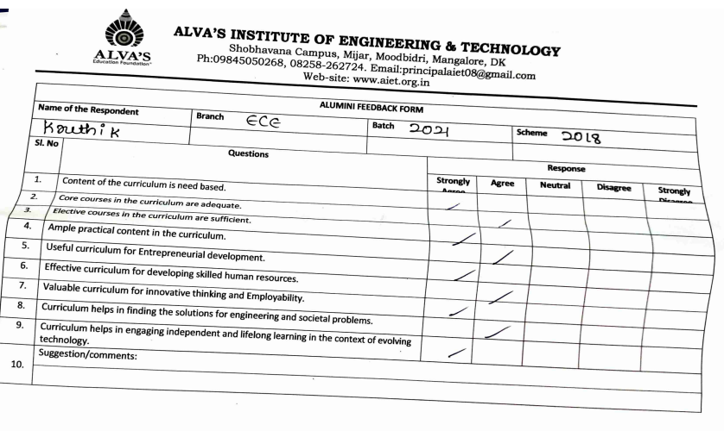

**3.2 Feedback Analysis report**

An effort was made to receive feedback from alumni’s, those who visit the college. For this purpose, feedback form had been prepared and taken feedback. As many as 11 Alumni’s visited college and responses have been collected from the Alumni on syllabus. In order to arrive to comprehensive results, useful statistical tools like percentage, etc. have been used. For the effective presentation of the data, various types of graphs have been used.

89% students found curriculum to be very effective in enhancing team work, developing analytical skills and constructive learning and 11% students are expecting improvement in curriculum and resolving it timely.

|  |  |  |  |  |  |  |  |  |  |
| --- | --- | --- | --- | --- | --- | --- | --- | --- | --- |
| **Alumni FEEDBACK** | | | | | | | | | |
|  | **Total : 11 Alumna are provided the feedback on curriculum** | | | | | | | | |
| **Sl. No** | **Feedback Question** | **Strongly Agree** | **Agree** | **Neutral** | **Disagree** | **Strongly Disagree** | **total** | **A+B+C/ total** | **D+E/ total** |
|  |  | **A** | **B** | **C** | **D** | **E** |
| D1 | Content of the curriculum is need based. | 7 | 3 | 1 | 0 | 0 | 11 | 100% | 0% |
| D2 | Core courses in the curriculum are adequate. | 7 | 4 | 0 | 0 | 0 | 11 | 100% | 0% |
| D3 | Elective courses in the curriculum are sufficient. | 5 | 6 | 0 | 0 | 0 | 11 | 100% | 0% |
| D4 | Ample practical content in the curriculum. | 5 | 3 | 3 | 0 | 0 | 11 | 100% | 0% |
| D5 | Useful curriculum for Entrepreneurial development. | 4 | 3 | 2 | 1 | 1 | 11 | 82% | 18% |
| D6 | Effective curriculum for developing skilled human resources. | 3 | 4 | 2 | 2 | 0 | 11 | 82% | 18% |
| D7 | Valuable curriculum for innovative thinking and Employability. | 3 | 4 | 2 | 1 | 1 | 11 | 82% | 18% |
| D8 | Curriculum helps in finding the solutions for engineering and societal problems. | 3 | 3 | 3 | 2 | 2 | 11 | 82% | 18% |
| D9 | Curriculum helps in engaging independent and lifelong learning in the context of evolving technology. | 4 | 2 | 2 | 2 | 1 | 11 | 73% | 27% |
|  |  |  |  |  | **Average** | | | 89% | 11% |

**4. Employer Feedback**

The IQAC creates a feedback form, which is distributed to all departments for response collection

**4.1 Employer Feedback form on curriculum**

|  |  |  |  |  |  |  |  |  |  |
| --- | --- | --- | --- | --- | --- | --- | --- | --- | --- |
| **EMPLOYER FEEDBACK FORM** | | | | | | | | | |
| **Name of the Respondent** | | **Organization** | **Designation** | | | **Contact Details** | | | |
|  | |  |  | | |  | | | |
| Respected Employer, The purpose of this is to,   1. Obtain your input on the quality of education our graduates received, 2. Asses the quality of the academic program. | | | | | | | | | |
| **Sl. No** | **Questions** | | | **Response** | | | | | |
| **Strongly Agree** | **Agree** | | **Neutral** | **Disagree** | **Strongly Disagree** |
|  | Curriculum updated as per the needs of the industry. | | |  |  | |  |  |  |
|  | Effective ordering of the courses in the curriculum. | | |  |  | |  |  |  |
|  | Core and elective course contents in the curriculum are sufficiently addressing the industrial requirements. | | |  |  | |  |  |  |
|  | Practical content in the curriculum is adequate. | | |  |  | |  |  |  |
|  | Curriculum is designed effectively for Entrepreneurial development. | | |  |  | |  |  |  |
|  | Designed curriculum is useful for developing skilled human resources. | | |  |  | |  |  |  |
|  | Valuable curriculum for innovative thinking and employability | | |  |  | |  |  |  |
|  | Knowledge on recent tools and their usage are sufficiently addressed. | | |  |  | |  |  |  |
|  | Applicability of the engineering knowledge to solve the problems is sufficient. | | |  |  | |  |  |  |
|  | Suggestion/comments: | | | | | | | | |
|  | | | | | | | | |

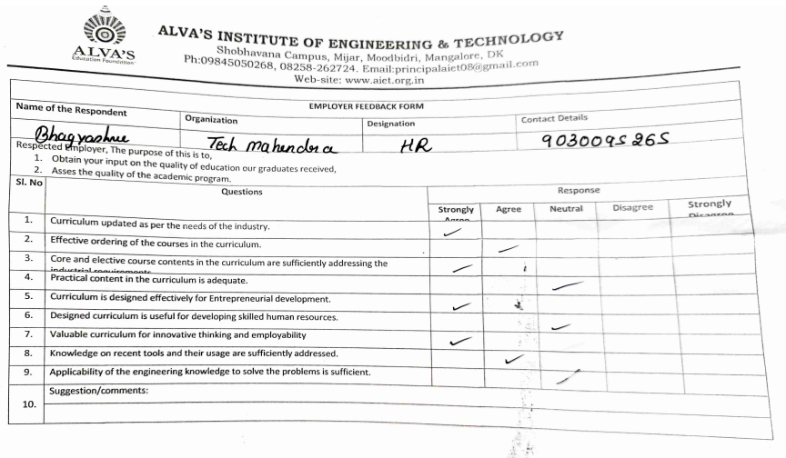

**4.2 Feedback Analysis Report**

An effort was made to receive feedback from employers, those who visit of the college for placement, workshop technical talks...etc. For this purpose, feedback form had been prepared and taken feedback. As many as 6 employee visited college and responses have been collected from them on curriculum. In order to arrive to comprehensive results, useful statistical tools like percentage, etc. have been used. For the effective presentation of the data, various types of graphs have been used

98 % Employers are Satisfied with the process of Curriculum design and development. Employers opined that AIET’s Curriculum is effective in developing ICT & communication skills and Curriculum has relevance to real life situations; reflects current trends and practices in the respective disciplines. 2% employers denied and suggested to improve the curriculum as per the industrial standards.

|  |  |  |  |  |  |  |  |  |  |
| --- | --- | --- | --- | --- | --- | --- | --- | --- | --- |
|  | Empolyer count: 6 |  |  |  |  |  |  |  |  |
| **Sl. No** | **Feedback Question** | **Strongly Agree** | **Agree** | **Neutral** | **Disagree** | **Strongly Disagree** | **Total Response** | **A+B+C/total** | **D+E/total** |
|  |  | **A** | **B** | **C** | **D** | **E** |  |  |  |
| D1 | Curriculum updated as per the needs of the industry. | 5 | 1 | 0 | 0 | 0 | 6 | 100% | 0% |
| D2 | Effective ordering of the courses in the curriculum. | 3 | 3 | 3 | 0 | 0 | 6 | 150% | 0% |
| D3 | Core and elective course contents in the curriculum are sufficiently addressing the industrial requirements. | 3 | 2 | 1 | 0 | 0 | 6 | 100% | 0% |
| D4 | Practical content in the curriculum is adequate. | 2 | 2 | 0 | 1 | 0 | 6 | 67% | 17% |
| D5 | Curriculum is designed effectively for Entrepreneurial development. | 2 | 3 | 1 | 0 | 0 | 6 | 100% | 0% |
| D6 | Designed curriculum is useful for developing skilled human resources. | 3 | 2 | 0 | 1 | 0 | 6 | 83% | 17% |
| D7 | Valuable curriculum for innovative thinking and employability | 2 | 3 | 0 | 1 | 0 | 6 | 83% | 17% |
| D8 | Knowledge on recent tools and their usage are sufficiently addressed. | 3 | 2 | 1 | 0 | 0 | 6 | 100% | 0% |
| D9 | Applicability of the engineering knowledge to solve the problems is sufficient. | 3 | 2 | 1 | 0 | 0 | 6 | 100% | 0% |
|  |  |  |  |  |  | **Average** | | **98%** | **2%** |