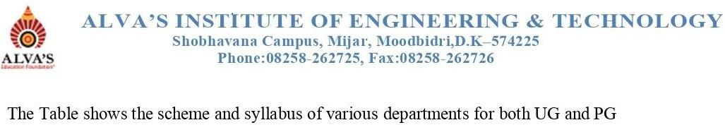

| **Sl.No** | **Year** | **Program** | **YearofStudy [2023-24]** | | | |
| --- | --- | --- | --- | --- | --- | --- |
| **I-Year** | **II-Year** | **III-Year** | **IV-Year** |
| 1 | 2023-24 |  | [Syllabus](https://cloud.aiet.org.in/storage/NAAC/NAAC%20AQAR%20(2022-23)/Criteria%201/1.1.1/ME/Syllubus/CSE%20STream%20Merged.pdf) |  |  |  |
| 2 | Computer Science and Design | [Syllabus](https://cloud.aiet.org.in/storage/NAAC/NAAC%20AQAR%202023-24/CRITERIA%20I/1.1/1.1.1/CSD/University%20Scheme%20and%20Syllabus(2022%20Batch%202%20nd%20Year).pdf) | [Syllabus](https://cloud.aiet.org.in/storage/NAAC/NAAC%20AQAR%202023-24/CRITERIA%20I/1.1/1.1.1/CSD/University%20Scheme%20and%20Syllabus(2021%20Batch%203%20rd%20Year).pdf) |  |
| 3 |  |  |  |  |
| 4 |  |  |  |  |
| 5 |  |  |  |  |
| 6 |  |  |  |  |