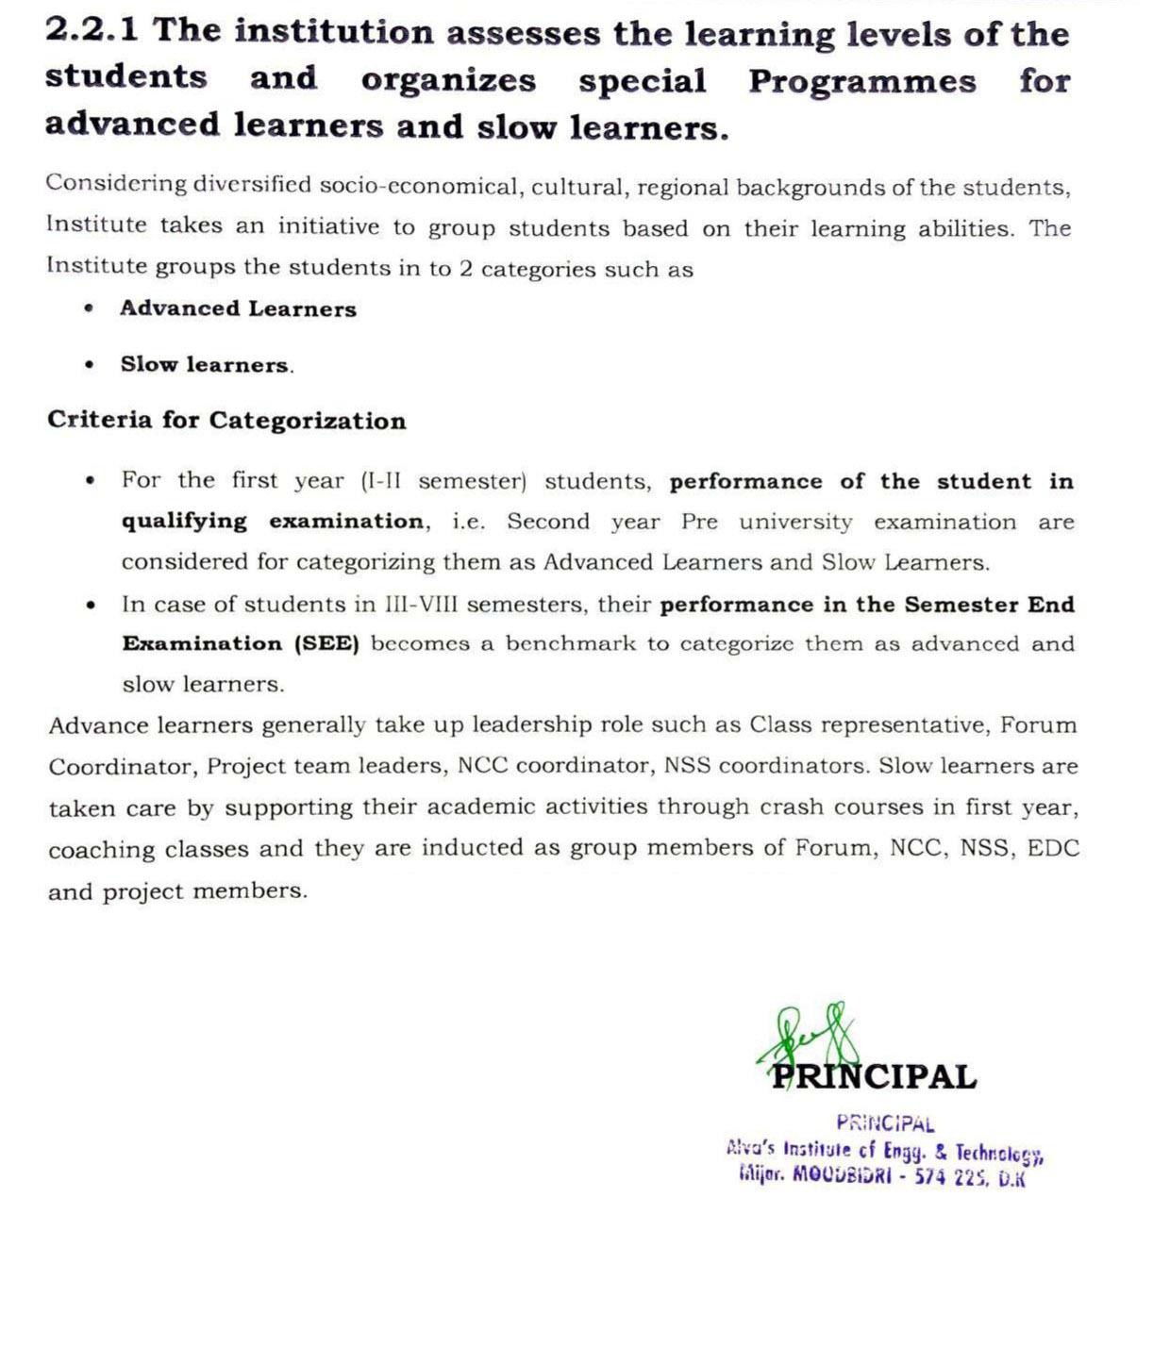

**2.2.1 The institution assesses the learning levels of the students and organizes special Programmes for advanced learners and slow learners.**

1. **Policy on Teaching Learning** [VIEW DOCUMENT](https://cloud.aiet.org.in/storage/NAAC/criteria-2/2.2.1%2020-3-22/Policy-on-teaching-learning-process.pdf)
2. **Advanced Learners and Slow Learner List**

|  |  |  |
| --- | --- | --- |
| **Sl. No.** | **Program** | **Advance Learner & Slow Learner** |
| 1 | CSE | [VIEW DOCUMENTS](https://cloud.aiet.org.in/storage/NAAC/NAAC%20AQAR%202023-24/CRITERIA%202/2.2.1/CSE/Advanced%20Learners/AdvancedLearners.pdf) |
| 2 | ISE | [VIEW DOCUMENTS](https://cloud.aiet.org.in/storage/NAAC/NAAC%20AQAR%202023-24/CRITERIA%202/2.2.1/ISE/Advanced_and_Slow_Learners_ISE.pdf) |
| 3 | AIML | [VIEW DOCUMENTS](https://cloud.aiet.org.in/storage/NAAC/NAAC%20AQAR%202023-24/CRITERIA%202/2.2.1/AIML/Advanced%20and%20Slow%20Learners%20new.pdf) |
| 4 | CSD | [VIEW DOCUMENTS](https://cloud.aiet.org.in/storage/NAAC/NAAC%20AQAR%202023-24/CRITERIA%202/2.2.1/CSD/Advanced_and_Slow_learners_list.pdf) |
| 5 | MECH | [VIEW DOCUMENTS](https://cloud.aiet.org.in/storage/NAAC/NAAC%20AQAR%202023-24/CRITERIA%202/2.2.1/ME/ADL%20&%20LL.pdf) |
| 6 | CIVIL | [VIEW DOCUMENTS](https://cloud.aiet.org.in/storage/NAAC/NAAC%20AQAR%202023-24/CRITERIA%202/2.2.1/Civil/2.%20Advance%20and%20Slow%20Learner.pdf) |
| 7 | AGRI | [VIEW DOCUMENTS](https://cloud.aiet.org.in/storage/NAAC/NAAC%20AQAR%202023-24/CRITERIA%202/2.2.1/AG/AG-21st%20Batch-AL&SL-2022-23-ODD%20SEM.pdf) |
| 8 | MBA | [VIEW DOCUMENTS](https://cloud.aiet.org.in/storage/NAAC/NAAC%20AQAR%20(2023-24)/CRITERIA%202/2.2.1/MBA/advance%20and%20slow%20learner.pdf) |

1. **Advanced Learners as Class representative (CR)**

|  |  |  |
| --- | --- | --- |
| **Sl. No.** | **Program** | **CR list** |
| 1 | CSE | [VIEW DOCUMENTS](https://cloud.aiet.org.in/storage/NAAC/NAAC%20AQAR%202023-24/CRITERIA%202/2.2.1/CSE/Advanced%20Learners/ADL_CR.pdf) |
| 2 | ISE | [VIEW DOCUMENTS](https://cloud.aiet.org.in/storage/NAAC/NAAC%20AQAR%202023-24/CRITERIA%202/2.2.1/ISE/CR_List_ISE.pdf) |
| 3 | AIML | [VIEW DOCUMENTS](https://cloud.aiet.org.in/storage/NAAC/NAAC%20AQAR%202023-24/CRITERIA%202/2.2.1/AIML/CR%20List.pdf) |
| 4 | CSD | [VIEW DOCUMENTS](https://cloud.aiet.org.in/storage/NAAC/NAAC%20AQAR%202023-24/CRITERIA%202/2.2.1/CSD/Class_CR_S.pdf) |
| 5 | MECH | [VIEW DOCUMENTS](https://cloud.aiet.org.in/storage/NAAC/NAAC%20AQAR%202023-24/CRITERIA%202/2.2.1/Supporting%20Documents/ME/CR%20list.pdf) |
| 6 | CIVIL | [VIEW DOCUMENTS](https://cloud.aiet.org.in/storage/NAAC/NAAC%20AQAR%202023-24/CRITERIA%202/2.2.1/Civil/3.%20CR-List%20Advance%20Learners.pdf) |
| 7 | MBA | [VIEW DOCUMENTS](https://cloud.aiet.org.in/storage/NAAC/NAAC%20AQAR%20(2023-24)/CRITERIA%202/2.2.1/MBA/CR.pdf) |

1. **Advanced Learners as Forum Coordinators**

|  |  |  |
| --- | --- | --- |
| **Sl. No.** | **Program** | **Forum Coordinators** |
| 1 | CSE | [VIEW DOCUMENTS](https://cloud.aiet.org.in/storage/NAAC/NAAC%20AQAR%202023-24/CRITERIA%202/2.2.1/CSE/ForumOfficeBarrers.pdf) |
| 2 | ISE | [VIEW DOCUMENTS](https://cloud.aiet.org.in/storage/NAAC/NAAC%20AQAR%202023-24/CRITERIA%202/2.2.1/ISE/Forum_Coordinator_ISE.pdf) |
| 3 | AIML | [VIEW DOCUMENTS](https://cloud.aiet.org.in/storage/NAAC/NAAC%20AQAR%202023-24/CRITERIA%202/2.2.1/AIML/Forum%20List.pdf) |
| 4 | CSD | [VIEW DOCUMENTS](https://cloud.aiet.org.in/storage/NAAC/NAAC%20AQAR%202023-24/CRITERIA%202/2.2.1/CSD/Forum_Coordinators.pdf) |
| 5 | MECH | [VIEW DOCUMENTS](https://cloud.aiet.org.in/storage/NAAC/NAAC%20AQAR%202023-24/CRITERIA%202/2.2.1/Supporting%20Documents/ME/Club%20coordinator.pdf) |
| 6 | CIVIL | [VIEW DOCUMENTS](https://cloud.aiet.org.in/storage/NAAC/NAAC%20AQAR%202023-24/CRITERIA%202/2.2.1/Civil/4.%20Forum%20Coordinator%20List%20-Advance%20Learners.pdf) |
| 7 | AGRI | [VIEW DOCUMENTS](https://cloud.aiet.org.in/storage/NAAC/NAAC%20AQAR%202023-24/CRITERIA%202/2.2.1/AG/2.2.1-2023-24-List%20of%20Forum-co-ordinators.pdf) |
| 8 | MBA | [VIEW DOCUMENTS](https://cloud.aiet.org.in/storage/NAAC/NAAC%20AQAR%20(2023-24)/CRITERIA%202/2.2.1/MBA/Club%20Co-ordinators.pdf) |

1. **Motivating the Advanced Learners to Apply for Funding for their Final year Projects**

|  |  |  |
| --- | --- | --- |
| **Sl. No.** | **Program** | **CR list** |
| 1 | CSE | VIEW DOCUMENTS |
| 2 | ISE | [VIEW DOCUMENTS](https://cloud.aiet.org.in/storage/NAAC/NAAC%20AQAR%202023-24/CRITERIA%202/2.2.1/ISE/47S_BE_1194_ProjectFunding-merged.pdf) |
| 3 | MECH | [VIEW DOCUMENTS](https://cloud.aiet.org.in/storage/NAAC/NAAC%20AQAR%202023-24/CRITERIA%202/2.2.1/Supporting%20Documents/ME/ME-KSCST%20project.pdf) |
| 4 | CIVIL | [VIEW DOCUMENTS](https://cloud.aiet.org.in/storage/NAAC/NAAC%20AQAR%202023-24/CRITERIA%202/2.2.1/Civil/6.%20KSCST%20Project-1.pdf) |
| 5 | AMIL | VIEW DOCUMNETS |

1. **Representation of Advanced Learners in KSCST Projects as Team Leader**

|  |  |
| --- | --- |
| **Academic Year** | **Document Link** |
| **2023-24** | [VIEW DOCUMENTS](https://cloud.aiet.org.in/storage/NAAC/NAAC%20AQAR%202023-24/CRITERIA%202/2.2.1/Supporting%20Documents/ME/ME-KSCST%20project.pdf) |

1. **Advanced Learners as Final Year Project Team Leader**

|  |  |  |
| --- | --- | --- |
| **Academic Year** | **Program** | **Document Link** |
| 2023-24 | CSE | VIEW DOCUMENTS |
| ISE | [VIEW DOCUMENTS](https://cloud.aiet.org.in/storage/NAAC/NAAC%20AQAR%202023-24/CRITERIA%202/2.2.1/ISE/AL_as_TeamLeader_BatchList_ISE.pdf) |
| ECE | [VIEW DOCUMENTS](https://cloud.aiet.org.in/storage/NAAC/NAAC%20AQAR%202023-24/CRITERIA%202/2.2.1/ECE/Project%20list.pdf) |
| MECH | [VIEW DOCUMENTS](https://cloud.aiet.org.in/storage/NAAC/NAAC%20AQAR%202023-24/CRITERIA%202/2.2.1/Supporting%20Documents/ME/ME_PROJECT%20Details_20%2023-24.pdf) |
| CIVIL | [VIEW DOCUMENTS](https://cloud.aiet.org.in/storage/NAAC/NAAC%20AQAR%202023-24/CRITERIA%202/2.2.1/Civil/7.%20Project%20Team%20Leader%202023-24.pdf) |
| AMIL | [VIEW DOCUMNETS](https://cloud.aiet.org.in/storage/NAAC/NAAC%20AQAR%202023-24/CRITERIA%202/2.2.1/AIML/project%20List.pdf) |

1. **Advanced Learners Involved In Executing Special Advanced Projects**

|  |  |
| --- | --- |
| **Academic Year** | **Document Link** |
| 2023-24 | [VIEW DOCUMENTS](https://cloud.aiet.org.in/storage/NAAC/NAAC%20AQAR%202023-24/CRITERIA%202/2.2.1/Supporting%20Documents/ME/Advance%20project.pdf) |

1. **Participation of Advanced Learners & Slow learners in Entrepreneurship Development (ED) Cell**

|  |  |  |
| --- | --- | --- |
| **Academic Year** | **Program** | **Document Link** |
| **2023-24** | All Branch Students | [VIEW DOCUMENTS](https://cloud.aiet.org.in/storage/NAAC/NAAC%20AQAR%202023-24/CRITERIA%202/2.2.1/Supporting%20Documents/EDC%201-merged.pdf) |

1. **Representation of Advanced Learners & Slow learners in NSS**

|  |  |  |
| --- | --- | --- |
| **Academic Year** | **Program** | **Document Link** |
| **2023-24** | All Branch Students | [VIEW DOCUMENTS](https://cloud.aiet.org.in/storage/NAAC/NAAC%20AQAR%202023-24/CRITERIA%202/2.2.1/Supporting%20Documents/NSS/NSS1_merged.pdf) |

1. **Representation of Advanced Learners & Slow learners in NCC**

|  |  |  |
| --- | --- | --- |
| **Academic Year** | **Program** | **Document Link** |
| **2023-24** | All Branch Students | [VIEW DOCUMENTS](https://cloud.aiet.org.in/storage/NAAC/NAAC%20AQAR%202023-24/CRITERIA%202/2.2.1/Supporting%20Documents/Advance%20project%20(1).pdf) |

1. **Crash Course/remedial Classes for Slow Learners**

|  |  |
| --- | --- |
| **Academic Year** | **Crash Course Slow Learners** |
| **2023-24** | [VIEW DOCUMENTS](https://cloud.aiet.org.in/storage/NAAC/NAAC%20AQAR%202023-24/CRITERIA%202/2.2.1/Supporting%20Documents/carsh%20course.pdf) |

1. **Coaching Classes for Slow Learners**

|  |  |  |
| --- | --- | --- |
| **Academic Year** | **Program** | **Document Link** |
| **2023-24** | CSE | [VIEW DOCUMENTS](https://cloud.aiet.org.in/storage/NAAC/NAAC%20AQAR%202023-24/CRITERIA%202/2.2.1/CSE/Coaching%20Class/Coaching%20Class.pdf) |
| ISE | [VIEW DOCUMENTS](https://cloud.aiet.org.in/storage/NAAC/NAAC%20AQAR%202023-24/CRITERIA%202/2.2.1/ISE/CoachingClass_ISE.pdf) |
| AIML | [VIEW DOCUMENTS](https://cloud.aiet.org.in/storage/NAAC/NAAC%20AQAR%202023-24/CRITERIA%202/2.2.1/AIML/Coaching%20class%200f%202021%20batch%20even%20sem.pdf) |
| ECE | [VIEW DOCUMENTS](https://cloud.aiet.org.in/storage/NAAC/NAAC%20AQAR%202023-24/CRITERIA%202/2.2.1/ECE/2.2.1%20COACHINGCLASS.pdf) |
| MECH | [VIEW DOCUMENTS](https://cloud.aiet.org.in/storage/NAAC/NAAC%20AQAR%202023-24/CRITERIA%202/2.2.1/ME/coaching%20class%20AY%202023-24.pdf) |
| CIVIL | [VIEW DOCUMENTS](https://cloud.aiet.org.in/storage/NAAC/NAAC%20AQAR%20(2023-24)/CRITERIA%202/2.2.1/Civil/14.%20Coaching%20class.pdf) |
| CHEMISTRY | [VIEW DOCUMENTS](https://cloud.aiet.org.in/storage/NAAC/NAAC%20AQAR%202023-24/CRITERIA%202/2.2.1/CHE/CHE%20COACHING%20CLASS.pdf) |
| Maths | [VIEW DOCUMENTS](https://cloud.aiet.org.in/storage/NAAC/NAAC%20AQAR%202023-24/CRITERIA%202/2.2.1/MATHS/Evening%20coaching%20class%2023-24%20even%20sem%20.pdf) |
| CSD | [VIEW DOCUMNETS](https://cloud.aiet.org.in/storage/NAAC/NAAC%20AQAR%202023-24/CRITERIA%202/2.2.1/CSD/Coaching_classes.pdf) |

1. **Bridge Course**

|  |  |
| --- | --- |
| **Academic Year** | **Bridge Course Document Link** |
| **2023-24** | [VIEW DOCUMENTS](https://cloud.aiet.org.in/storage/NAAC/NAAC%20AQAR%202023-24/CRITERIA%202/2.2.1/MATHS/Bridge%20course%20.pdf) |