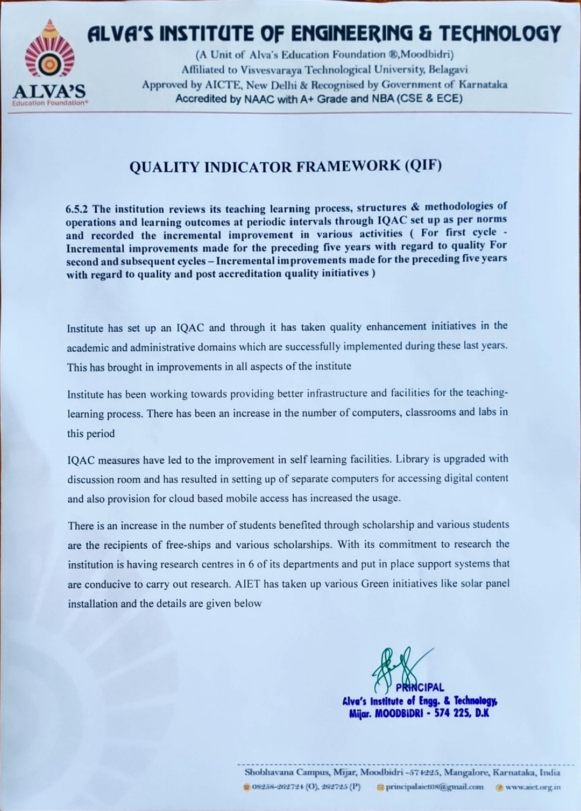

**ALVA’S INSTITUTE OF ENGINEERING & TECHNOLOGY**

Shobhavana Campus, Mijar, Moodbidri, D.K – 574225

**Phone: 08258-262725, Fax: 08258-262726**

**QUALITY INDICATOR FRAMEWORK (QIF)**

|  |  |  |  |
| --- | --- | --- | --- |
| **Sl.no** | **Facility** | **2022-23** | **2023-24**  **Current Year** |
|  | Number of full time teachers with Ph.D. | 39 | 52 |
|  | Final year University Exam Results | 97.77% | 99.78 |
|  | Number of classrooms with ICT  facilities | 45 | 48 |
|  | Annual expenditure for purchase of e-journals year-wise(INR in Lakhs) | 18.38 | 23.95 |
|  | No. of computers | 951 | 1277 |
|  | Number of students benefited by scholarships and freeships provided by the Institute | 712 | 756 |

|  |  |  |
| --- | --- | --- |
| **Sl.**  **No.** | **Particulars** | **Document Link** |
|  | Teaching Learning Policy | [View Document](https://www.aiet.org.in/wp-content/uploads/2021/12/Policy-on-teaching-learning-process.pdf#page%3D4) |
|  | Number of faculty with PhDs | [View Document](https://cloud.aiet.org.in/storage/NAAC/NAAC%20AQAR%20(2023-24)/CRITERIA%202/2.4.2/2.4.2%20Average%20Percentage%20of%20full%20time%20teachers%20with%20Ph.D.WITH%20CERTIFICATES.pdf) |
|  | Final year University Exam Results  in percentage | [View Document](https://cloud.aiet.org.in/storage/NAAC/NAAC%20AQAR%202023-24/CRITERIA%202/2.6.3/2.6.3%20Claim%20Sheet.pdf) |
|  | Annual expenditure for purchase of  e-journals year-wise | [View Document](https://cloud.aiet.org.in/storage/NAAC/NAAC%20AQAR%202023-24/Criteria%204/4.2.3/Supporting%20docments/E%20resourse%20Subscription/Vtu%20e%20resource%20detail%20updated%204.2.3.pdf) |
|  | No. of computers | [View Document](https://cloud.aiet.org.in/storage/NAAC/NAAC%20AQAR%202023-24/Criteria%204/4.3.1/4.3.1-%20Upload%20any%20additional%20information-1.pdf) |
|  | Number of students benefited by scholarships and freeships | [View Document](https://cloud.aiet.org.in/storage/NAAC/NAAC%20AQAR%202023-24/Criteria%205/5.1.2/) |