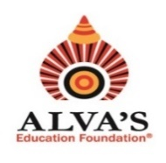 **ALVA’S INSTITUTE OF ENGINEERING & TECHNOLOGY**

(Unit of Alva’s Education Foundation (R), Moodbidri)

Affiliated to Visvesvaraya Technological University, Belagavi & Approved by AICTE,

New Delhi. Recognized by Government of Karnataka.

**A+, Accredited by NAAC & NBA (ECE & CSE)**

Shobhavana Campus, MIJAR-574225, Moodbidri, D.K., Karnataka

Ph: 08258-262725; Mob:722262724,7026262725, mail:principalaiet08@gmail.com

**QUALITY INDICATOR FRAMEWORK (QIF)**

**5.2.2 Average percentage of students progressing to higher education during**

**the last five years**

Alva’s Institute of Engineering and Technology encourages students to pursue higher education by conducting various career counselling programs and competitive examination training. In the year 2023-24, a total of seven graduated students progressed to higher studies in national and international universities.

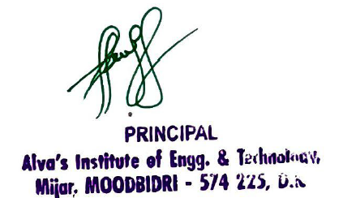

** ALVA’S INSTITUTE OF ENGINEERING & TECHNOLOGY**

(Unit of Alva’s Education Foundation (R), Moodbidri)

Affiliated to Visvesvaraya Technological University, Belagavi & Approved by AICTE,

New Delhi. Recognized by Government of Karnataka.

**A+, Accredited by NAAC & NBA (ECE & CSE)**

Shobhavana Campus, MIJAR-574225, Moodbidri, D.K., Karnataka

Ph: 08258-262725; Mob:722262724,7026262725, mail:principalaiet08@gmail.com

**QUALITY INDICATOR FRAMEWORK (QIF)**

**5.2.2 Average percentage of students progressing to higher education during**

**the last five years**

The following table enumerates the details of students progressing to higher education during the year 2023-24.

|  |  |  |  |
| --- | --- | --- | --- |
| **Sl. No** | **Academic Year** | **No. students progressing to higher education** | **Document link** |
| 1 | 2023-24 | 7 | [View document](https://cloud.alvas.org/?r=/download&path=L05BQUMvTkFBQyBBUUFSICgyMDIzLTI0KS9Dcml0ZXJpYSA1LzUuMi4yL3N1cHBvcnRpbmcgZG9jdW1lbnRzLnBkZg%3D%3D) |