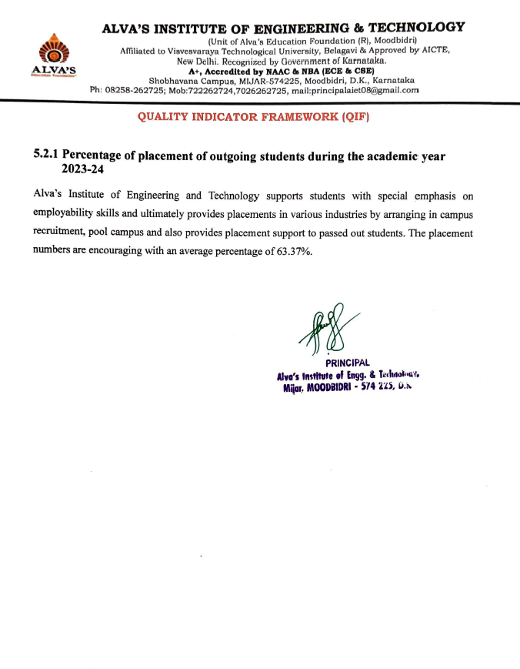

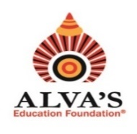 **ALVA’S INSTITUTE OF ENGINEERING & TECHNOLOGY**

(Unit of Alva’s Education Foundation (R), Moodbidri)

Affiliated to Visvesvaraya Technological University, Belagavi & Approved by AICTE,

New Delhi. Recognized by Government of Karnataka.

**A+, Accredited by NAAC & NBA (ECE & CSE)**

Shobhavana Campus, MIJAR-574225, Moodbidri, D.K., Karnataka

Ph: 08258-262725; Mob:722262724,7026262725, mail:principalaiet08@gmail.com

**QUALITY INDICATOR FRAMEWORK (QIF)**

**5.2.1 Percentage of placement of outgoing students during the academic year**

**2023-24**

Alva’s Institute of Engineering and Technology supports students with special emphasis on employability skills and ultimately provides placements in various industries by arranging in campus recruitment, pool campus and also provides placement support to passed out students. The placement numbers are encouraging with an average percentage of 63.37%.

|  |  |  |  |
| --- | --- | --- | --- |
| **Academic Year** | **Number of Outgoing Students** | **Number of Outgoing Students Placed** | **Document Link** |
| 2023-24 | 456 | 289 | [View](https://cloud.alvas.org/?r=/download&path=L05BQUMvTkFBQyBBUUFSICgyMDIzLTI0KS9Dcml0ZXJpYSA1LzUuMi4xL1N1cHBvcnRpbmcgRG9jdW1lbnRzIC9TdXBwb3J0aW5nIGRvY3VtZW50cy5wZGY%3D) |
| **Percentage** | | | 63.37 % |