**IT Maintenance**

A team of well-trained technicians will maintain the computers and network related issues in the entire institute (including computers available in library, laboratory, office, staff rooms, and any other) under the guidance of System Administrator.

* **Any IT related complaint** in class room/staff room/labs/Hostels will be communicated to the System Administrator by the head of the department/in charges **through indent or the IT Support Email ID** only.
* Issues will be resolved on a **First-Come-First-Served basis.** However, the priority can be changed on request at the sole discretion of the designated team in IT Dept.
* System admin will assign the job to the technician as per indent placed & If any material is required to solve the problem, the same will be brought to the notice of Administrative Officer & Principal.

**Indent Copy**

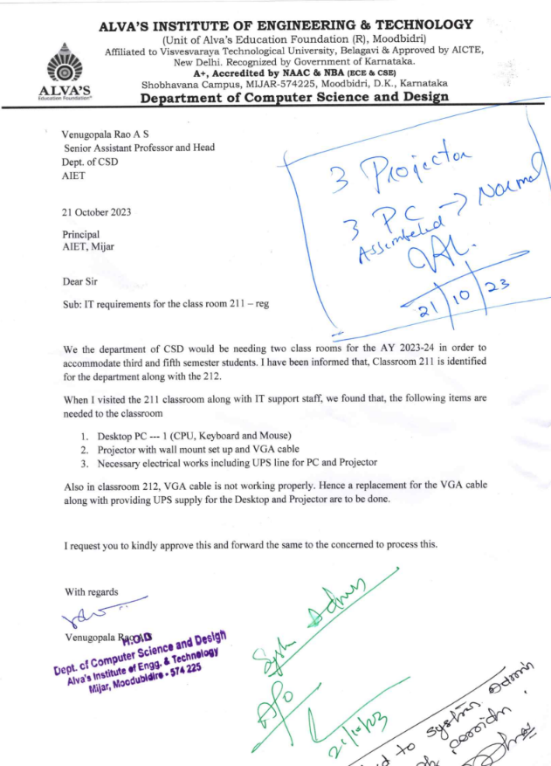

* System administrator will place the order with the help of Purchase committee for further processing of procurement as per standard procedure.

**Purchase Order Copy**

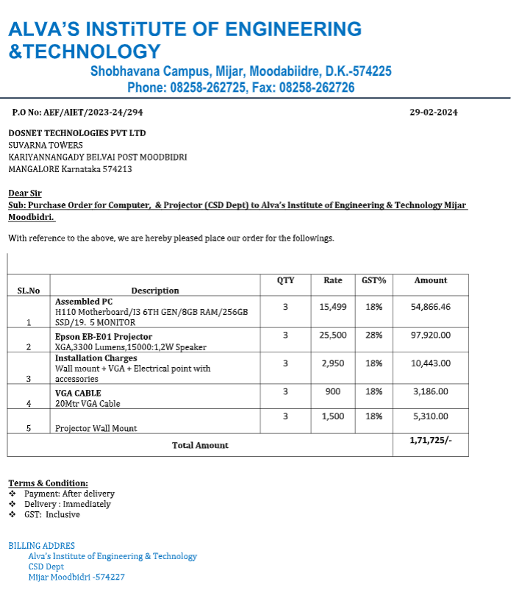

* After procuring the equipment the technician under the supervision of the system administrator solves the problem and the indent request is considered as closed.

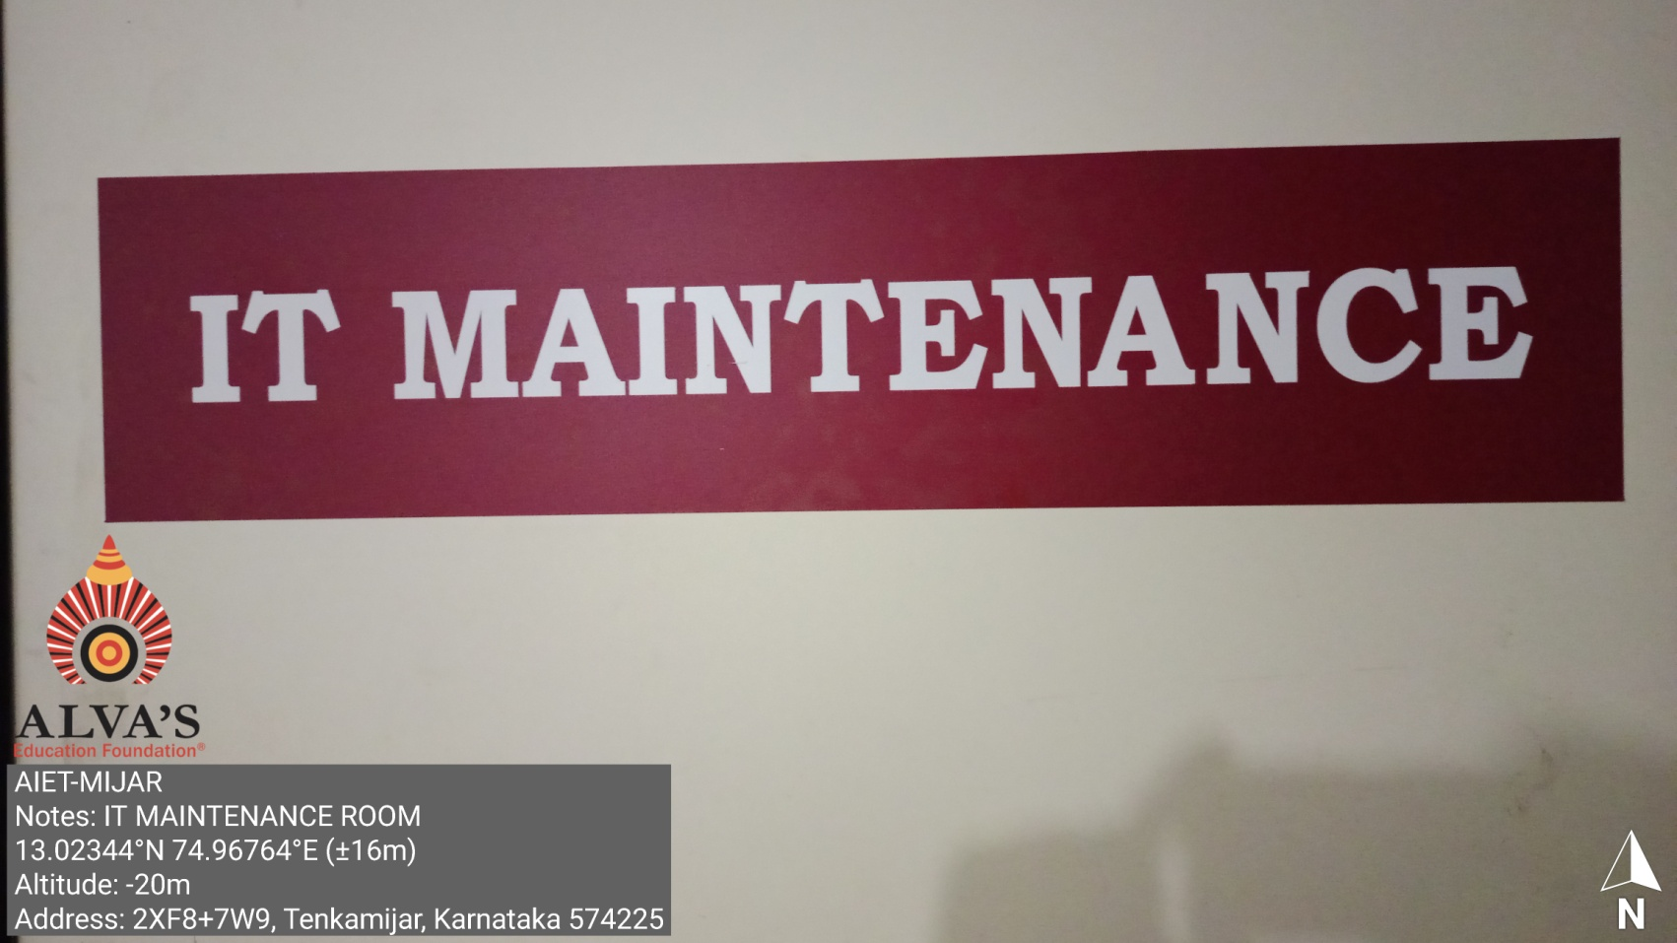

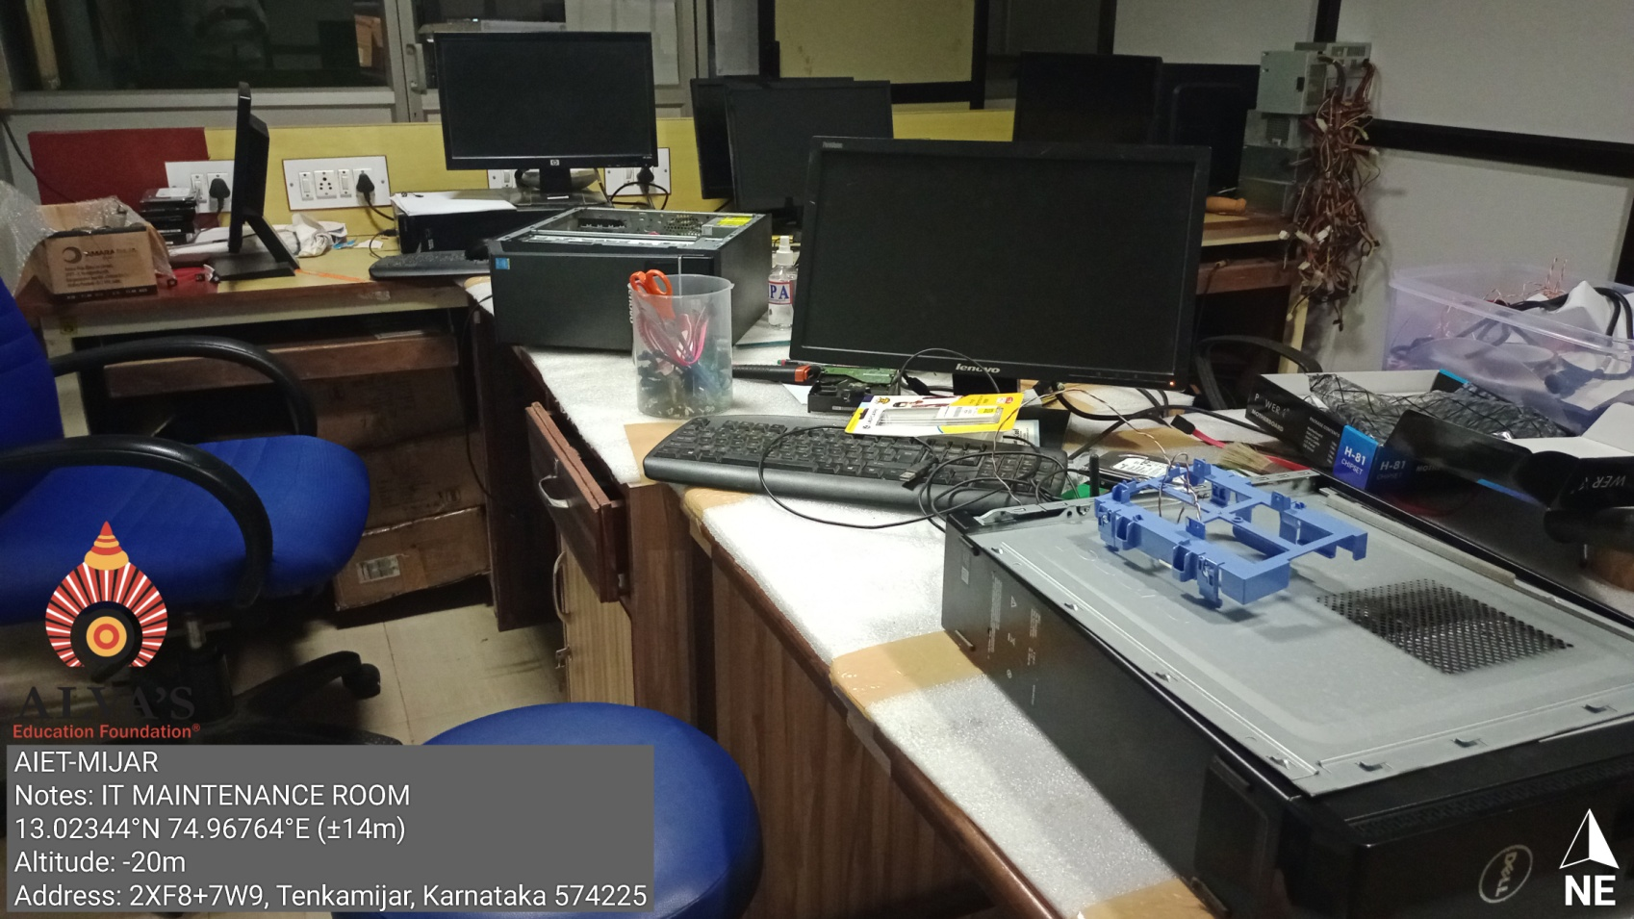

* The System admin will notify principal about all the completed works by taking signature for the same. The approved bills will be submitted to the purchase committee for further processing.

**Supplier Invoice Copy**

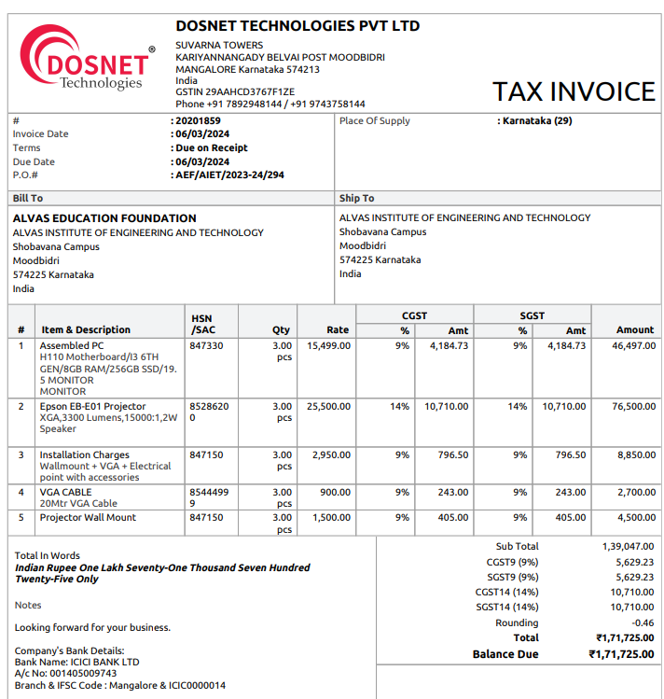

System Admin Principal