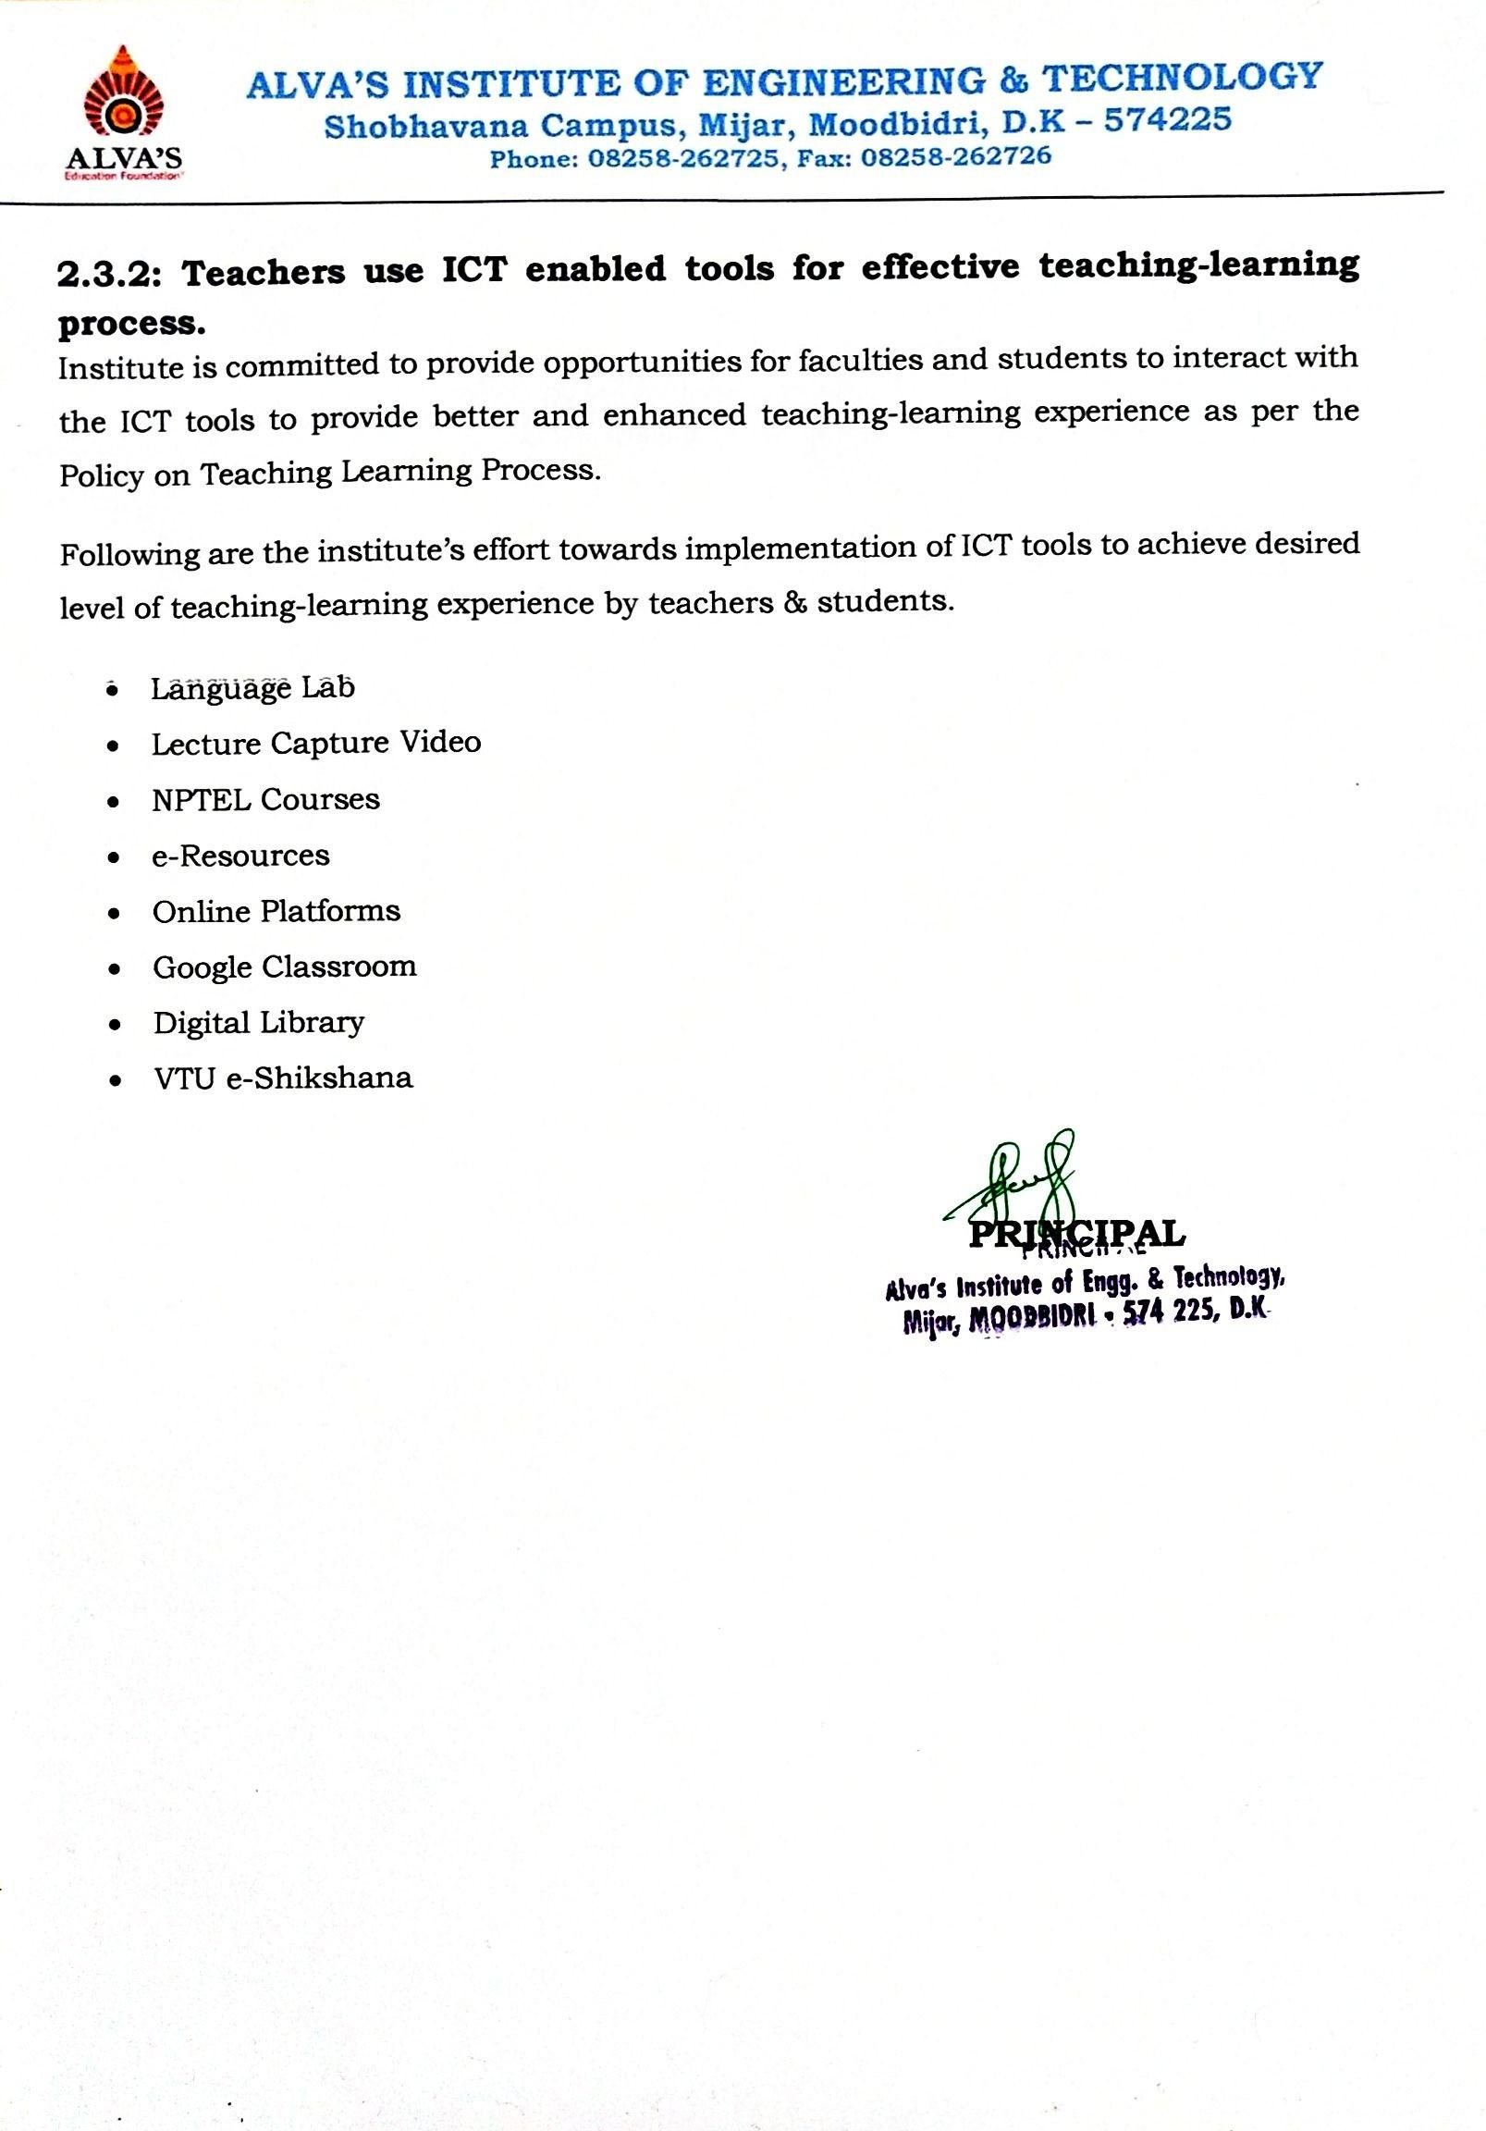

**ALVA’S INSTITUTE OF ENGINEERING & TECHNOLOGY**

**Shobhavana Campus, Mijar, Moodbidri, D.K – 574225**

**Phone: 08258-262725, Fax: 08258-262726**

|  |  |
| --- | --- |
| **e- Resources** | |
| Faculty using ICT tools | [View Document](https://drive.google.com/file/d/1mC4c98HhvkIwO-rWSJ0v1amp92c3qIwp/view?usp=drive_link) |

**List of ICT Tools-**

|  |  |  |
| --- | --- | --- |
|  | Video lecture | [View Document](https://drive.google.com/file/d/1Tv-Tli6rXJpmRtysjM_mhC_ZoG1GiA9z/view?usp=drive_link) [View Sample Video](https://youtu.be/_ck1Lnm28hQ) |
| NPTEL Courses | [View Document](https://drive.google.com/file/d/1pF1el6R8Rt1pZ0uAzW-2j9GqOfEf06BS/view?usp=drive_link) |
| e-Resources | [View Document](https://cloud.aiet.org.in/storage/NAAC/NAAC%20AQAR%20(2022-23)/Criteria%202/2.3.2/VTU%20e%20resource%20details%202023%203rd%20updated%20final.pdf) |
| Online Platforms | [View Document](https://cloud.aiet.org.in/storage/NAAC/NAAC%20AQAR%20(2022-23)/Criteria%202/2.3.2/Online%20Platform%20Certification.pdf) |
| Google Classroom | [View Document](https://drive.google.com/file/d/1MhoiMJNJcJfF1tKst-SOMW1VisrDUsAf/view?usp=drive_link) |
| Digital Library | [View Document](https://aietm.knimbus.com/user#/home) |
| VTU e-Shikshana | [View Document](https://cloud.aiet.org.in/storage/NAAC/criteria-2/2.3.2/e-shikshana/eshikshana_report.pdf)  [View Weblink](http://elearning.vtu.ac.in/esk3.php) |