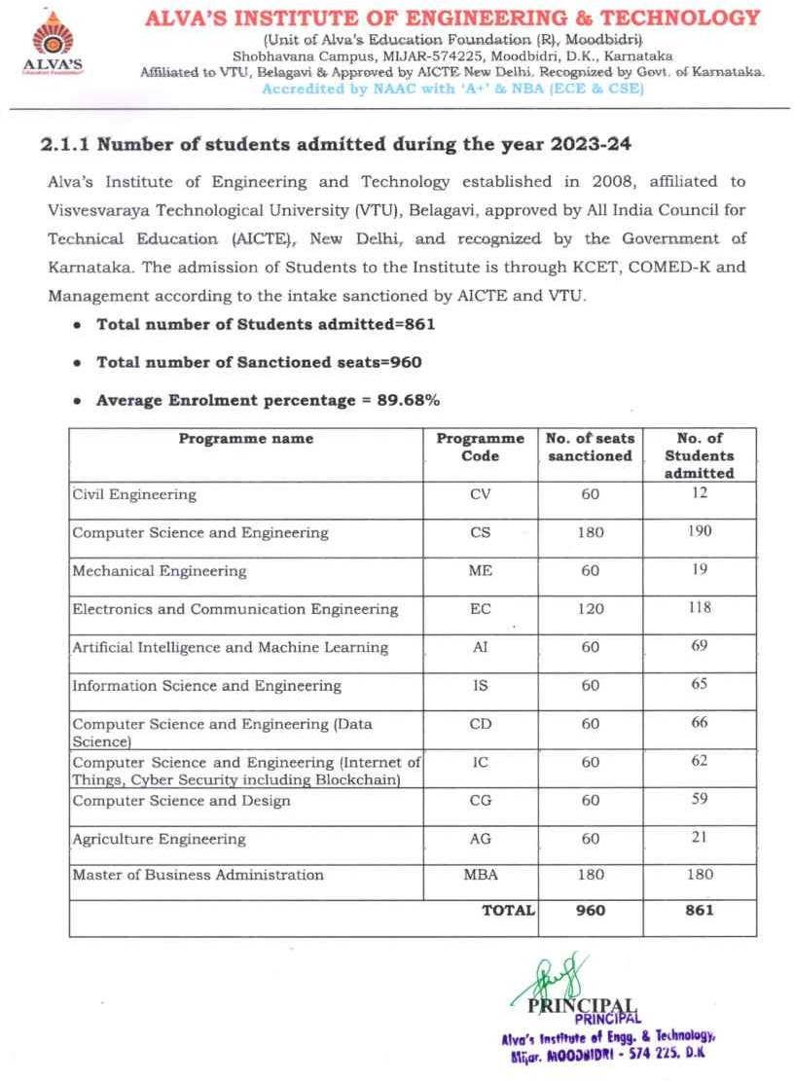

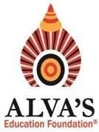ALVA’S INSTITUTE OF ENGINEERING & TECHNOLOGY

# (Unit of Alva’s Education Foundation (R), Moodbidri)

Shobhavana Campus, MIJAR-574225, Moodbidri, D.K., Karnataka

Affiliated to VTU, Belagavi & Approved by AICTE New Delhi. Recognized by Govt. of Karnataka.

# Accredited by NAAC with ‘A+’ & NBA (ECE & CSE)

Hyperlinks of Supporting Documents for Enrolment

|  |  |  |  |  |
| --- | --- | --- | --- | --- |
| Sl. No. | Academic Year | Extension of Approval (EOA) documents AICTE  (UG+PG) | VTU Affiliation documents  (UG+PG) | VTU approved students list (UG+PG) |
| 1 | 2023-24 | [View Document](https://cloud.aiet.org.in/storage/NAAC/NAAC%20AQAR%20(2023-24)/CRITERIA%202/2.1.1/All%20India%20Council%20for%20Technical%20Education.pdf) | [View Document](https://cloud.aiet.org.in/storage/NAAC/NAAC%20AQAR%20(2023-24)/CRITERIA%202/2.1.1/VTU%20Affiliation%20Notification%20dtd.%2024-06-2024.pdf) | [View Document](https://cloud.aiet.org.in/storage/NAAC/NAAC%20AQAR%20(2023-24)/CRITERIA%202/2.1.1/2.1.1%20first%20year%20student%20list-2023-24.pdf) |

# Note: UG: B.E.,PG: MBA