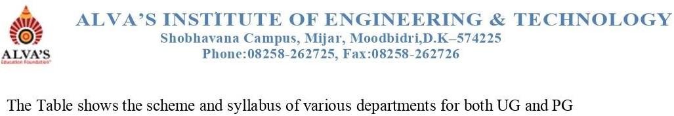

|  |  |  |  |  |  |  |
| --- | --- | --- | --- | --- | --- | --- |
| **Sl. No** | **Year** | **Program** | **Year of Study [2023-24]** | | | |
| **I-Year** | **II-Year** | **III-Year** | **IV-Year** |
| 1 | 2023-24 | Artificial Intelligence and  Machine Learning | [Syllabus](https://cloud.aiet.org.in/storage/NAAC/NAAC%20AQAR%20(2022-23)/Criteria%201/1.1.1/ME/Syllubus/CSE%20STream%20Merged.pdf) | Syllabus | Syllabus | Syllabus |
| 2 | Computer Science and Design | Syllabus | Syllabus | Syllabus |
| 3 | Computer science and  Engineering | Syllabus | Syllabus | Syllabus |
| 4 | Computer science and Engineering [Data science] | Syllabus | Syllabus | Syllabus |
| 5 | Computer science and  Engineering [IOT] | Syllabus | Syllabus | Syllabus |
| 6 | Information Science and  Engineering | Syllabus | Syllabus | Syllabus |
| 7 | Electronics and  Communications Engineering | Syllabus | Syllabus | Syllabus | Syllabus |
| 8 | Mechanical Engineering | Syllabus | [Syllabus](https://cloud.aiet.org.in/storage/NAAC/NAAC%20AQAR%202023-24/CRITERIA%20I/1.1/1.1.1/ME/Syllubus%20And%20Scheme/23-24(3&4).pdf) | [Syllabus](https://cloud.aiet.org.in/storage/NAAC/NAAC%20AQAR%202023-24/CRITERIA%20I/1.1/1.1.1/ME/Syllubus%20And%20Scheme/21-22(5&6).pdf) | [Syllabus](https://cloud.aiet.org.in/storage/NAAC/NAAC%20AQAR%202023-24/CRITERIA%20I/1.1/1.1.1/ME/Syllubus%20And%20Scheme/18-19(7&8).pdf) |
| 9 | Agriculture Engineering | Syllabus | Syllabus |  |  |
| 10 | Civil Engineering | Syllabus | Syllabus |  |  |
| 11 | MBA | Syllabus | Syllabus |  |  |