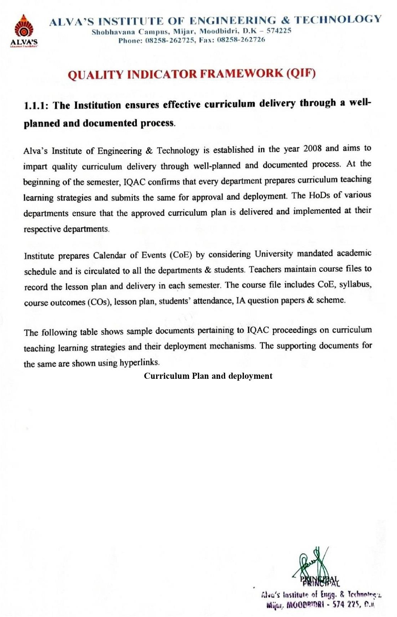

|  |  |  |
| --- | --- | --- |
| **Sl.No** | **NameoftheDocument** | **Document** |
| 1 | University Scheme and Syllabus | ViewDocument |
| 2 | IQAC Proceedings | [ViewDocument](https://www.aiet.org.in/iqac/) |
| 3 | Minutes of Meeting on Subject Allotment | [ViewDocument](https://cloud.aiet.org.in/storage/NAAC/NAAC%20AQAR%202023-24/CRITERIA%20I/1.1/1.1.1/ME/MOM/ALL%20MOM%20Merged%20.pdf) |
| 4 | Institute Calendar of Events[COE] | [ViewDocument](https://cloud.aiet.org.in/storage/NAAC/NAAC%20AQAR%202023-24/CRITERIA%20I/1.1/1.1.1/ME/4%20-%20Institute%20CoE%202023-24%20%5bOdd%20and%20Even%5d.pdf) |
| 5 | Approved Lesson Plan and Delivery | [ViewDocument](https://cloud.aiet.org.in/storage/NAAC/NAAC%20AQAR%202023-24/CRITERIA%20I/1.1/1.1.1/ME/Lesson%20Plan/leSSON%20pLAN%20mERGED.pdf) |
| 6 | Course file samples | [ViewDocument](https://cloud.aiet.org.in/storage/NAAC/NAAC%20AQAR%202023-24/CRITERIA%20I/1.1/1.1.1/ISE/Course%20File/ATC%20Course%20File.pdf) |
| 7 | Workshop/FDP–Sample Documents | ViewDocument |
| 8 | Curriculum feedback Analysis Report sample | [ViewDocument](https://cloud.aiet.org.in/storage/NAAC/NAAC%20AQAR%202023-24/CRITERIA%20I/1.4/1.4.1/MBA/MBA%20Feedback%20Analysis%20Report%202023-24.pdf) |