**DEPARTMENT OF COMPUTER SCIENCE AND ENGINEERING**

**REPORT ON “Reading Mongo DB Time Series data using Python”**

**Date: 26/05/2023**

**Venue: Machine learning laboratory**

**Resource Person: Mr. Darshan Jayarama, Senior Technical Services Engineer,**

**Mongo DB, Bengaluru, India.**

Department of CSE, CMANIAX FORUM, AIET organized a hands on session on “**Reading Mongo DB Time Series data using Python** “on 26/05/2023 for interested students of CSE. Dr. Manjunath Kotari, HOD, CSE welcomed the resource person and also all the students.

The objective of the workshop was basically to ensure that the students should develop skills on Mongo DB and they should get the idea that how to start projects in this domain And as a speaker is working in industry as a Head of Python Development, so the students should take benefit and a lot of insights could be inferred from his experience in the industry.

Mongo DB is an evolving and leading database technology for unorganized data and it has vast applications in Big Data Analysis also. On the other hand, Node.JS is basically the only available technology with which JavaScript can be implemented on the server side of the web-site. Also, Node.JS and its different packages serves as alternative to many well-known technologies in computer development. It is used considerably in Web-App development, Cross-Platform App development, Machine Learning, Internet of Things etc.

Topics covered:

1. Build Database and Front-End of Website

● Getting Started with MongoDB

○ Exposure to NoSQL database

○ BSON & JSON format

○ Unstructured Database

○ Mongo Compass

1. Getting Started with NoSQL

○ Create Database

○ Create/Drop Collection

○ Insert, Remove, Update, Find Document (One or Many)

○ Find with Pretty format

○ Working with $and | $or with MongoDB find().

○ Introduction to Sharding Concept.

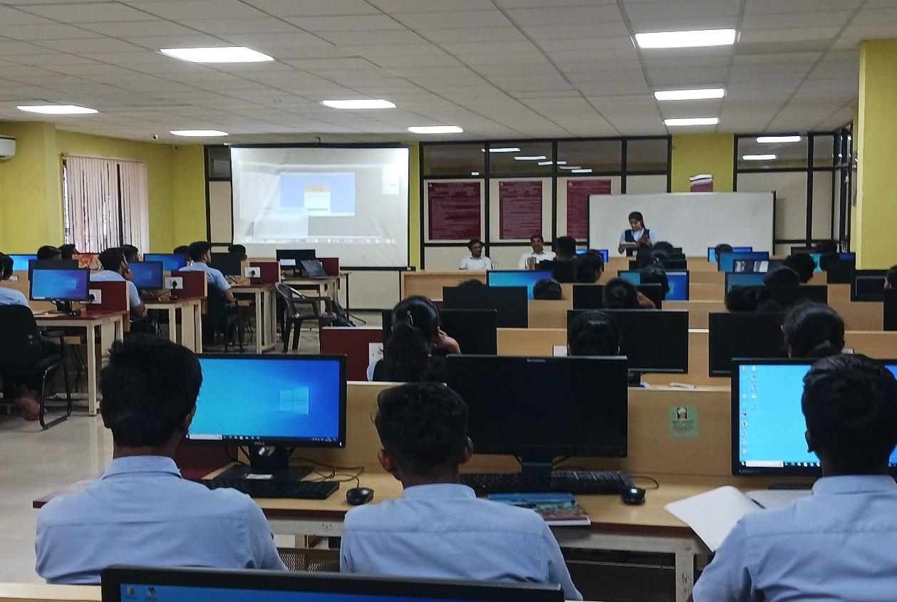

The session was very interactive and it helped students to get more insights in the database concepts. Overall 70 students of CSE were present for the workshop. This was a very informative and useful workshop for students.

Forum coordinator HOD