**Technical TalK-1 on the topic**

**“Placement Opportunity and Preparation”**

***DATE & VENUE:01/10/2022 , MBA SEMINAR HALL***

**Resource Person: Mr.Mohith Puthuraya, Director and CTO, Amazon Services, USA.**

Department Of CSE, CMANIAX Forum Oragazied a Technical Talk On the Topic on 01/10/2022.Dr.Manjunath Kotari, HOD CSE welcomed the guest.

Mr. Mohith Puthuraya started the session by explaining about how should one prepare for placement.He gave few tips for aptitude preparations for placements like Solve random aptitude-based tasks constantly & consistently, Gather previous aptitude test papers & solve them to get hands-on experience, Talk to professionals/seniors in your domain & ask for relevant tips etc.

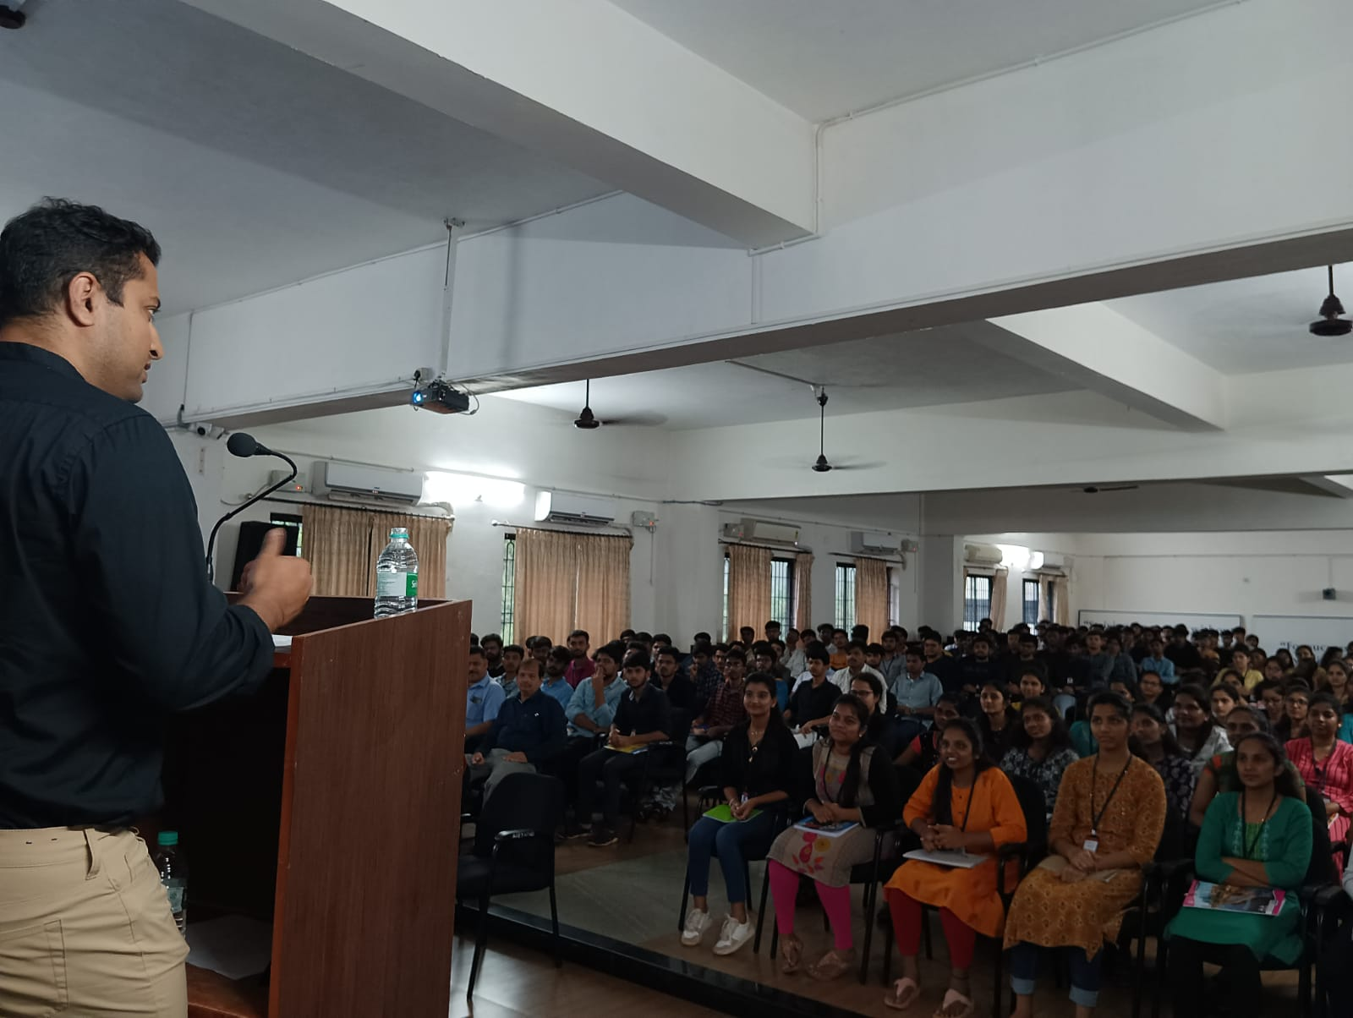

He continued the talk by explaining about why placement preparation is important? .He mentioned Preparing for the placements is the first step to starting one's professional career. It also **paves a path for a Professional Career, hence ensuring a bright future**. Placements are very significant in one's life to kick-start one's career. He also mentioned some of the websites to refer to improve aptitude skils and also communication.

The session continued by explaining about types of placement,and how to buid your resume.He said Campus placements relieve you from the stress of filling up lengthy applications. All you need is a well-worded resume. It should be brief and clear. Use the words given in the company’s job description. And do not forget to highlight your skills. This way, you will explain why the firm should hire you etc. He also said students to stay updated like to browse the news portal in its field. Absorb as much information as possible. Doing this creates the impression that you live in the present. And you know topical events.

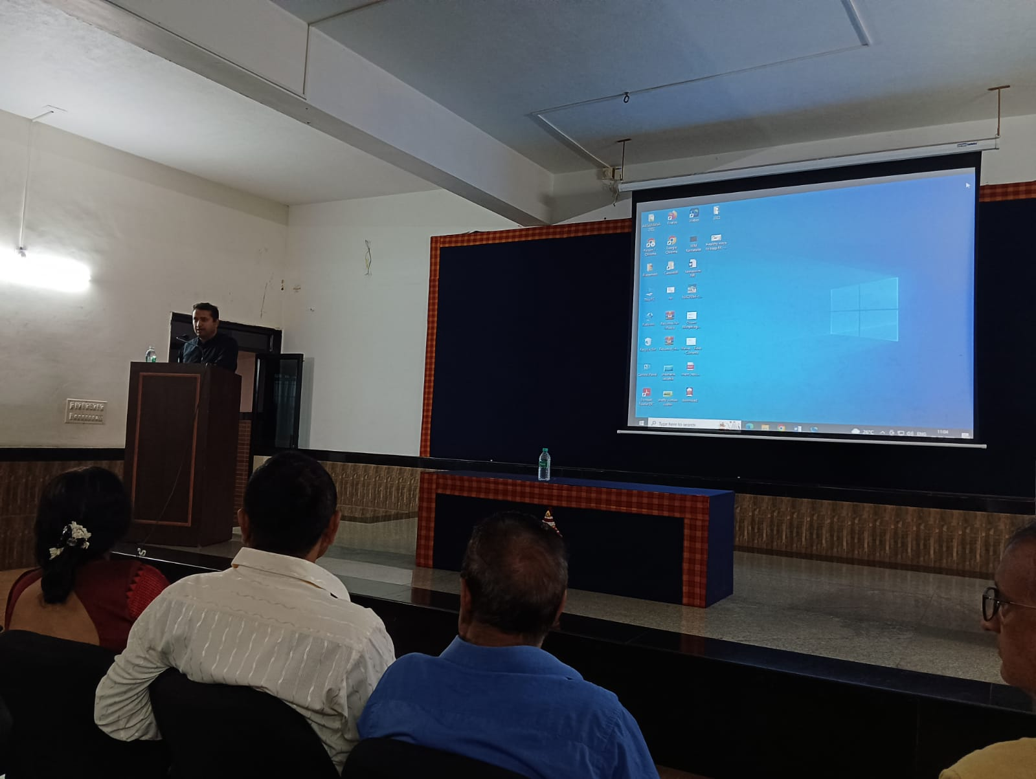

The session was very interesting and it helped our students to understand about importance of placements. Overall 115 students of final year CSE were attended the session.

**Forum coordinator HOD**