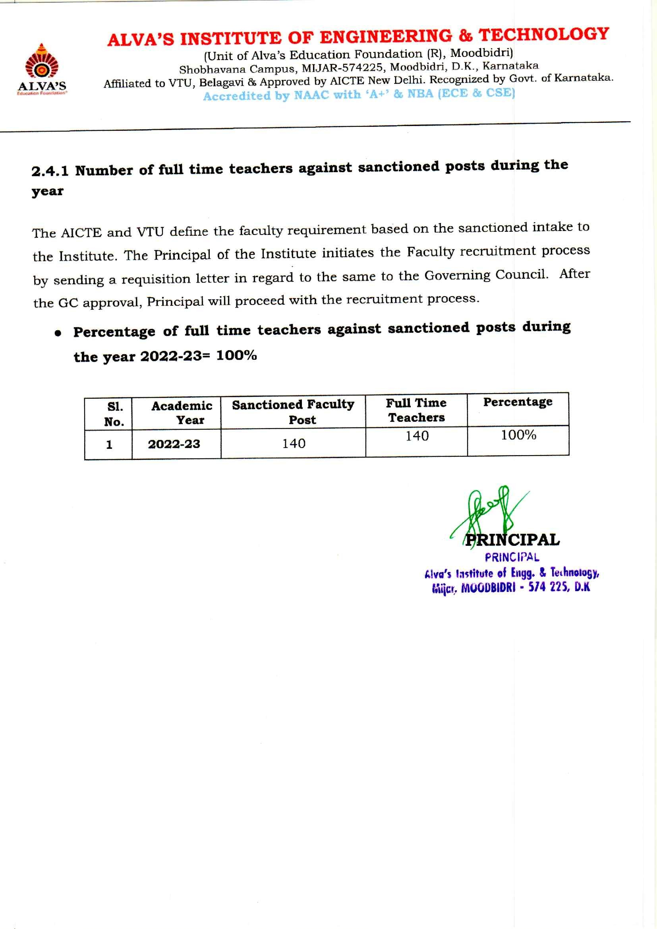

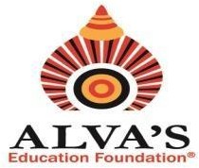ALVA’S INSTITUTE OF ENGINEERING & TECHNOLOGY

# (Unit of Alva’s Education Foundation (R), Moodbidri)

Shobhavana Campus, MIJAR-574225, Moodbidri, D.K., Karnataka

Affiliated to VTU, Belagavi & Approved by AICTE New Delhi. Recognized by Govt. of Karnataka.

# Accredited by NAAC with ‘A+’ & NBA (ECE & CSE)

The table renders information regarding full time teachers and sanctioned posts for year 2022-23

Approved Letter by Head of HEI

|  |  |  |
| --- | --- | --- |
| Sl.  No. | Academic Year | Sanctioned Posts |
| 1 | 2022-23 | [View Document](https://cloud.aiet.org.in/storage/NAAC/NAAC%20AQAR%20(2022-23)/Criteria%202/2.4.1/2.4.1%20Sanctioned%20Post.pdf) |