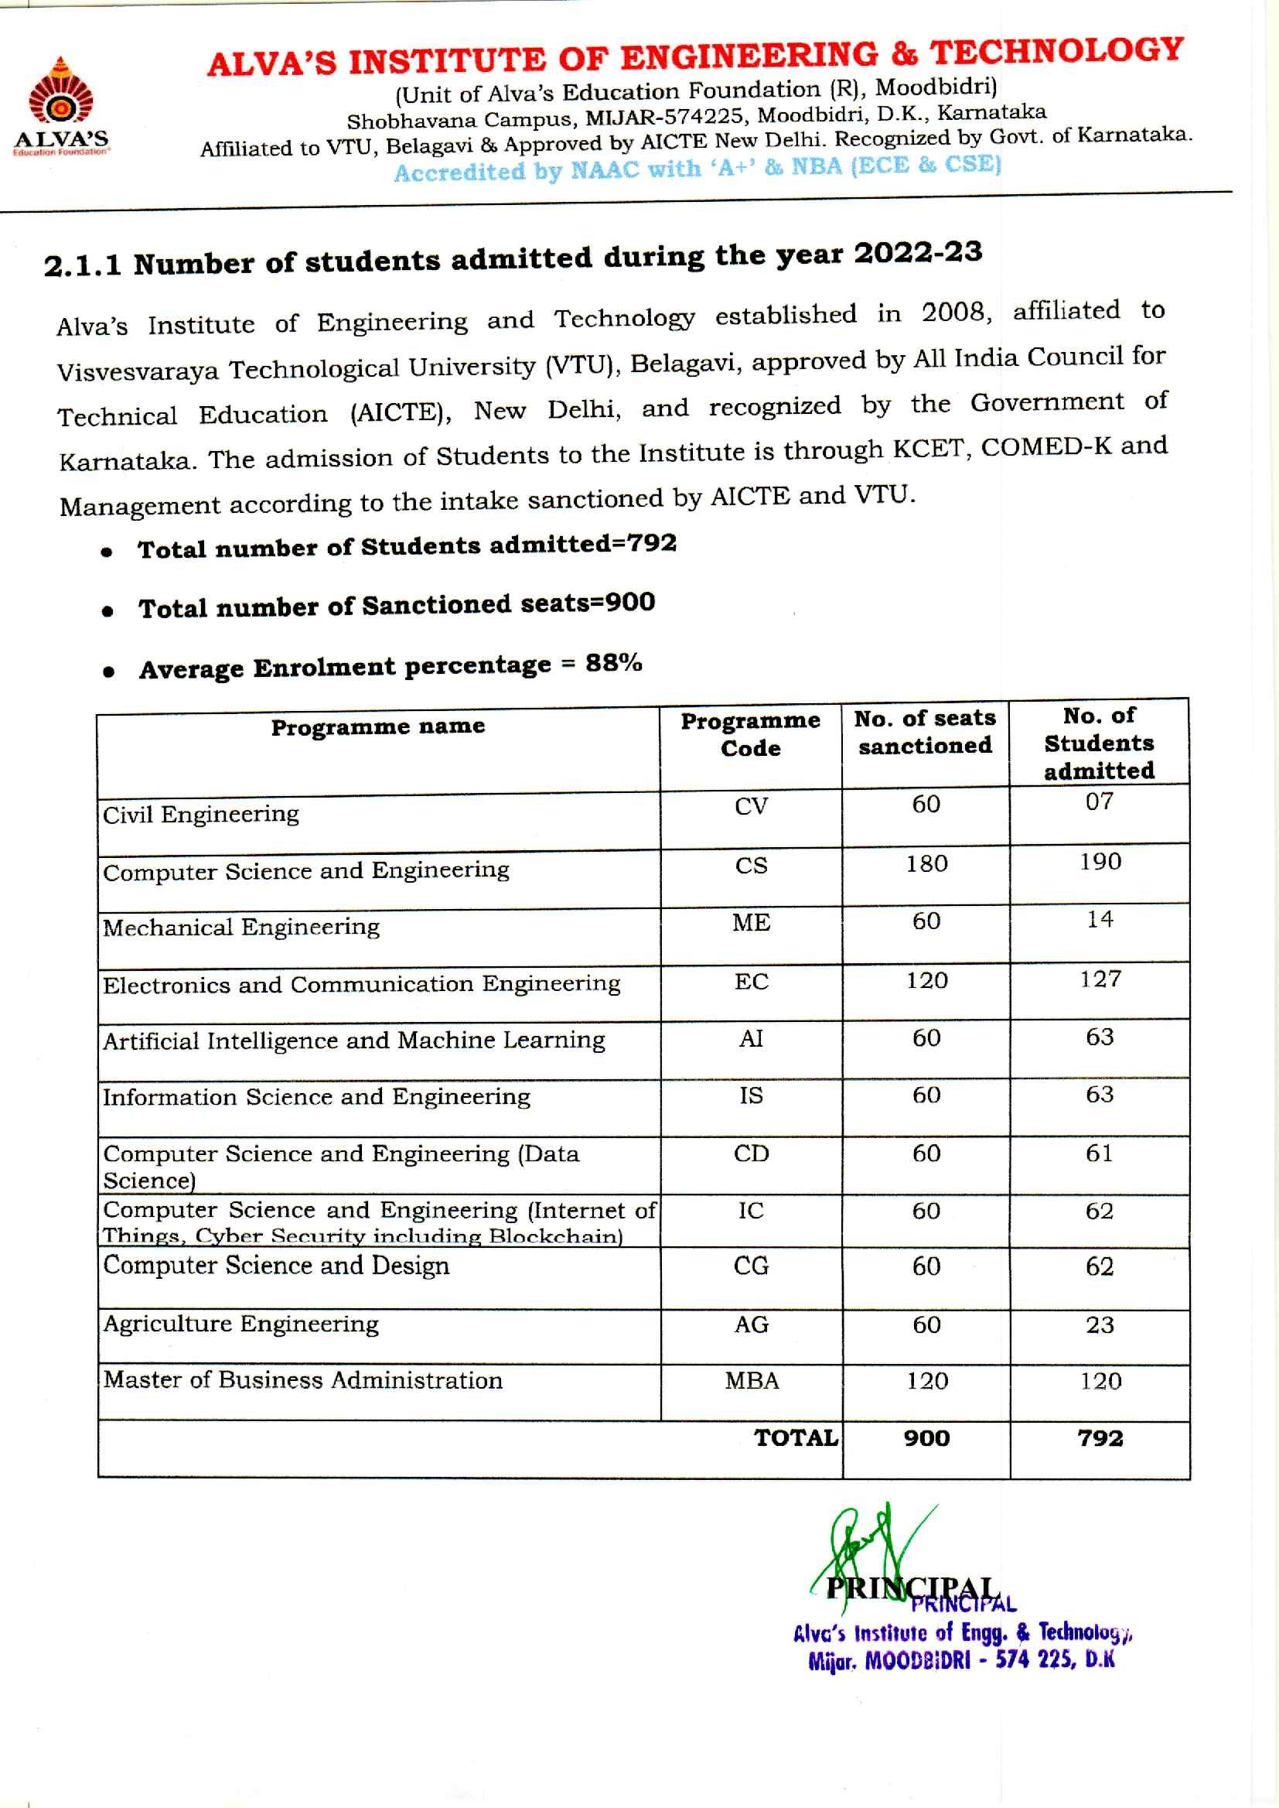

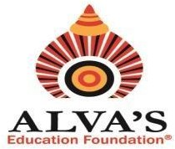ALVA’S INSTITUTE OF ENGINEERING & TECHNOLOGY

# (Unit of Alva’s Education Foundation (R), Moodbidri)

Shobhavana Campus, MIJAR-574225, Moodbidri, D.K., Karnataka

Affiliated to VTU, Belagavi & Approved by AICTE New Delhi. Recognized by Govt. of Karnataka.

# Accredited by NAAC with ‘A+’ & NBA (ECE & CSE)

Hyperlinks of Supporting Documents for Enrolment

|  |  |  |  |  |
| --- | --- | --- | --- | --- |
| Sl. No. | Academic Year | Extension of Approval (EOA) documents AICTE  (UG+PG) | VTU Affiliation documents  (UG+PG) | VTU approved students list (UG+PG) |
| 1 | 2022-23 | [View Document](https://cloud.aiet.org.in/storage/NAAC/NAAC%20AQAR%20(2022-23)/Criteria%202/2.1.1/2.1.1%20Approval%20Process%202022-23%20(1).pdf) | [View Document](https://cloud.aiet.org.in/storage/NAAC/NAAC%20AQAR%20(2022-23)/Criteria%202/2.1.1/2.1.1%20Affiliation%20notification%20(1).pdf) | [View Document](https://cloud.aiet.org.in/storage/NAAC/NAAC%20AQAR%20(2022-23)/Criteria%202/2.1.1/2.1.1%20I%20year%20USN%20List%202022-23.pdf) |

# Note: UG: B.E.,PG: MBA