|  |  |
| --- | --- |
| **Feedback Analysis Report** | |
| **Branch** | **AY 2022-23** |
| AIML | [View Document](https://cloud.aiet.org.in/storage/NAAC/NAAC%20AQAR%20(2022-23)/Criteria%201/1.4/AIML/Feedback%20Analysis%20.pdf) |
| Agri | [View Document](https://cloud.aiet.org.in/storage/NAAC/NAAC%20AQAR%20(2022-23)/Criteria%201/1.4/AGRI/AG%20Curriculum%20feedback%20analysis%20report%202022-23.pdf) |
| CSE | [View Document](https://cloud.aiet.org.in/storage/NAAC/NAAC%20AQAR%20(2022-23)/Criteria%201/1.4/CSE/feedback%20/CSE%20Feedback%20analysis%20Report%20on%20Curriculam.pdf) |
| CSD | [View Document](https://cloud.aiet.org.in/storage/NAAC/NAAC%20AQAR%20(2022-23)/Criteria%201/1.4/CSD/Feedback%20on%20curriculum.pdf) |
| Civil | [View Document](https://cloud.aiet.org.in/storage/NAAC/NAAC%20AQAR%20(2022-23)/Criteria%201/1.4/CV/CV%20Feedback%20Analysis%20Report_22-23.pdf) |
| ECE | [View Document](https://cloud.aiet.org.in/storage/NAAC/NAAC%20AQAR%20(2022-23)/Criteria%201/1.4/ECE/Feedback%20Analysis%20Report%202022-2023%20ECE.pdf) |
| ISE | [View Document](https://cloud.aiet.org.in/storage/NAAC/NAAC%20AQAR%20(2022-23)/Criteria%201/1.4/ISE/2022-23%20punched%20Curriculum%20feedback.pdf) |
| ME | [View Document](https://cloud.aiet.org.in/storage/NAAC/NAAC%20AQAR%20(2022-23)/Criteria%201/1.4/ME/feedback%20analysis%20report%202022-23-%20signed.pdf) |
| MBA | [View Document](https://cloud.aiet.org.in/storage/NAAC/NAAC%20AQAR%20(2022-23)/Criteria%201/1.4/MBA/MBA%20Feedback%20Analysis%20Report%202022-23.pdf) |

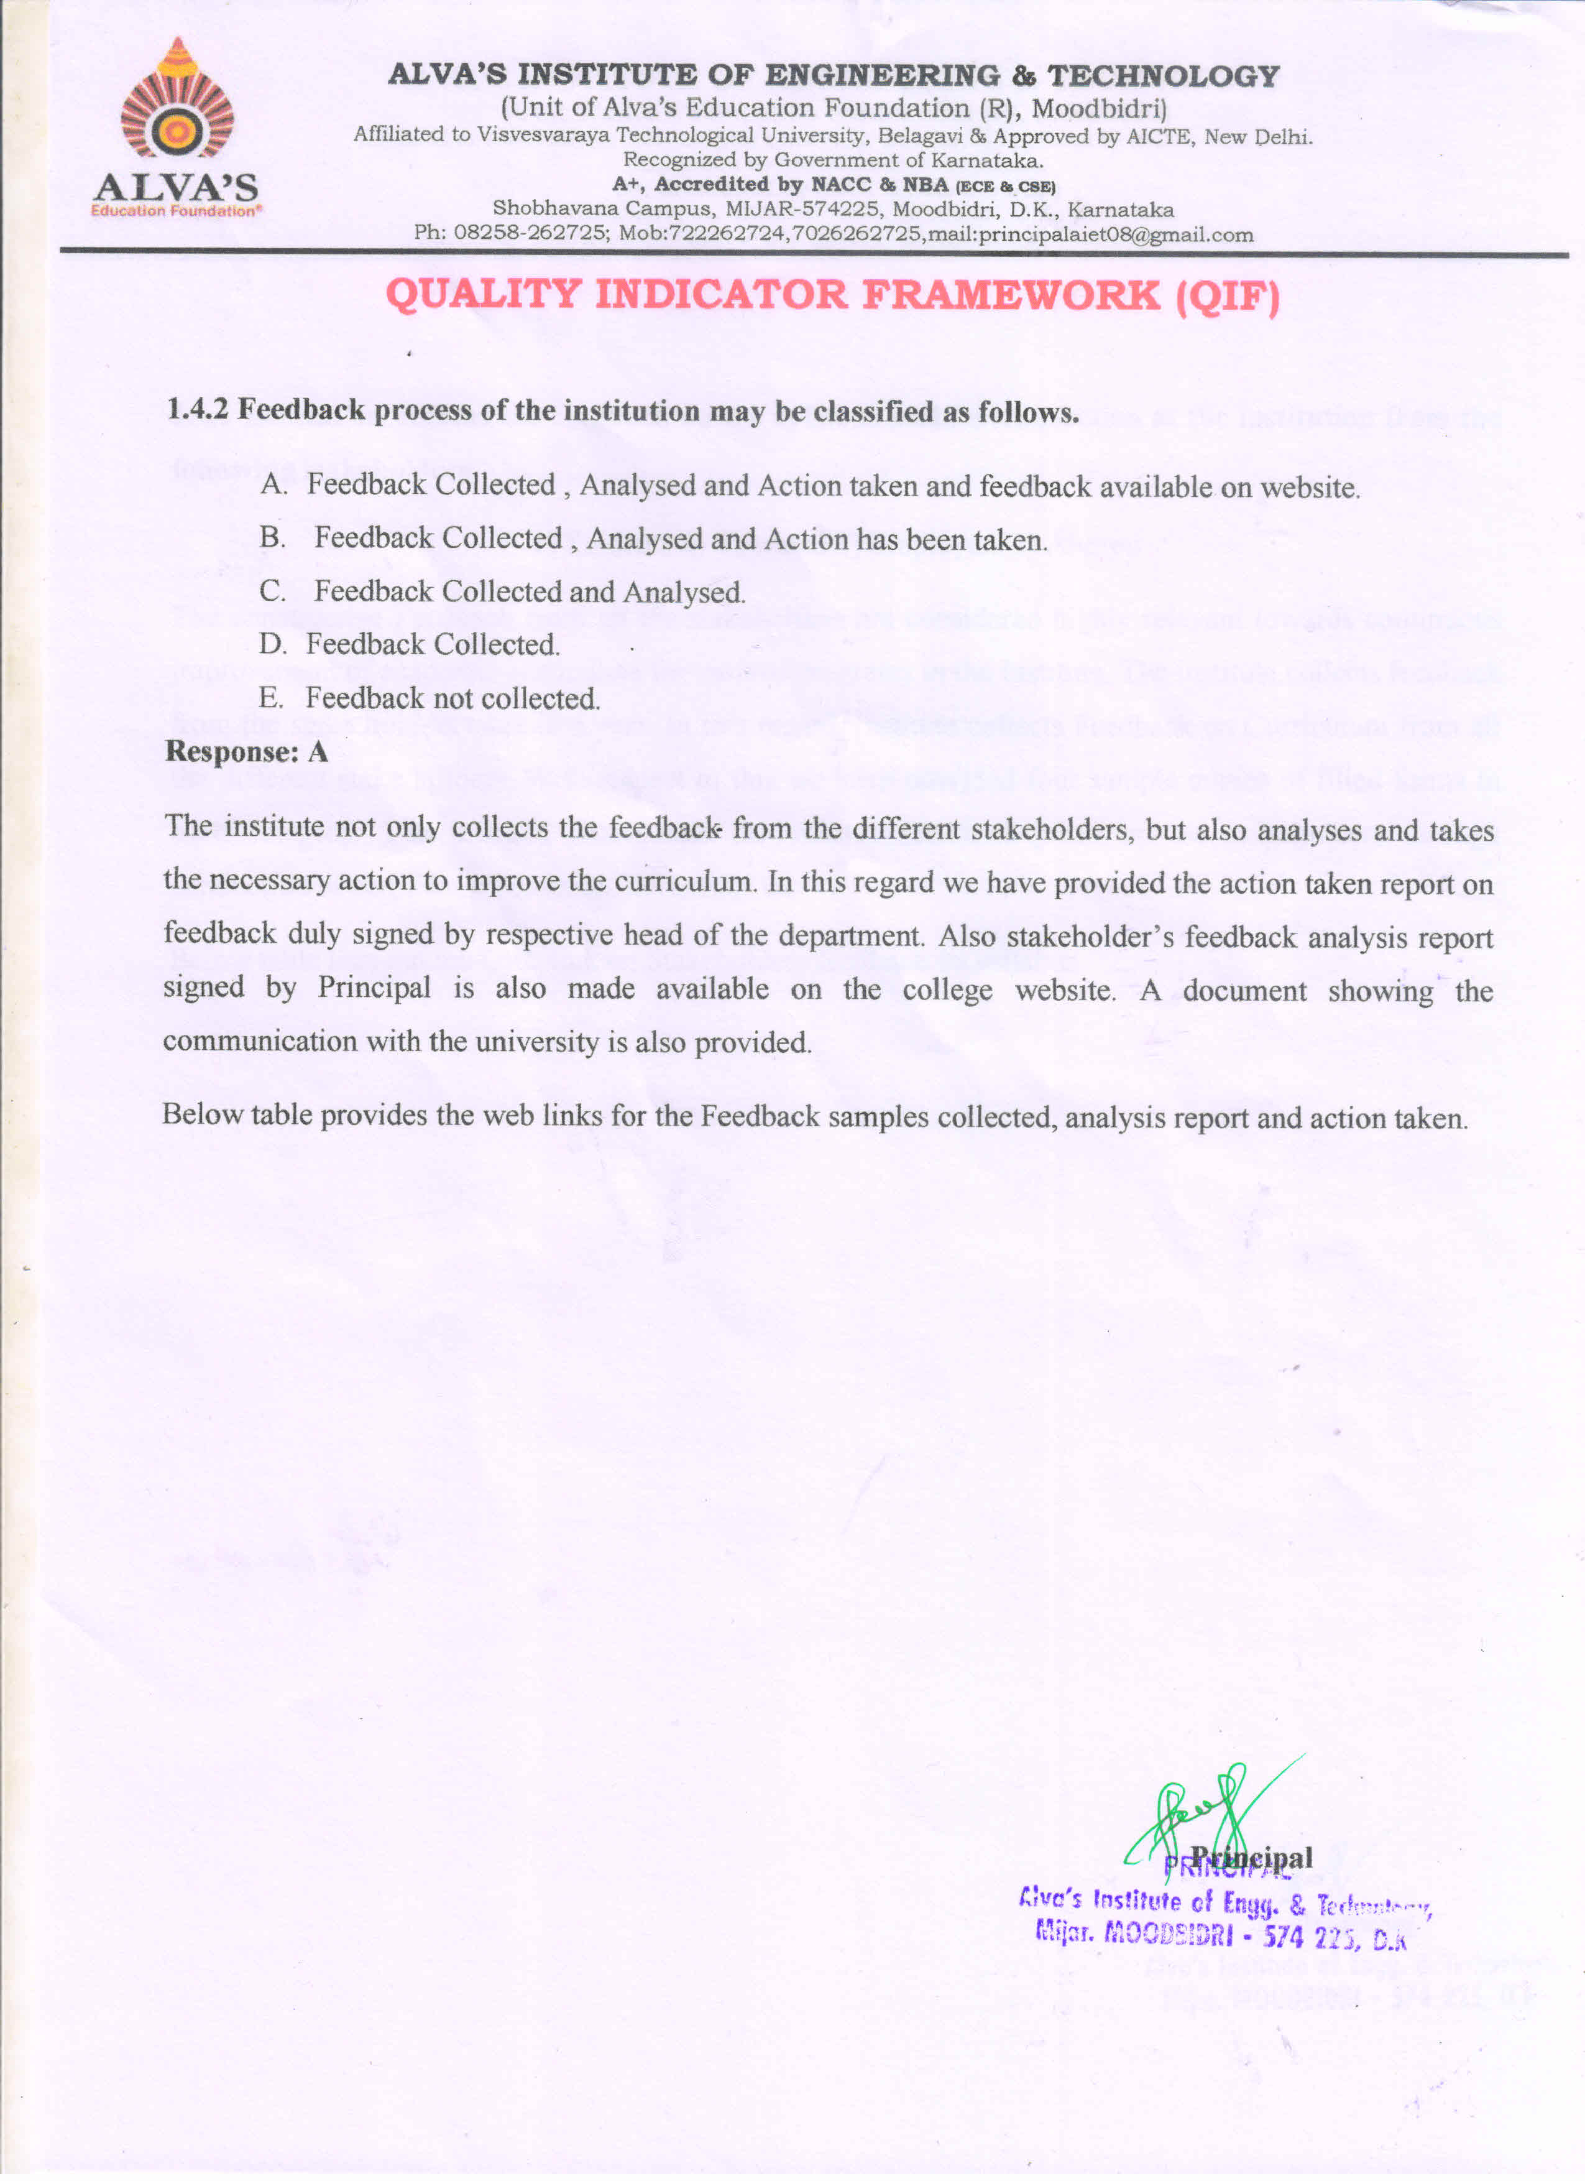

**Action Taken Report**

|  |  |  |
| --- | --- | --- |
| **Branch** | **AY 2022-23** | **VTU Scheme** |
| AIML | [View Document](https://cloud.aiet.org.in/storage/NAAC/NAAC%20AQAR%20(2022-23)/Criteria%201/1.4/AIML/Action%20taken%20report%202022-23.pdf) | [View Document](https://cloud.aiet.org.in/storage/NAAC/NAAC%20AQAR%20(2022-23)/Criteria%201/1.4/AIML/2021%20schem%20aimlsch.pdf) |
| Agri | [View Document](https://cloud.aiet.org.in/storage/NAAC/NAAC%20AQAR%20(2022-23)/Criteria%201/1.4/AGRI/AG%20ACTION%20PLAN.pdf) | [View Document](https://cloud.aiet.org.in/storage/NAAC/NAAC%20AQAR%20(2022-23)/Criteria%201/1.4/AGRI/AG%202021%20SCHEME.pdf%20highlighted.pdf) |
| CSE | [View Document](https://cloud.aiet.org.in/storage/NAAC/NAAC%20AQAR%20(2022-23)/Criteria%201/1.4/CSE/feedback%20/CSE%20Action%20Taken%20report%20for%20AY%202022-23.pdf) | [View Document](https://cloud.aiet.org.in/storage/NAAC/NAAC%20AQAR%20(2022-23)/Criteria%201/1.4/CSE/feedback%20/VTU%202021CSE%20HIGHLIGHTED%20SCHEME.pdf) |
| CSD | [View Document](https://cloud.aiet.org.in/storage/NAAC/NAAC%20AQAR%20(2022-23)/Criteria%201/1.4/CSD/Action%20taken%20report.pdf) | [View Document](https://cloud.aiet.org.in/storage/NAAC/NAAC%20AQAR%20(2022-23)/Criteria%201/1.4/CSD/1.4.1%202021csd%20scheme%20-%20Highlighted.pdf) |
| Civil | [View Document](https://cloud.aiet.org.in/storage/NAAC/NAAC%20AQAR%20(2022-23)/Criteria%201/1.4/CV/ACTION%20PLAN%20%202022-23.pdf) | [View Document](https://cloud.aiet.org.in/storage/NAAC/NAAC%20AQAR%20(2022-23)/Criteria%201/1.4/CV/2021-SCHEME.pdf) |
| ECE | [View Document](https://cloud.aiet.org.in/storage/NAAC/NAAC%20AQAR%20(2022-23)/Criteria%201/1.4/ECE/Action%20Taken%20Report.pdf) | [View Document](https://cloud.aiet.org.in/storage/NAAC/NAAC%20AQAR%20(2022-23)/Criteria%201/1.4/ECE/2021%20VTU%20Scheme.pdf) |
| ISE | [View Document](https://cloud.aiet.org.in/storage/NAAC/NAAC%20AQAR%20(2022-23)/Criteria%201/1.4/ISE/2022-23%20Action%20Taken%20report%20ise.pdf) | [View Document](https://cloud.aiet.org.in/storage/NAAC/NAAC%20AQAR%20(2022-23)/Criteria%201/1.4/ISE/vtu%202021%20ise%20scheme%20highlight.pdf) |
| ME | [View Document](https://cloud.aiet.org.in/storage/NAAC/NAAC%20AQAR%20(2022-23)/Criteria%201/1.4/ME/Action%20taken%20report-signed.pdf) | [View Document](https://cloud.aiet.org.in/storage/NAAC/NAAC%20AQAR%20(2022-23)/Criteria%201/1.4/ME/mecsyll%2021%20scheme.pdf) |
| MBA | [View Document](https://cloud.aiet.org.in/storage/NAAC/NAAC%20AQAR%20(2022-23)/Criteria%201/1.4/MBA/Action%20Taken%20Report%202022-23.pdf) | [View Document](https://cloud.aiet.org.in/storage/NAAC/NAAC%20AQAR%20(2022-23)/Criteria%201/1.4/MBA/MBA%20New%20scheme%20&%20Syllabus%20changes%202022.pdf) |

All documents are uploaded into college website: [View documents](https://www.aiet.org.in/feedback-on-the-curriculum/)

IQAC proceeding: [View documents](https://www.aiet.org.in/iqac/)