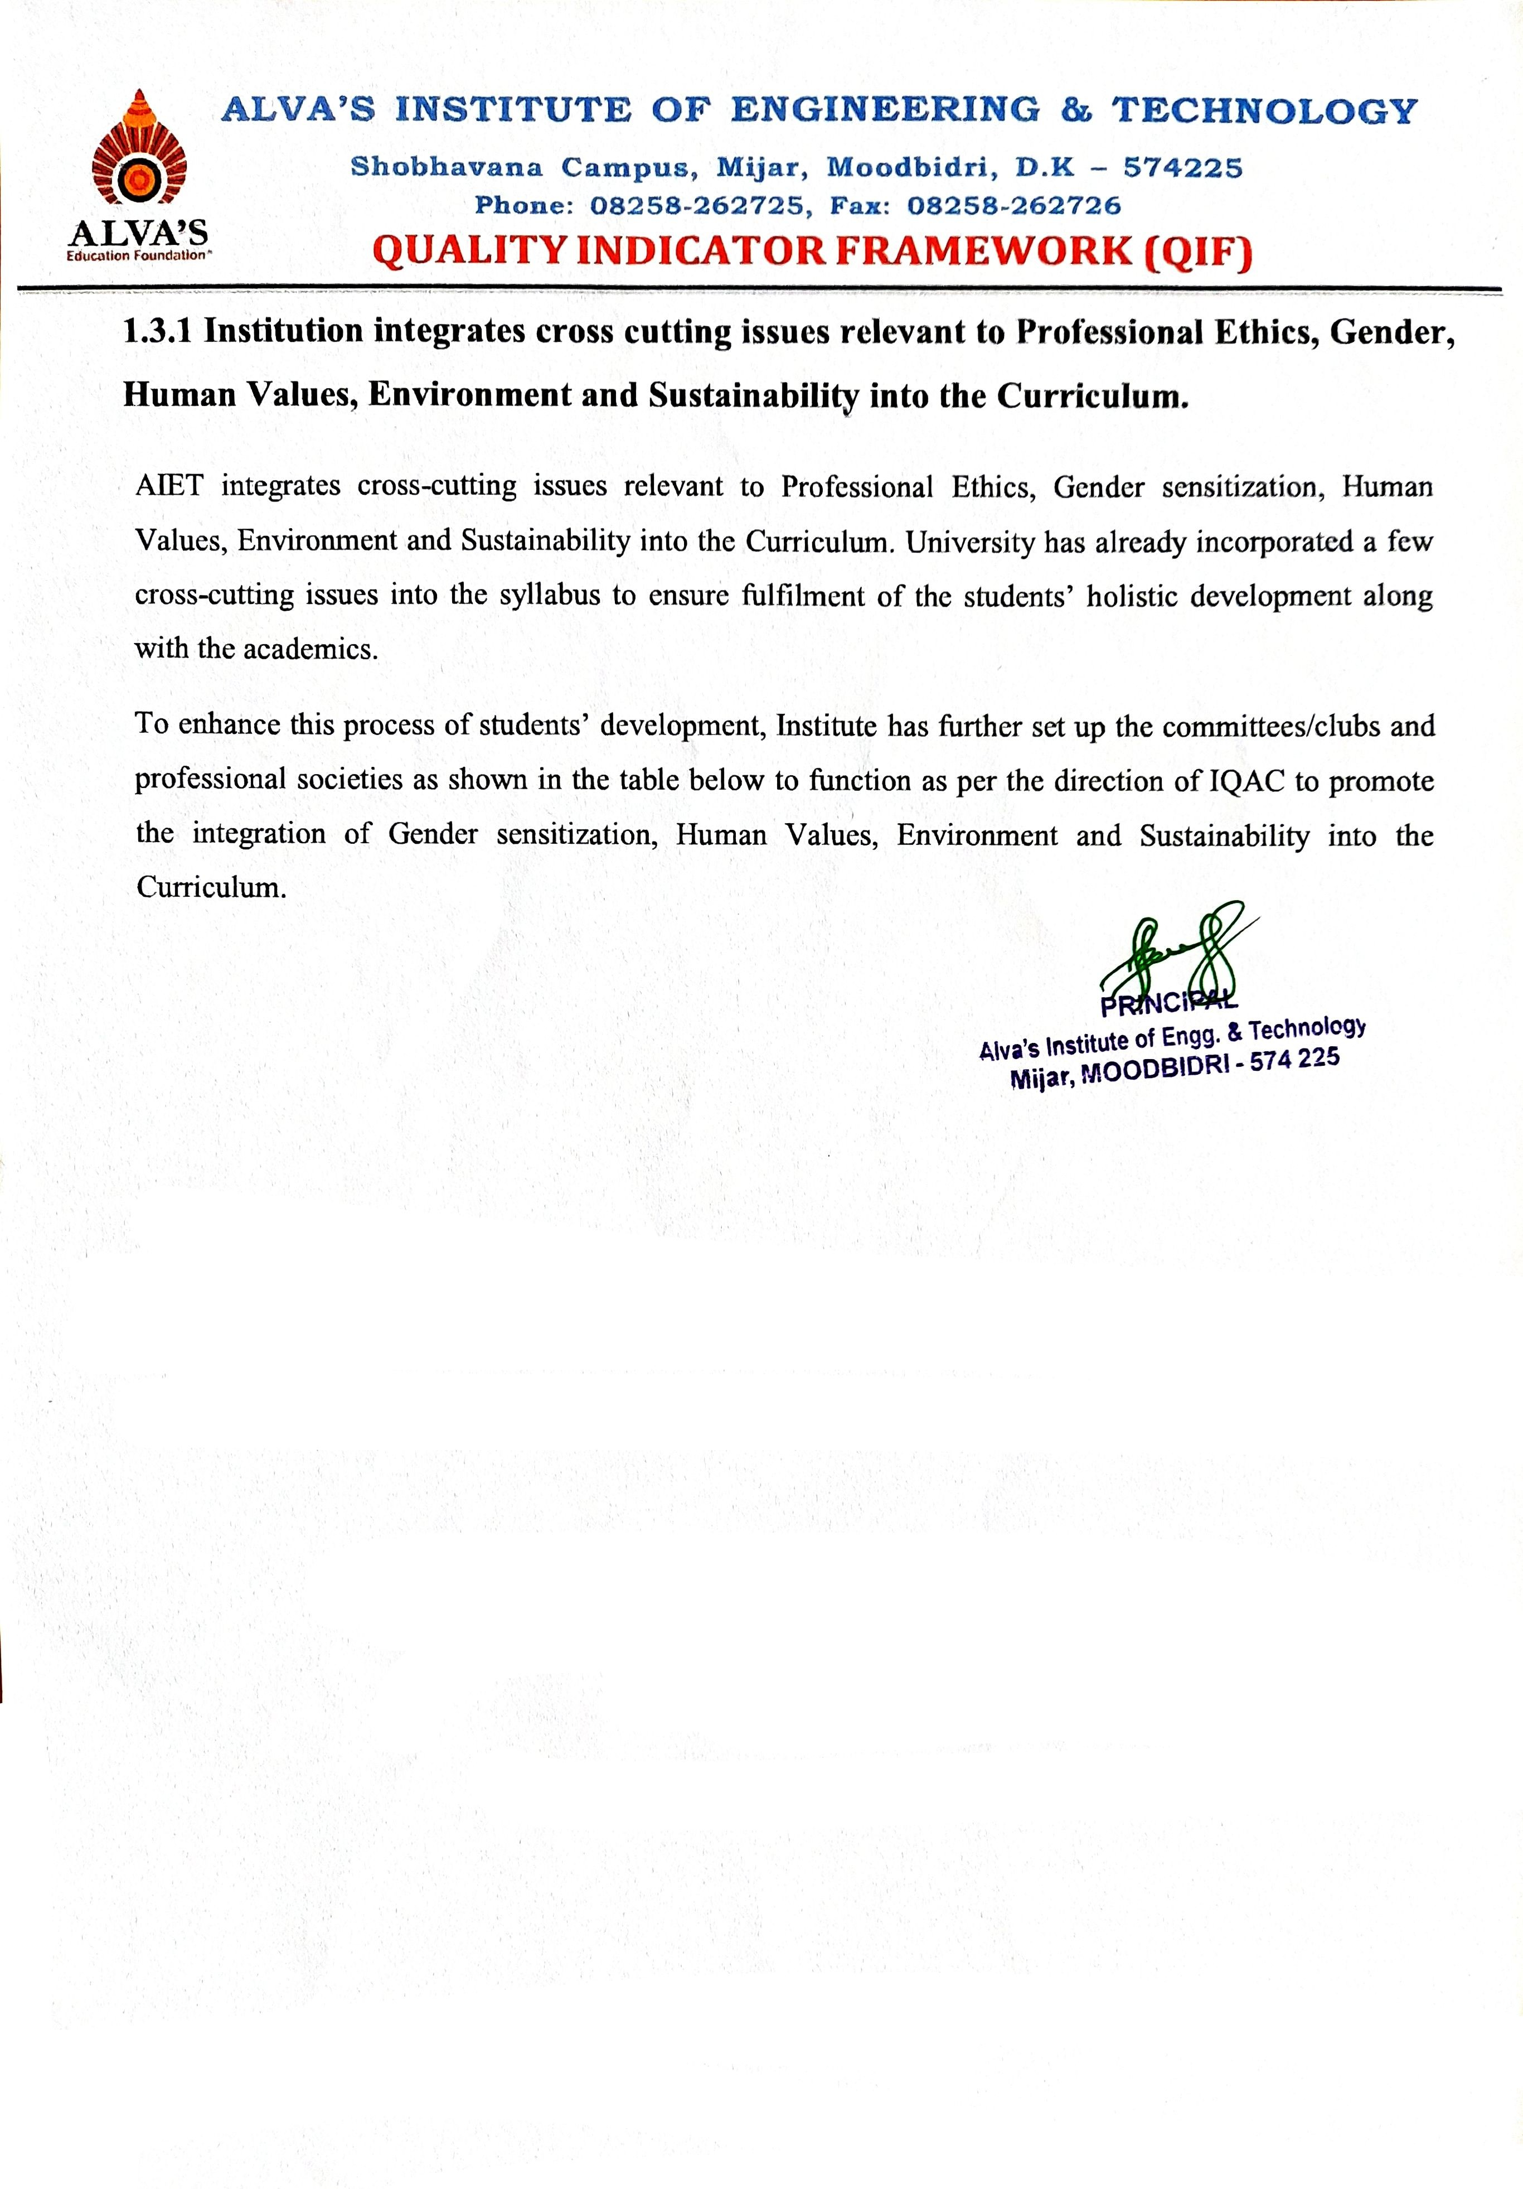

# C:\Users\Shilpa\Desktop\aiet logo.pngALVA’SINSTITUTEOFENGINEERING&TECHNOLOGY

**Shobhavana Campus, Mijar, Moodbidri, D.K–574225 Phone: 08258-262725,Fax:08258-262726**

# QUALITY INDICATOR FRAMEWORK(QIF)

**1.3.1 Institution integrates cross cutting issues relevant to Professional Ethics, Gender, Human Values, Environment and Sustainability into the Curriculum.**

The below tables shows the cross-cutting issues activities reports relevant to Professional Ethics, Gender, Human Values, Environment and Sustainability.

|  |  |  |  |
| --- | --- | --- | --- |
| **SL.**  **No** | **Cross Cutting**  **Issues** | **Various CELLS** | **Document Link (Sample)** |
| 1. | **Vision & Mission of the Institution** | | [View Document](https://www.aiet.org.in/about-us/vision-and-mission/) |
| 2. | **Non-Core Courses** | | [View Document](https://cloud.aiet.org.in/storage/NAAC/NAAC%20AQAR%20(2022-23)/Criteria%201/1.3.1/ISE/1.3.1%20Non%20core%20courses%202022-23.docx) |
| 3. | **Gender sensitization programs** | Committee for prevention of sexual  harassment | [View Document](https://cloud.aiet.org.in/storage/NAAC/NAAC%20AQAR%20(2022-23)/Criteria%201/1.3.1/ISE/PSHC%20Report%202022-23.pdf) |
| 4. | Women empowerment cell | [View Document](https://cloud.aiet.org.in/storage/NAAC/NAAC%20AQAR%20(2022-23)/Criteria%201/1.3.1/ISE/WEC%20Consolidated%20Report%202022-23.pdf) |
| 5. | NCC activities | [View Document](https://cloud.aiet.org.in/storage/NAAC/NAAC%20AQAR%20(2022-23)/Criteria%201/1.3.1/ISE/Full%20Report%20Envirnoment%20day%20NCC.pdf) |
| 6. | NSS activities | [View Document](https://cloud.aiet.org.in/storage/NAAC/NAAC%20AQAR%20(2022-23)/Criteria%201/1.3.1/ISE/NSS%20%20Utility%20assistance%2020.08.22.pdf) |
| 7. | **Environment and Sustainability programs** | Srishti Club- *Natures Club* | [View Document](https://cloud.aiet.org.in/storage/NAAC/NAAC%20AQAR%20(2022-23)/Criteria%201/1.3.1/ISE/SRISTHi%20report%202022-23.pdf) |
| 8. | Shobhavana Herbal Garden | [View Document](https://cloud.aiet.org.in/storage/NAAC/criteria-1/1.3.1/Supportive_Document/Shobhavana%20Herbal%20Garden.pdf) |
| 9. | Birds Park (Garden) | [View Document](https://cloud.aiet.org.in/storage/NAAC/criteria-1/1.3.1/Supportive_Document/AIET%20birds%20park.pdf) |
| 10. | NCC activities | [View Document](https://cloud.aiet.org.in/storage/NAAC/NAAC%20AQAR%20(2022-23)/Criteria%201/1.3.1/ISE/Full%20Report%20Envirnoment%20day%20NCC.pdf) |
| 11. | NSS activities | [View Document](https://cloud.aiet.org.in/storage/NAAC/NAAC%20AQAR%20(2022-23)/Criteria%201/1.3.1/ISE/NSS%20%20Utility%20assistance%2020.08.22.pdf) |
| 12. | Departmental students’ forums | [View Document](https://cloud.aiet.org.in/storage/NAAC/NAAC%20AQAR%20(2022-23)/Criteria%201/1.3.1/ISE/ISE%20Forum%20Avani%20Kesard%20Onji%20Dina%2027th%20November%202022.pdf) |
| 13. | **Human Values & Professional Ethics** | NCC activities | [View Document](https://cloud.aiet.org.in/storage/NAAC/criteria-1/1.3.1/Supportive_Document/NCC/NCC%20HV.pdf) |
| 14. | NSS activities | [View Document](https://cloud.aiet.org.in/storage/NAAC/NAAC%20AQAR%20(2022-23)/Criteria%201/1.3.1/ISE/NSS%20%20Utility%20assistance%2020.08.22.pdf) |
| 15. | Tulu Sangha (Local Language) | [View Document](https://cloud.aiet.org.in/storage/NAAC/criteria-1/1.3.1/Supportive_Document/Tulu%20Sangha/Tulu%20Sangha.pdf) |
| 16. | Departmental students’ forums | [View Document](https://cloud.aiet.org.in/storage/NAAC/criteria-1/1.3.1/Supportive_Document/Dept.%20forum/HV.pdf) |
| 17. | Rostrum–*Speakers Club* | [View Document](https://cloud.aiet.org.in/storage/NAAC/criteria-1/1.3.1/Supportive_Document/Rostrum%20HV.pdf) |
| 18. | Kannada Sangha | [View Document](https://cloud.aiet.org.in/storage/NAAC/NAAC%20AQAR%20(2022-23)/Criteria%201/1.3.1/ISE/Kannada%20Debate%20Competition.pdf) |
| 19. | Personal Holistic Competence Foundation Course (PHCFC) | [View Document](https://cloud.aiet.org.in/storage/NAAC/criteria-1/1.3.1/Supportive_Document/PHCFC%20report.pdf) |