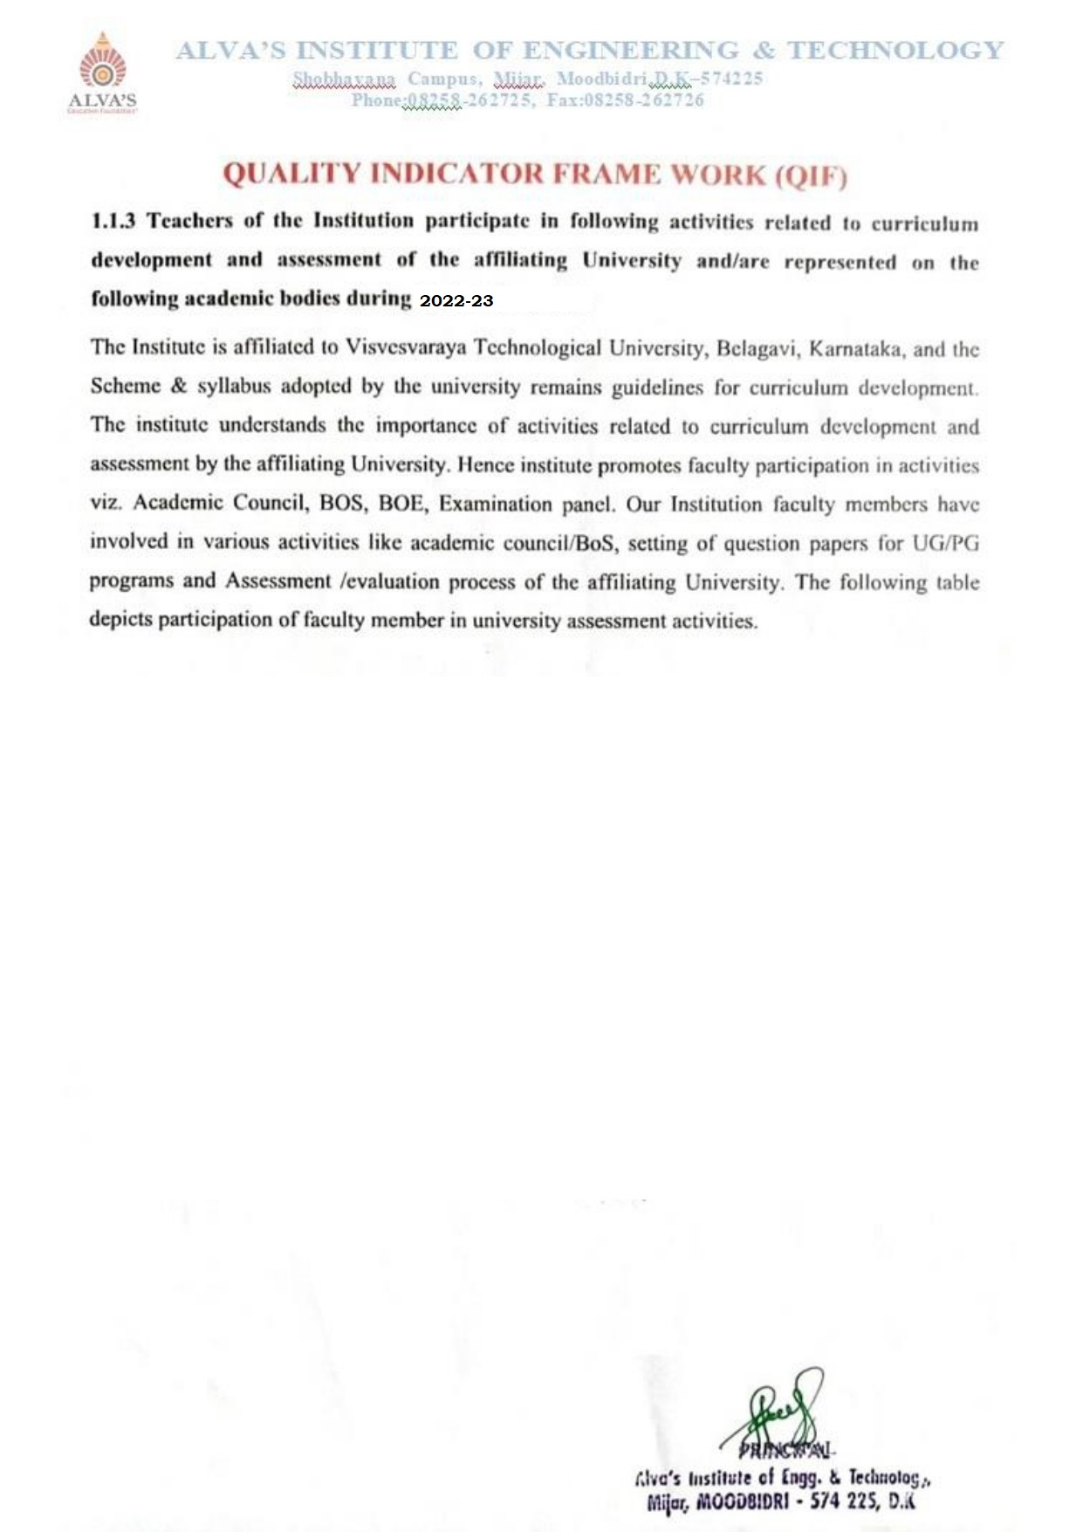

|  |  |  |  |  |
| --- | --- | --- | --- | --- |
| **Year** | **Total** | **Documents** | **Percentage** | **List of Faculty** |
| 2022-23 | 140 | [101](https://cloud.aiet.org.in/storage/NAAC/NAAC%20AQAR%20(2022-23)/Criteria%201/1.1.3/ISE/UPDATED%201.1.3%20excel%20file%2030%20OCT%202023.xlsx) | 60.71 | [View Document](https://cloud.aiet.org.in/storage/NAAC/NAAC%20AQAR%20(2022-23)/Criteria%202/2.2.2/2.2.2%20FACULTY%20LIST%20UPDATED.pdf) |