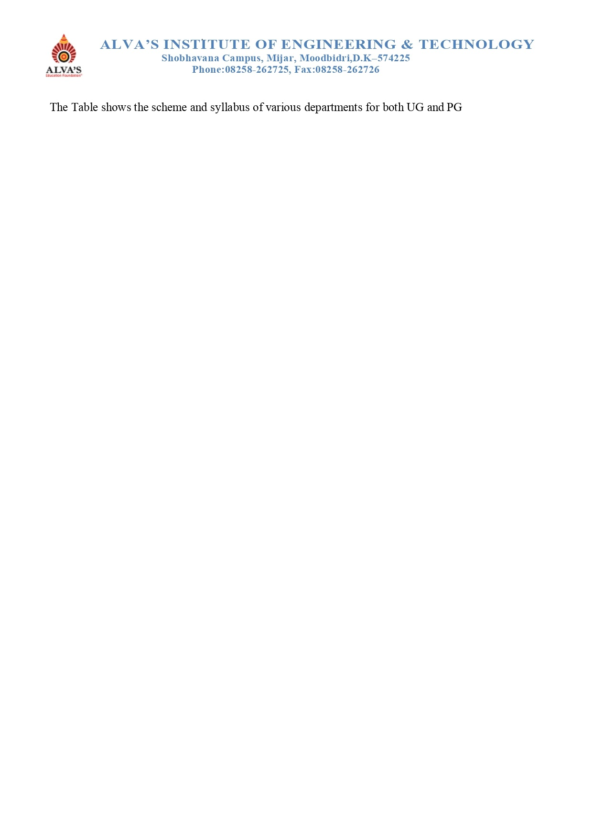

|  |  |  |  |  |  |  |
| --- | --- | --- | --- | --- | --- | --- |
| **Sl. No** | **Year** | **Program** | **Year of Study** | | | |
| **I-Year** | **II-Year** | **III-Year** | **IV-Year** |
| 1 | 2022-23 | Artificial Intelligence and Machine Learning | Syllabus | [Syllabus](https://cloud.alvas.org/?r=/download&path=L05BQUMvTkFBQyBBUUFSICgyMDIyLTIzKS9Dcml0ZXJpYSAxLzEuMS4xL0FJTUwvVW5pdmVyc2l0eSBTY2hlbWUgYW5kIFN5bGxhYnVzLzNyZCAsIDR0aCBzY2hlbWUgYW5kIHN5bGxhYnVzLnBkZg%3D%3D) | [Syllabus](https://cloud.alvas.org/?r=/download&path=L05BQUMvTkFBQyBBUUFSICgyMDIyLTIzKS9Dcml0ZXJpYSAxLzEuMS4xL0FJTUwvVW5pdmVyc2l0eSBTY2hlbWUgYW5kIFN5bGxhYnVzLzV0aCAsIDZ0aCBzZW0gU2NoZW1lIGFuZCBTeWxsYWJ1cy5wZGY%3D) | -------------- |
| 2 | Agriculture Engineering | Syllabus | Syllabus | Syllabus | Syllabus |
| 3 | Civil Engineering | Syllabus | Syllabus | Syllabus | Syllabus |
| 4 | Computer Science and Design | Syllabus | Syllabus | Syllabus | Syllabus |
| 5 | Computer science and Engineering | Syllabus | Syllabus | Syllabus | Syllabus |
| 6 | Computer science and Engineering [Data science] | Syllabus | Syllabus | Syllabus | Syllabus |
| 7 | Computer science and Engineering [IOT] |  |  |  |  |
| 8 | Electronics and Communications Engineering | Syllabus | Syllabus | Syllabus | Syllabus |
| 9 | Information Science and Engineering | Syllabus | Syllabus | Syllabus | Syllabus |
| 10 | Mechanical Engineering | [Syllabus](https://cloud.aiet.org.in/storage/NAAC/NAAC%20AQAR%20(2022-23)/Criteria%201/1.1.1/ME/scheme%20and%20syllubus/22%20schem%20-%201%20and%202%20sem.pdf) | [Syllabus](https://cloud.aiet.org.in/storage/NAAC/NAAC%20AQAR%20(2022-23)/Criteria%201/1.1.1/ME/scheme%20and%20syllubus/21%20sche%20-%202%20and%204sem.pdf) | [Syllabus](https://cloud.aiet.org.in/storage/NAAC/NAAC%20AQAR%20(2022-23)/Criteria%201/1.1.1/ME/scheme%20and%20syllubus/18%20sceme%205%20and%206%20sem.pdf) | [Syllabus](https://cloud.aiet.org.in/storage/NAAC/NAAC%20AQAR%20(2022-23)/Criteria%201/1.1.1/ME/scheme%20and%20syllubus/18%20scheme%207%20and%208%20sem.pdf) |
| 11 | MBA | Syllabus | Syllabus | Syllabus | Syllabus |